STEM dimensions critiquing checklist
Overview
The purpose of this critiquing checklist is to scaffold a critique of a Science, Technologies, Engineering and Mathematics (STEM) Connections unit of work or project using the STEM dimensions. In a STEM Connections unit of work or project, students develop STEM practices (STEM ways of thinking, knowing and doing) by addressing the STEM dimensions:
Relationships: an understanding of how ideas, things or events are related to one another; for example, how causality (one event or action is the direct result of another) or equivalence is crucial to problem-solving and designing solutions. This dimension underpins the other dimensions.
Patterns: an ability to recognise, describe, create and visualise patterns; make predictions based on observations; and see connections and make generalisations.
Structure and function: an understanding of how the physical or abstract form of objects, systems or processes (including sub-structures, organisation and hierarchy) relate to their function or purpose.
Systems: an understanding of how interconnected procedures and or components (objects, processes and concepts) are organised and work together, and the ability to abstract the relevant details of these systems according to the situation.
Measurement and data: an ability to collect and analyse information that provides insight, allows for formation of theories and influences design and iteration.
Models and modelling: a representation that describes, simplifies, clarifies or provides an explanation of the workings, structure or relationships within an object, system or idea; and the ability to create physical, mathematical or conceptual models that may enhance
problem-solving.
Figure 1 provides a representation of the elements of a STEM Connections unit. See Appendix for more detail on the STEM Connections conceptual framework and dimensions.
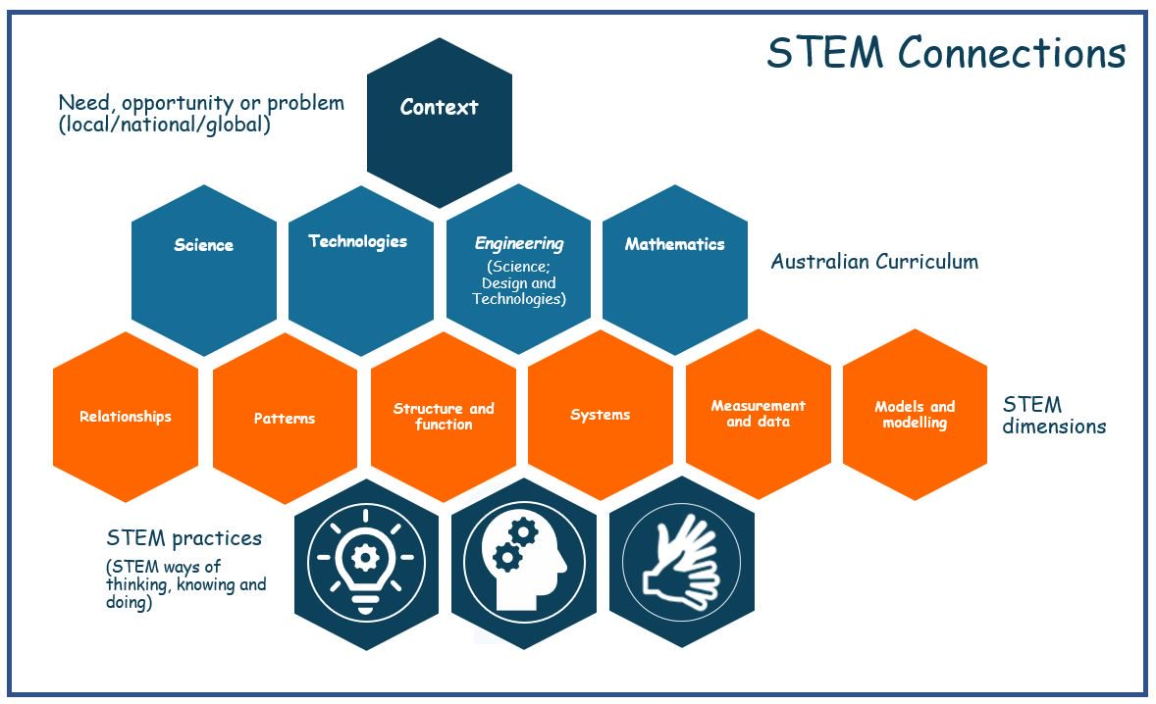
Figure 1: Representation of the elements of a STEM Connections unit
STEM dimensions critiquing checklist
Once you have developed a STEM Connections unit, use the following points to check the depth and rigour in terms of STEM dimensions. The list is not exhaustive but may provide prompts to think more deeply about the opportunities for learning about and applying each dimension.
Dimension  Assess if there are opportunities for students to: | Evident  (Yes/No) | If yes, how is it addressed?  If no, how could it be addressed?
Relationships
- consider cause and effect
- compare and contrast
- respond to feedback to inform decisions
- predict and infer
- consider alternative perspectives
- explore the impact of change

Patterns
- sort, classify and explain patterns
- make connections within and between Science, Technologies, Engineering and Mathematics
- make predictions or generalisations from identified patterns
- consider functions, rules and relationships
- consider patterns or repeated events when making decisions

Structure and function
- recognise how form and function inform systems and processes
- consider purpose and function when designing solutions
- test and use materials, systems, components, tools or equipment

Systems
- identify and describe the components of systems
- explore and analyse the interactions between components
- consider the impact of system components on each other
- make connections and transfer knowledge to real-world applications

Measurement and data
- use appropriate units of measurement
- collect, interpret and present data
- identify patterns in data
- investigate and define needs, opportunities or problems
- use data to predict and infer
- use data to inform decisions for designed solutions
- reflect on validity and reliability of data

Models and modelling
- use models (mathematical, physical, conceptual) to communicate ideas and solve problems
- explore ‘what if …?’ questions using models or simulations
- prototype to explore ideas and plans for designed solutions
- simulate systems
- use models to examine alternative perspectives and to see new opportunities

Appendix
Science, Technologies, Engineering and Mathematics (STEM) Connections conceptual framework
Overview
The purpose of this document is to provide a conceptual framework for teachers to design transdisciplinary STEM Connections units that focus on the Australian Curriculum: Science, Technologies and Mathematics. Note: Engineering is addressed through the technologies context: engineering principles and systems in the Design and Technologies subject, and in the Science sub-strand: physical sciences. This framework provides the basis for a critiquing checklist for educators to use to help increase the depth and rigour of STEM Connections units.
Opportunities for STEM
The opportunities for STEM learning:
- exist within learning areas themselves (disciplinary)
- are strengthened when the connections between learning areas are emphasised (interdisciplinary)
- are richest when learning areas combine to find authentic learning opportunities for students in answer to an identified problem or in the creation of a solution (transdisciplinary).
A culminating STEM Connections (transdisciplinary) unit can help students transfer their learning from one learning area to others and can lead to a better conceptual understanding of the relationships between the disciplines.
A transdisciplinary approach
Transdisciplinary approaches reflect real problems or needs in society – where needs, opportunities or problems are interconnected. Transdisciplinary learning promotes multi-causal explanations to complex phenomena or events, and this reflects our connected, knowledge-based society.
A STEM Connections unit should address content from at least two learning areas in some depth; however, addressing more than three subjects from these learning areas may lead to a lack of focus in teaching, learning and assessment.
The output of a STEM Connections unit should ideally be a ‘workable’ product, service or environment rather than just an elaborated idea. Such outputs increase the opportunity for students to seek feedback from an audience and potentially to develop enterprise skills.
STEM in the early years
STEM Connections in the early years provides a bridge between the Australian Curriculum and the Early Years Learning Framework. For more information about a specific project focused on STEM in the early years see the Early Learning STEM Australia (ELSA) project: https://elsa.edu.au.

STEM practices and STEM dimensions
In a STEM Connections unit, students:
- develop STEM practices (STEM ways of thinking, knowing and doing) by addressing the STEM dimensions (relationships, patterns, structure and function, systems, measurement and data, and models and modelling). These dimensions contribute to a holistic understanding of STEM, are reliant on each other, and provide the language for a conversation about STEM in the Australian Curriculum. The STEM Connections critiquing checklist focuses on these dimensions.
- develop a deep understanding of the concepts and processes of Science and Mathematics and their relationship to Technologies and Engineering
- use their knowledge, understanding and skills in response to identified needs, opportunities and problems from their communities (local, national or global)
- apply the general capabilities, Critical and Creative Thinking, and Ethical Understanding, to make informed decisions and choices when creating solutions for complex needs, opportunities or problems.
Figure 1 provides a representation of the elements of a STEM Connections unit.
The next section, Exploring the STEM dimensions, provides more detail on each dimension.

Exploring the STEM dimensions
This section expands on each of the six STEM dimensions. When planning STEM Connections units, give students opportunities to learn about and apply these dimensions.
Relationships
An understanding of how ideas, things or events are related to one another; for example, how causality (one event or action is the direct result of another) or equivalence is crucial to problem-solving and designing solutions. This dimension underpins the other dimensions. Figure 2 identifies some key points about relationships.

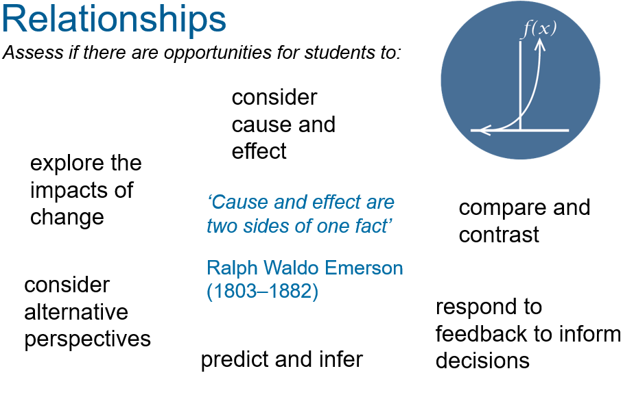
Figure 2: Key points about relationships

Relationships in each STEM learning area/subject
Science: relationships that result in system changes. For example, in Year 7, exploring how living things can cause changes to their environment and impact other living things, such as the effect of cane toads (ACSSU112, Elaboration 5)
Technologies: considering competing factors when designing alternative solutions. For example, in Years 3 and 4:
Design and Technologies (engineering principles and systems): conducting investigations to understand the characteristics and properties of materials and forces that may affect the behaviour and performance of a product or system (ACTDEK011, Elaboration 3)
Digital Technologies: exploring information systems that suit particular home or personal needs, for example water consumption in the home (ACTDIP012, Elaboration 3)
Mathematics: a relationship where one variable is independent and the other is dependent. For example, in Year 8, solving real life problems by using variables to represent unknowns (ACMNA194, Elaboration 1)

Patterns
An ability to recognise, describe, create and visualise patterns; make predictions based on observations; and see connections and develop generalisations. Figure 3 identifies some key points about patterns.

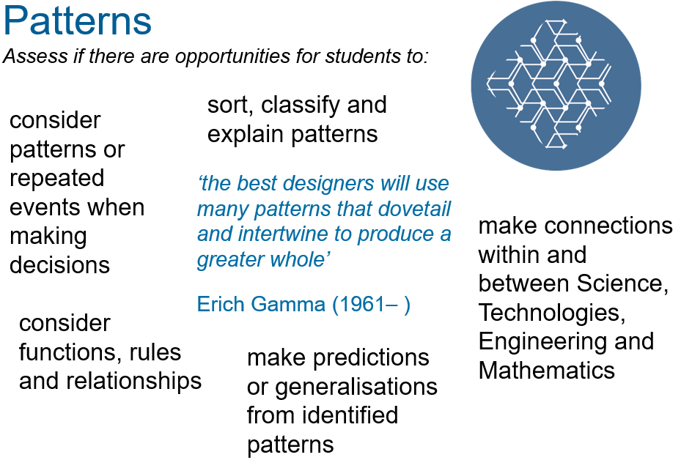

Figure 3: Key points about patterns

Patterns in each STEM learning area/subject
Science: helps us to recognise patterns in the world around us, order and organise phenomena, identify (or understand) relationships and make predictions. For example, in Year 4, considering how scientific practices such as sorting, classification and estimation are used by Aboriginal and Torres Strait Islander Peoples in everyday life (ACSHE061, Elaboration 1)
Technologies: identifying patterns in Technologies helps to make sense of information and aids decision-making.
Design and Technologies: for example, in Years 7 and 8, considering which ideas to further explore and investigating the benefits and drawbacks of ideas (ACTDEP036, Elaboration 2)
Digital Technologies: for example, in Foundation to Year 2, creating different patterns using the same elements, for example using patterns of coloured counters to communicate and give meaning such as a response of ‘yes’ or ‘no’ (ACTDIK002, Elaboration 5)
Mathematics: in the patterns and algebra sub-strand students build algebraic and computational thinking. For example, in Year 5, using the number line or diagrams to create patterns involving fractions or decimals (ACMNA107, Elaboration)

Structure and function
An understanding of how physical or abstract form of objects, systems or processes (including sub-structures, organisation and hierarchy) relate to their function or purpose. Figure 4 identifies some key points about structure and function.

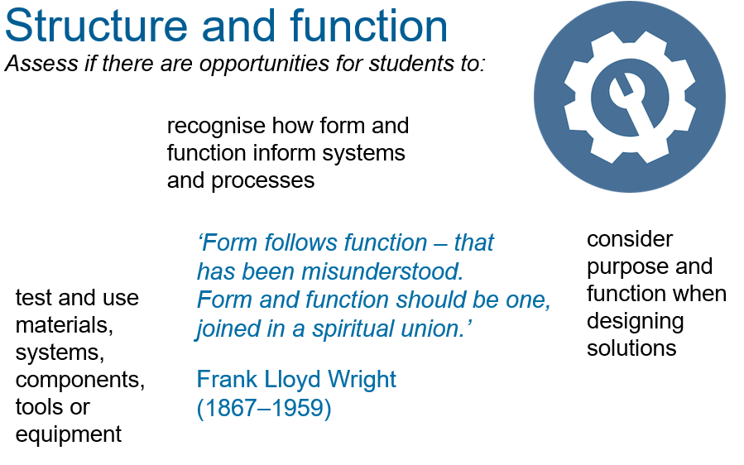
Figure 4: Key points about structure and function

Structure and function in each STEM learning area/subject
Science: relationships between form (the nature or make-up of an object or organism) and function. For example, in Year 3, exploring differences between living, once living and products of living things (ACSSU044, Elaboration 6)
Technologies: designing solutions requires an understanding of structure and function. For example, in Years 3 and 4:
Design and Technologies (engineering principles and systems): identifying and exploring properties and construction relationships of an engineered product or system, for example a structure that floats; a bridge to carry a load (ACTDEK011, Elaboration 5)
Digital Technologies: exploring common elements of standard user interfaces that are familiar and appeal to users (ACTDIP011, Elaboration 3)
Mathematics: working and thinking mathematically, students become aware of the structure of numbers and the algebraic, geometric and stochastic structures in order to understand how these objects are related to each other through abstraction. For example, in Year 5, identifying the shape and relative position of each face of a solid to determine the net of the solid, including that of prisms and pyramids (ACMMG111, Elaboration 1)

Systems
An understanding of how interconnected procedures and or components (objects, processes and concepts) are organised and work together, and the ability to abstract the relevant details of these systems according to the situation. Figure 5 identifies some key points about systems.

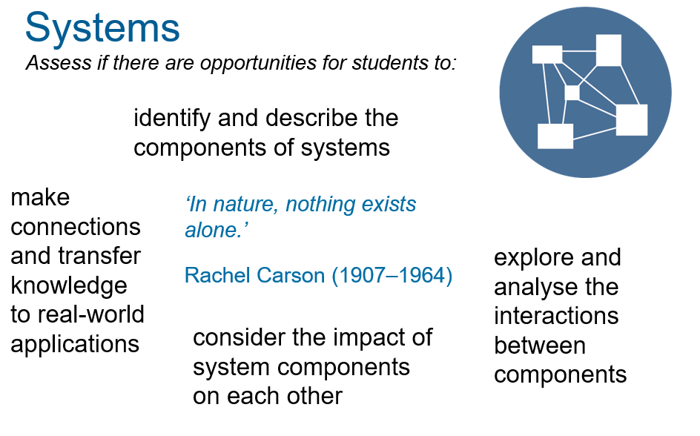
Figure 5: Key points about systems

Systems in each STEM learning area/subject
Science: systems is a key idea in Science. It is a way to define boundaries and represent the interconnectedness of and relationships between individual components. For example, in Year 9, investigating how ecosystems change as a result of events such as bushfires, drought and flooding (ACSSU176, Elaboration 5)
Technologies: systems thinking is one of the key ideas and is fundamental to creating solutions.
Design and Technologies (engineering principles and systems): for example, in Years 3 and 4, deconstructing a product or system to identify how motion and forces affect behaviour (ACTDEK011, Elaboration 4)
Digital Technologies: for example, in Years 7 and 8, evaluating the success of information systems in meeting an economic, environmental or social objective, for example interviewing a local business owner to find out how effectively their information system supports a business objective such as increasing market share (ACTDIP031, Elaboration 4)
Mathematics: consists of multiple interrelated and interdependent concepts and systems, such as the number system and the coordinate system. For example, in Year 2, recognising that sets of objects can be partitioned in different ways to demonstrate fractions (ACMNA033, Elaboration 1)

Measurement and data
An ability to collect and analyse information that provides insight, allows for formation of theories and influences design and iteration. Figure 6 identifies some key points about measurement and data.

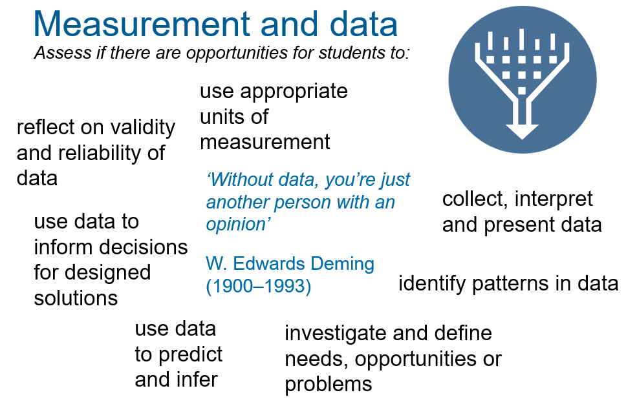
Figure 6: Key points about measurement and data

Measurement and data in each STEM learning area/subject
Science: measurement is essential for gathering evidence, identifying trends, patterns and relationships in data, and using this evidence to support of refute hypotheses and justify conclusions. For example, in Year 9, considering how investigation methods and equipment may influence the reliability of collected data (ACSIS165, Elaboration 7)
Technologies: data informs user needs which in turn may drive the design of innovative solutions.
Design and Technologies: for example, in Years 3 and 4, using tools and equipment accurately when measuring, marking and cutting; and explaining the importance of accuracy when designing and making, for example creating a template, measuring ingredients in a recipe, sowing seeds (ACTDEP016, Elaboration 3)
Digital Technologies: for example, in Years 5 and 6, using software to automate calculations to help with interpreting data, for example using functions to make arithmetic calculations using multiple cells and summing cell ranges (ACTDIP016, Elaboration 4)
Mathematics: measurement and statistics build skills in estimation, validity approximation, error and precision. For example, in Year 8, posing 'and', 'or' and 'not' probability questions about objects or people (ACMSP205, Elaboration)

Models and modelling
A representation that describes, simplifies, clarifies or provides an explanation of the workings, structure or relationships within an object, system or idea; and the ability to create physical, mathematical or conceptual models that may enhance problem-solving. Figure 7 identifies some key points about models and modelling.

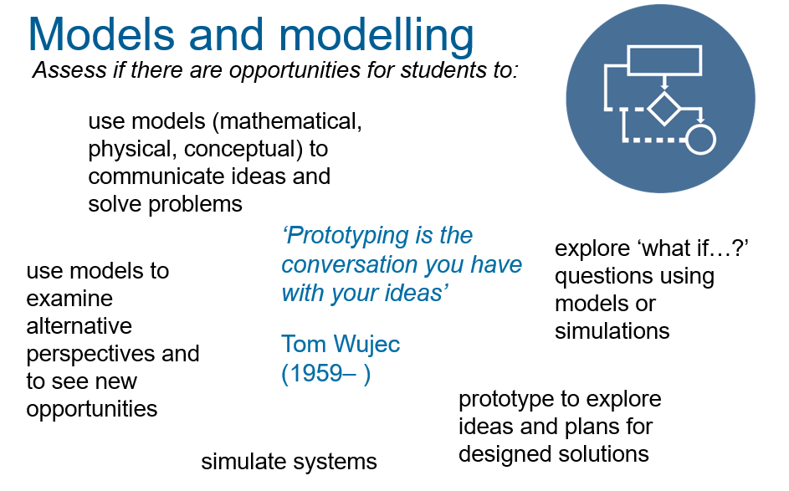
Figure 7: Key points about models and modelling
Models and modelling in each STEM learning area/subject
Science: models in science aim to make parts or features of the physical and material world easier to understand by defining, quantifying, visualising or simulating. For example, in Year 3, modelling the relative sizes and movement of the sun, Earth and moon (ACSSU048, Elaboration 5)
Technologies: Models may be physical or digital representations and allow for iteration of ideas and a focus for collaboration and discussion.
Design and Technologies (engineering principles and systems): for example, in Years 3 and 4, examining models to identify how forces and materials are used in the design of a toy (ACTDEK011, Elaboration 1)
Digital Technologies: for example, in Years 5 and 6, using different design tools to record ways in which digital solutions will be developed, for example creating storyboards or flowcharts to record relationships or instructions about content or processes (ACTDIP019, Elaboration 6)
Mathematics: a mathematical model is a description of a system using mathematical concepts and language. Mathematical models often consist of numbers, equations or other forms of data and can be presented as graphs, tables, pie charts, formulas and diagrams. Mathematical modelling involves a cycle (describe, specify, formulate, solve, interpret, evaluate and report). For example, in Year 2, demonstrating and using models such as linking blocks, sticks in bundles, place-value blocks and Aboriginal bead strings and explaining reasoning (ACMNA028, Elaboration 3)

Further reading
Anderson, J 2017, ‘Leading STEM education in your school’, presentation to the ACSA 2017 Australian Curriculum Conference, 4–6 October 2017, Australian Curriculum Studies Association, viewed 2 December 2019, https://www.acsa.edu.au/pages/images/Judy%20Anderson.pdf.
Harland, J, Moor, H, Kinder, K & Ashworth, M 2002, Is the curriculum working? The key stage 3 phase of the Northern Ireland curriculum cohort study, National Foundation for Educational Research, Slough, UK, viewed 19 December 2019, https://www.nfer.ac.uk/publications/91105/91105.pdf.
Kelley, TR & Knowles, JG 2016, ‘A conceptual framework for integrated STEM education’, International Journal of STEM Education, vol. 3, article 11. Viewed 19 December 2019, https://doi.org/10.1186/s40594-016-0046-z.
Lowrie, T & Larkin, L 2019, ‘Experience, represent, apply (ERA): a heuristic for digital engagement in the early years’, British Journal of Educational Technology, viewed 2 December 2019, https://doi.org/10.1111/bjet.12789.
Lowrie, T, Leonard, S & Fitzgerald, R 2018, ‘STEM practices: a translational framework for large-scale STEM education design’, EDeR – Educational Design Research, vol. 2, no. 1, pp. 1–20, viewed 2 December 2019, http://dx.doi.org/10.15460/eder.2.1.1243.
Miller, M & Boix-Mansilla, V 2004, ‘Thinking across perspectives and disciplines’, Good work project report series, no. 27, Harvard Graduate School of Education.
Rosicka, C 2016, From concept to classroom: translating STEM education research into practice, Australian Council for Education Research, Melbourne, viewed 2 December 2019, https://research.acer.edu.au/cgi/viewcontent.cgi?article=1010&context=professional_dev.

