CASE - Curriculum planning questions

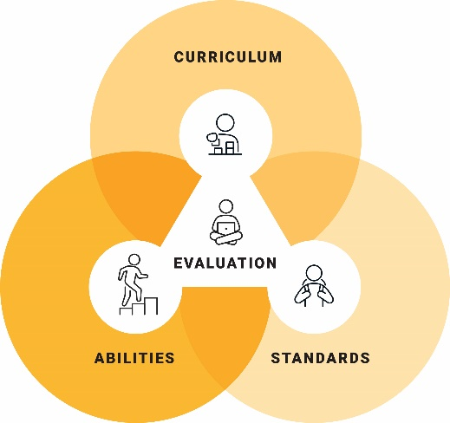
- How will I use content from the 3 dimensions of the Australian Curriculum to develop meaningful personalised learning goals for students?
- How will I plan rigorous, dignified and meaningful learning experiences, starting with adjustments to content from the Australian Curriculum?
- How will I use knowledge of students’ learning and level of abilities to make adjustments in relation to curriculum?
- How will I use content from the Australian Curriculum to ensure all students have opportunities to progress in their learning?
- How will I support students to explore content from the Australian Curriculum in more depth or breadth?
Access further information about the Learning areas, General capabilities and Cross-curriculum priorities.

© ACARA 2023

