STEM practices support material

Overview
The Australian Curriculum: STEM Connections resource describes the key aspects of STEM learning https://v9.australiancurriculum.edu.au/resources/curriculum-connections. These have been developed in consultation with state and territory STEM educators.
Key aspects are used to highlight how STEM can be addressed across the learning areas.
The 3 interrelated key aspects of STEM are:
- responding to needs, opportunities or problems
- using STEM practices (ways of thinking, knowing, doing and being)
- designing and producing STEM solutions and/or enterprises.

Responding to needs, opportunities or problems
STEM contexts can be transdisciplinary and/or authentic. Contexts can be drawn from authentic needs, opportunities or problems; related content in the Australian Curriculum; technologies contexts; and the Sustainability organising ideas. They can also be school-defined.
Authentic needs, opportunities or problems: Students can identify an authentic need, opportunity or problem to create an innovative or impactful solution locally or globally. They can then consider how STEM knowledge and skills might be used together to solve that problem or create a solution.
Related content: The related content identified on the Australian Curriculum website is a good source of inspiration for STEM contexts. The related content can help to determine connecting ideas that can inform the choice of STEM contexts. In each year or band level, there is content in at least one other learning area that relates closely to learning in another and, in many cases, complements content.
For example, contemporary food and fibre production involves:
- knowledge and skills associated with managed environments such as aquaculture spaces, plantations and farms (Design and Technologies)
- data analytics skills (Mathematics and Digital Technologies)
- knowledge of natural systems like weather, animal and plant growth and production, and associated knowledge and skills such as sustainable practices and breeding (animal husbandry) and hybridisation (Science) and content in Geography.
Design and Technologies: Underpinning the Design and Technologies curriculum are the core concepts of the Technologies learning area. The subject-specific core concepts for Design and Technologies (the technologies contexts) are Engineering principles and systems, Food and fibre production, Food specialisations, and Materials and technologies specialisations.
- Engineering principles and systems: knowledge and understanding of scientific and mathematical principles and concepts through the application of engineering design processes and practical skills.
- Food and fibre production: knowledge and understanding of the sustainable management of the environments in which they are produced.
- Food specialisations: knowledge and understanding of what constitutes healthy and sustainable food systems to make informed food selection and preparation choices.
- Materials and technologies specialisations: knowledge and understanding of characteristics and properties of a range of materials, components and production technologies.
Sustainability cross-curriculum priority organising ideas: Actions to improve sustainability may be individual or collective endeavours shared across local, national and global communities. The organising ideas may provide the basis for a STEM context.
- Systems: The interdependence of Earth’s systems (geosphere, biosphere, hydrosphere and atmosphere) that support all life on Earth, and social and economic systems.
- World views: The role of world views (sets of attitudes, values and beliefs) that shape individual and community ideas about how the world works and our role in the world.
- Design: The role of innovation and creativity in sustainably designed solutions, including products, environments and services, that aim to reduce present and future impacts or to restore the health or diversity of environmental, social and economic systems.
- Futures: Ways of thinking and acting that seek to empower young people to speculate and design more equitable, sustainable and inclusive futures.

Using STEM practices (ways of thinking, knowing, doing and being)
The STEM practices (ways of thinking, knowing, doing and being) provide a framework for planning rich STEM units, activities and tasks that provide opportunities for students to develop STEM dispositions.

STEM ways of thinking
While all aspects of the Australian Curriculum: Critical and Creative Thinking are used in STEM teaching and learning, there are specific ways of thinking that really enhance knowledge, understanding and skills in STEM subjects. These are systems thinking, computational thinking, design thinking, scientific thinking, mathematical thinking and futures thinking.
Systems thinking helps people to think holistically about the interactions and interconnections that shape the behaviour of systems.
Figure 1 shows the steps involved in systems thinking.

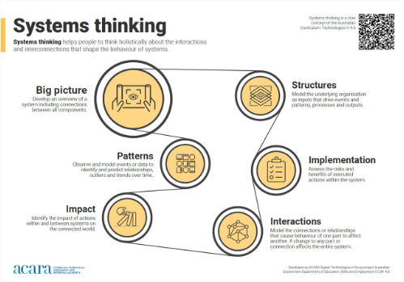
Figure 1: Systems thinking explained
Source: https://v9.australiancurriculum.edu.au/content/dam/en/curriculum/ac-version-9/downloads/technologies/Systems-thinking-poster.png

Computational thinking helps people to organise data logically by breaking down problems into parts; defining abstract concepts; and designing and using algorithms, patterns and models.
Students develop computational thinking through the application of its various components: decomposition, abstraction, pattern recognition, use of models and simulations, algorithms and generalisation. Computational thinking approaches involve experimental and logical analysis, empirical reasoning and computer-based simulations. The simulations can then be used to generate and test hypotheses and conjectures, identify patterns and key features (or counter examples), and dynamically explore variation in the behaviour of structures, systems and scenarios.
Computational thinking skills provide students with a strong foundation for understanding and working with digital tools, including AI systems, as part of a mathematical problem-solving process. This prepares them for future career pathways in AI development, data science, engineering and other STEM-related fields.
Figure 2 shows the steps involved in computational thinking.

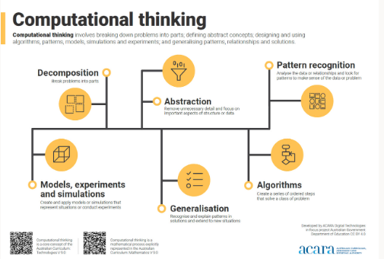
Figure 2: Computational thinking explained
Source: https://v9.australiancurriculum.edu.au/content/dam/en/curriculum/ac-version-9/downloads/technologies/Computational-thinking-poster.png

Design thinking helps people to empathise and understand needs, opportunities or problems; generate, iterate and represent innovative, user-centred ideas; and analyse and evaluate those ideas.
Figure 3 shows the steps involved in design thinking.

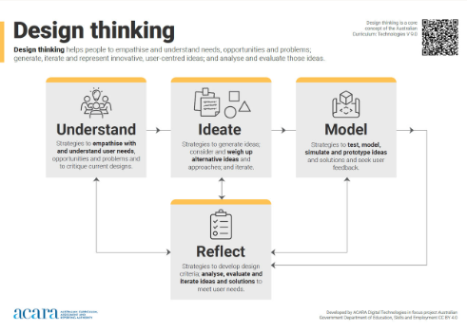
Figure 3: Design thinking explained
Source: https://v9.australiancurriculum.edu.au/content/dam/en/curriculum/ac-version-9/downloads/technologies/Design-thinking-poster.png

Mathematical thinking helps people to investigate and solve problems; visualise, recognise and generalise patterns and relationships; think abstractly and reason logically.
Scientific thinking helps people to understand the world around them and make better data- informed decisions through systematic research, observation, experimentation and reasoning.
Futures thinking helps people to speculate about what might be possible in the future. It involves identifying compelling visions of the future and making considered design decisions taking into account diversity; ethics; and economic, environmental and social sustainability factors.

STEM ways of knowing
In STEM subjects there are specific concepts (ways of knowing) that help students to organise content and to see the relationships between the concepts.
Relationships provides an understanding of how ideas, things or events are related to one another; for example, how causality and equivalence are crucial to problem-solving and designing solutions. This way of knowing underpins the other ways of knowing.
The concept of relationships relates to the concepts of interactions and impact. These need to be considered when creating solutions. This involves examining the relationships between components of technologies systems, sustainability and the effects of design decisions on users.
“Cause and effect are two sides of one fact.”
Ralph Waldo Emerson (1803–1882)
A focus on relationships is significant when a student is:
- exploring the impacts of change
- considering alternate perspectives
- comparing and contrasting
- considering cause and effect
- predicting and inferring
- responding to feedback to inform decision-making.
Systems comprise the structure, properties, behaviour and interactivity of people and components (inputs, processes and outputs) within and between natural, managed, constructed and digital environments.
The concept of systems involves an understanding of how interconnected procedures and/or components (objects, processes and concepts) are organised and work together. It involves the ability to abstract the relevant details of these systems according to the situation.
As students progress from Foundation to Year 10, they explore, describe and analyse increasingly complex systems. Initially, students identify the observable components of a clearly identified "whole" such as features of plants and animals, and parts of mixtures. Across Years 3 to 6, they learn to identify and describe relationships between components within simple systems. They begin to appreciate that components within living and non-living systems are interdependent. In Years 7 to 10, they are introduced to the processes and relationships that structure systems such as ecosystems, body systems and the carbon cycle.
They recognise that within systems, interactions between components can involve forces and changes acting in opposing directions. For a system to be in a steady state, these factors need to be in a state of balance or equilibrium. Students are increasingly aware that systems can exist as components within larger systems, and that one important part of thinking about systems is identifying boundaries, inputs and outputs.
“In nature, nothing exists alone.”
Rachel Carson (1907–1964)
Students might:
- identify and describe the components of a system
- make connections and transfer knowledge to real-world applications
- consider the impact of system components on each other
- explore and analyse the interactions between components.
Form and function and the relationships between form (the make-up of an aspect of an object or organism) and function (the use of that aspect) influence STEM projects.
Many aspects of science are concerned with the relationships between form and function. As students progress from Foundation to Year 10, they see that the functions of living and non-living objects rely on their forms. Students’ understanding of forms, such as the features of living things or the properties of various materials, and their related functions or uses, is initially based on observable behaviours and properties. In later years, students recognise that function often relies on form and that this relationship can be examined at many scales. They apply an understanding of microscopic and atomic structures, interactions of force, and flows of energy and matter to describe relationships between form and function.
This concept involves an understanding of how physical or abstract forms of objects, systems or processes (including sub-structures, organisation and hierarchy) relate to their functions or purposes.
“Form follows function – that has been misunderstood. Form and function should be one, joined in a spiritual union.”
Frank Lloyd Wright (1867–1959)
A focus on form and function allows students to:
- recognise how form and function inform systems and processes
- consider purpose and function when designing solutions
- test and use materials, systems, components, tools or equipment.
Patterns are an important aspect of science and mathematics. The concept of patterns involves recognising patterns in the world around us, and ordering and organising phenomena at different scales. It involves pattern recognition: an ability to recognise, describe, create and visualise patterns; make predictions and inferences based on observations; and see connections and develop generalisations.
An important aspect of science is recognising patterns in the world around us, and ordering and organising phenomena at different scales. As students progress from Foundation to Year 10, they build skills and understanding that will help them to observe and describe patterns at different scales. They develop and use classifications to organise events and phenomena, and make predictions.
As students progress through the primary years, they become more proficient in identifying and describing the relationships that underpin patterns, including cause and effect. Students increasingly recognise that scale plays an important role in the observation of patterns; some patterns may only be evident at certain time and spatial scales.
“The best designers will use many patterns that dovetail and intertwine
to produce a greater whole.”
Erich Gamma (1961–)
Opportunities exist for students to:
- consider patterns or repeated events when making decisions
- sort, classify and explain patterns
- make predictions or generalisations from identified patterns
- make connections within and between Science, Technologies, Engineering and Mathematics
- consider how patterns relate to functions, rules and relationships.
Science understanding and Technologies knowledge and understanding often provide the context for STEM teaching and learning. The 4 Science understanding sub-strands, Biological sciences, Chemical sciences, Earth and space sciences and Physical sciences, align well with the technologies contexts of Engineering principles and systems, Food and fibre production, Food specialisations, and Materials and technologies specialisations.

STEM ways of doing
The STEM ways of doing are the processes that are used to produce tangible evidence of students’ STEM thinking and knowledge such as measurement and data, models and modelling, investigating, designing, producing and implementing, evaluating and managing.
Measurement and data knowledge and skills are critical to STEM activities. Data can be acquired, interpreted and represented to help inform decision-making. It can be manipulated, stored and communicated by digital systems. Quantification of time and spatial scale is critical to the development of STEM understanding as it enables the comparison of observations. It involves an ability to collect and analyse information that provides insight, allows for formation of theories, and influences design and iteration.
Data can be acquired, interpreted and represented to help inform decision-making. It can be manipulated, stored and communicated by digital systems.
Quantification of time and spatial scale is critical to the development of science understanding as it enables the comparison of observations. However, students often find it difficult to work with scales outside their everyday experience. These include the vast distances in space, the incredibly small size of atoms and the slow processes that occur over geological time.
As students progress from Foundation to Year 10, their understanding of relative sizes and rates of change develops. They conceptualise events and phenomena at a broader range of scales. Students progress from working with scales related to their everyday experiences, and comparing events and phenomena using relative language (such as "bigger" or "faster") and informal measurement, to working with scales beyond human experience, and quantifying magnitudes, rates of change and comparisons using formal units of measurement.
This concept involves an ability to collect and analyse information that provides insight, allows for formation of theories, and influences design and iteration.
“Without data, you’re just another person with an opinion”
W. Edwards Deming (1900–1993)
A focus on measurement and data assists students to:
- purposefully acquire, interpret and present data for analysis
- use appropriate units of measurement
- use data to predict and infer
- investigate and define needs, opportunities or problems
- identify patterns in data
- reflect on the validity and reliability of data
- use data to inform decisions for designed solutions.
Models and modelling provide representations that describe, simplify, clarify or explain the workings, structure or relationships within an object, system or idea. The ability to create physical, mathematical or conceptual models may enhance problem-solving. Students develop an understanding of mathematical modelling when they use mathematics to gain insight into and make predictions about authentic phenomena. Mathematical models are used to inform judgements and make decisions in personal, civic and work life.
Figure 4 shows the steps involved in the mathematical modelling process.

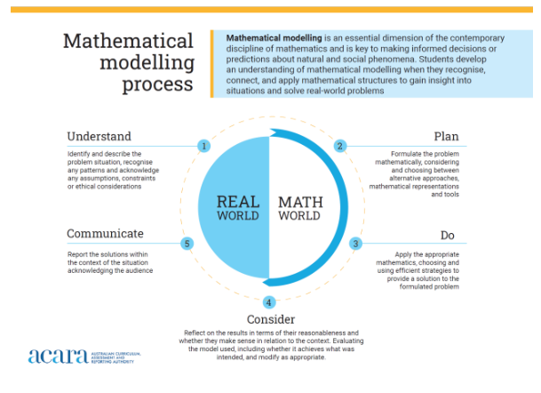
Figure 4: the mathematical modelling process explained
Source: https://v9.australiancurriculum.edu.au/content/dam/en/curriculum/ac-version-9/downloads/mathematics/Mathematical-modelling-process.png

A model is a representation that describes, simplifies, clarifies or explains the workings, structure or relationships within an object, system or idea. Modelling is the ability to create physical, mathematical or conceptual models that may enhance problem-solving.
Students develop an understanding of mathematical modelling when they use mathematics to gain insight into and make predictions about real-world phenomena. Mathematical models are used to inform judgements and make decisions in personal, civic and work life. When using mathematical modelling to solve problems, students make assumptions, recognise, connect and apply mathematical structures. The modelling process uses mathematics to formulate, analyse, solve, interpret, generalise and communicate results in response to a real-world situation.
“Prototyping is the conversation you have with your ideas”
Tom Wujec (1959–)
A focus on models and modelling allows students to:
- use mathematical, physical and conceptual models or simulations to communicate ideas and solve problems
- examine alternative perspectives and see new opportunities
- simulate systems
- explore “what if …?” questions
- prototype to explore ideas and plans for designed solutions.
Investigating processes are used in Science, Technologies and Mathematics. Science investigations are activities in which ideas, predictions or hypotheses are tested and conclusions are drawn in response to a question or problem. In Technologies, students are analysing, exploring, investigating and defining information, needs and opportunities. They critically reflect on the intention, purpose and operation of technologies and designed solutions. In Mathematics, students develop the ability to conduct statistical investigations through informal exploration in the early years. Later they use guided processes, which progressively lead them to conduct and review their own statistical investigations and to critique others’ processes and conclusions.
Science investigations are activities in which ideas, predictions or hypotheses are tested and conclusions are drawn in response to a question or problem. They can involve a range of activities including experimental testing, field work, locating and using information sources, conducting surveys, and using modelling and simulations. The choice of the approach taken will depend on the context and aims of the investigation.
In Technologies, students analyse, explore and investigate information, needs and opportunities. They critically reflect on the intention, purpose and operation of technologies and designed solutions. Analysing encourages students to examine values, and question and review processes and systems. Students reflect on how decisions they make may have implications for individuals, society, and the local and global environment, now and in the future.
Students explore and investigate technologies, systems, products, services and environments as they consider needs and opportunities. They progressively develop effective investigation strategies, consider the contribution of technologies to their lives and make judgements about them. Students develop design criteria in response to needs and opportunities, and may respond to or develop design briefs.
In Mathematics, students develop the ability to conduct statistical investigations through informal exploration in the early years. Later they use guided processes, which progressively lead them to conduct and review their own statistical investigations, experiments and probability simulations and to critique others’ processes and conclusions. Statistical investigation deals with uncertainty and variability in categorical (nominal or ordinal) or numerical (discrete or continuous) data arising from observations, surveys or experiments. It can be initiated by a specific question, a situation or an issue. Probability simulations and experiments enable students to understand contexts involving chance and to build mathematical models surrounding risk and decision-making in a range of areas of human endeavour.
Figures 5 and 6 show the steps involved in the statistical investigation process and probability experiments and simulations.

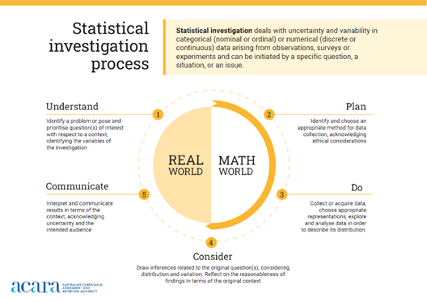
Figure 5: the statistical investigation process explained
Source: https://v9.australiancurriculum.edu.au/content/dam/en/curriculum/ac-version-9/downloads/mathematics/Statistical-investigation-process.png

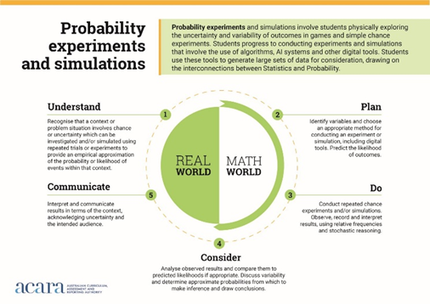
Figure 6: probability, experiments and simulations explained
Source: https://v9.australiancurriculum.edu.au/content/dam/en/curriculum/ac-version-9/downloads/mathematics/Probability-experiments-and-simulations.png

Designing is fundamental to Technologies education. Students are developing and communicating design ideas for a range of needs, opportunities or problems. They generate and iterate ideas, make choices, weigh up options, consider alternatives, and document various design ideas and possibilities. Students use critical and creative thinking strategies to generate, evaluate, modify and document ideas to meet needs, opportunities or problems identified by an individual, a group or a wider community.
In Technologies, students develop and communicate design ideas for a range of audiences. Students generate and iterate ideas, make choices, weigh up options, consider alternatives and document various design ideas and possibilities. They use critical and creative thinking strategies to generate, evaluate and document ideas to meet needs or opportunities that have been identified by an individual, a group or a wider community.
Generating creative and innovative ideas involves thinking differently. It entails proposing new approaches to existing solutions and identifying new design opportunities, considering preferred futures. Generating and developing ideas involves identifying various competing factors that may influence and dictate the focus of the idea. Students evaluate, justify and synthesise what they learn and discover. They use graphical representation techniques when they sketch, draw, model, simulate and design ideas that focus on well-considered designed solutions.
Producing and implementing solutions allows students to apply their learning and demonstrate STEM ways of thinking, knowing and being. In Technologies, students are learning and applying a variety of skills and techniques to make designed solutions to meet specific purposes and user needs. Students apply knowledge about components and materials and their characteristics and properties to ensure their suitability for use. They learn about the importance of adopting safe work practices. They develop production skills to produce prototypes that accurately reflect their proposed designed solutions.
Evaluating occurs throughout scientific inquiries and when working through a design process. It involves students reviewing design ideas, processes and solutions. Students seek feedback and make judgements throughout a design process and about the quality and effectiveness of their and others’ designed solutions.
In Technologies, students evaluate throughout a design process. Students review design ideas, processes and solutions. They seek feedback and make judgements throughout a design process and about the quality and effectiveness of their and others’ designed solutions. Students identify design criteria for needs or opportunities in the investigating and defining stage. They then use these criteria to consider the implications and consequences of actions and decision-making throughout the process. They determine effective ways to test, judge and improve their ideas, concepts and designed solutions. They reflect on processes and transfer their learning to other design needs or opportunities.
Managing resources using project management skills helps students to plan, manage and complete projects to meet identified design criteria successfully and efficiently. Students learn to work cooperatively and to manage time and other resources to effectively create designed solutions. They work individually and in groups to plan, organise and monitor timelines, activities and the use of resources.
In Technologies, this involves students learning to work cooperatively and to manage time and other resources to effectively create designed solutions. Students work individually and in groups to plan, organise and monitor timelines, activities and the use of resources. They progress from planning steps in a project through to more complex project management activities that consider factors such as time, cost, risk assessment and management, and quality control. Collaborating and managing occur throughout a design process.

STEM ways of being
STEM ways of being are those dispositions that are helpful when working on STEM projects and when considering impact. They enable collaborating, communicating, being ethical, and being enterprising and innovative.
Collaborating with others on a common task requires students to develop the ability to communicate and share ideas throughout the process. They need to negotiate roles and responsibilities and make compromises to work effectively as a team. Working with a group to achieve shared goals is a key employability skill. It involves developing Personal and Social capability. https://v9.australiancurriculum.edu.au/f-10-curriculum/general-capabilities/personal-and-social-capability?element=0&sub-element=0
Communicating involves listening and sharing ideas effectively using various tools, such as media and technology. It draws on the general capabilities of Literacy and Digital Literacy.
Being ethical involves students building a strong personal and socially oriented ethical outlook that helps them to manage design and technologies decisions. They develop awareness of the influence that their values and behaviours have on others, including impact and outcomes, and reflect on ethical action.
Being enterprising and innovative helps people to identify opportunities to take action and create change; follow through on initiatives; and generate new ideas, processes and solutions. Students develop the skills of responsible decision-making and enterprise. They learn to apply informed decision-making in a range of authentic contexts. They learn to use criteria to evaluate the advantages and disadvantages of alternative choices, leading to actions proposed in response to an issue or challenge.
Entrepreneurship demands the skills to manage people and resources, assess viability, identify pathways to adoption, and understand the environment. At the same time, entrepreneurs need to be comfortable with uncertainty and resilient in the face of failure and change.
Understanding the distinction between innovation and entrepreneurship is critical. Innovation often begins by assuming no constraints and imagining a world of possibility.
But entrepreneurship assumes resources are scarce and that success depends on overcoming obstacles and working with what’s available. While innovation can happen in isolation, entrepreneurship needs community, collaboration, feedback and constant adaptation.

Designing and producing STEM solutions and/or enterprises
Students design and produce STEM solutions and/or enterprises as a culminating activity in STEM learning to show evidence of transdisciplinary knowledge, understanding and skills.
In Design and Technologies, students should have the opportunity to produce 3 types of designed solutions (products, services and environments) in a number of technologies contexts, these are:
- engineering principles and systems
- food and fibre production
- food specialisations
- materials and technologies specialisations
The different types of designed solutions have been specified to give students opportunities to engage with a broad range of design thinking and production skills. The combination of technologies contexts and types of designed solutions is a school or student decision.
Solutions can be physical or digital solutions and may be one of the following types:
- products, for example, an engineered solution such as a robotic arm prototype, ethical and sustainable food, digital advertising product, a piece of clothing for a specific need
- environments, for example built, managed (such as a food production space) or virtual environments
- services, for example, customer (or other) experiences designed to take place in a particular setting, the service of a product, a designed user system or service operation, an online user experience.
- communications and reports, for example, science and engineering reports, portfolios to demonstrate critical and creative problem-solving, data representations and promotional materials.
- enterprises, for example, managing the production and sale of food from paddock to plate, a tech startup such as a new app service.

Further reading
Beyond the ivory tower: universities need to prioritise the entrepreneurial mindset, not just new ideas (theconversation.com)

