Workbook
STEM Connections
Acknowledgement of Country
ACARA acknowledges the Traditional Owners and Custodians of Country and Place throughout Australia and their continuing connection to land, waters, sky and community. We pay our respects to them and their cultures, and Elders past and present.
Copyright
© Australian Curriculum, Assessment and Reporting Authority (ACARA) 2024, unless otherwise indicated. Subject to the exceptions listed below, copyright in this document is licensed under a Creative Commons Attribution 4.0 International (CC BY) licence (https://creativecommons.org/ licenses/by/4.0/). This means that you can use these materials for any purpose, including commercial use, provided that you attribute ACARA as the source of the copyright material.

Exceptions
The Creative Commons licence does not apply to:
- logos, including (without limitation) the ACARA logo, the NAP logo, the Australian Curriculum logo, the My School logo, the Australian Government logo and the Education Services Australia Limited logo;
- other trade mark protected material;
- photographs; and
- material owned by third parties that has been reproduced with their permission. Permission will need to be obtained from third parties to re-use their material.
Attribution
ACARA requests attribution as: “© Australian Curriculum, Assessment and Reporting Authority (ACARA) 2025, unless otherwise indicated. This material was downloaded from [insert website address] (accessed [insert date]) and [was][was not] modified. The material is licensed under CC BY 4.0 (https://creativecommons.org/licenses/by/4.0/). ACARA does not endorse any product that uses ACARA’s material or make any representations as to the quality of such products. Any product that uses ACARA’s material should not be taken to be affiliated with ACARA or have the sponsorship or approval of ACARA. It is up to each person to make their own assessment of the product”.
Contact details
Australian Curriculum, Assessment and Reporting Authority
Level 13, Tower B, Centennial Plaza, 280 Elizabeth Street Sydney NSW 2000
T 1300 895 563 | F 1800 982 118 | www.acara.edu.au

Contents
1 About this resource 4
2 Information for project leaders 5
Role… 5
Considerations 5
Frequently asked questions 5
3 Suggested process 7
Step 1: Determine the school identified purpose 9
Step 2: Choose the connecting idea 11
Step 3 (i): Target the curriculum 16
Step 3 (ii): Using the general capabilities 17
Step 4: Design the common student task 18
Step 5: Plan assessment of the common student task 19
Step 6: Plan teaching and learning activities 24
Step 7: Reflect and evaluate 28
4 Further reading 29

About this resource
This workbook is a practical guide for schools to use when designing a Science, Technologies, Engineering and Mathematics (STEM) Connections unit of work. It has been produced in workbook format to allow information to be recorded as your team moves through the modelled process.
It includes:
- a suggested process for school teams to follow
- activities to be completed at each step
- sample project ideas
- suggested approaches to assessment
- resources.

Figure 1 shows the relationship between connecting ideas, subjects and a common student task.
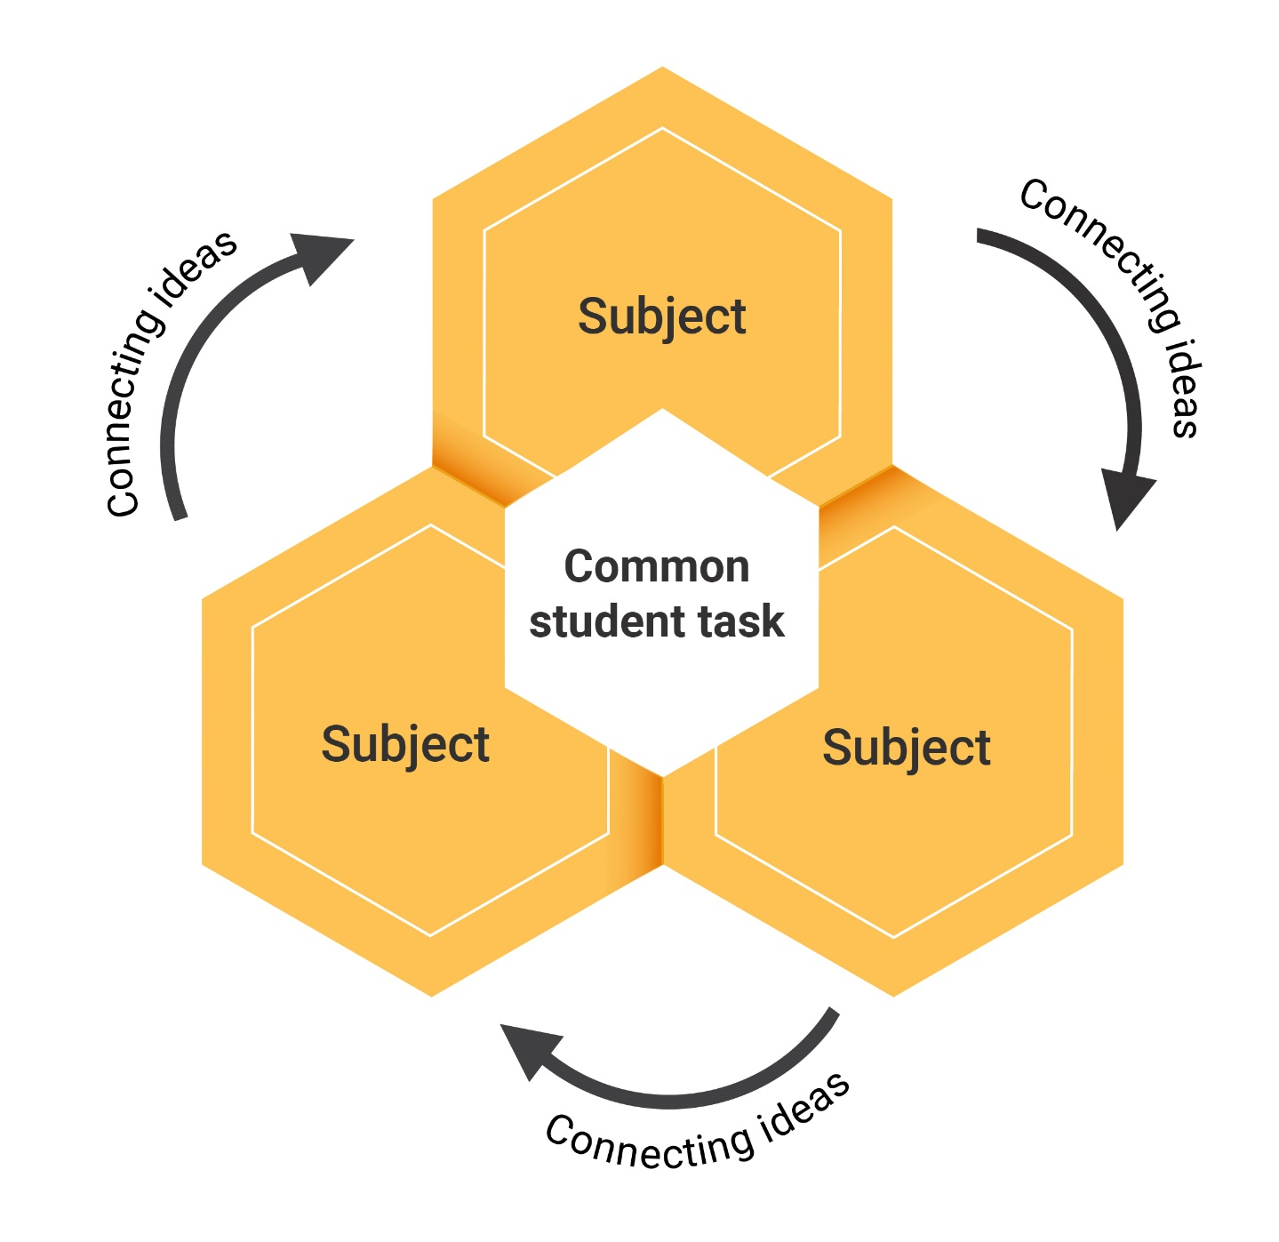
Figure 1: Relationship between connecting ideas, subjects and a common student task

Information for project leaders

Role
The project leader will support their team by:
- providing access to data, information and resources
- maintaining regular contact with the school executive
- providing personal and public recognition and praise
- creating a climate of mutual respect and support
- developing and implementing an effective management cycle for the project.

Considerations
The following needs to be determined:
- teachers involved
- the class or classes targeted
- the timing of the unit and the time required for designing it.

Frequently asked questions

How long should be spent planning the unit?
Two days (preferably away from school) is ideal. Use one day to plan the bigger picture and the second day for teachers to plan teaching and learning strategies together.

How long does a unit go for?
This is up to the school and teachers involved; however, one term is a common amount of time for one project.

Which classes do we target?
A STEM Connections unit can be developed for any class from Foundation to Year 10, based on an identified need.

Can we do more than one unit in the year?
You need plenty of time to plan a different scope and sequence to the “norm”. Project leaders should ensure teachers are given time to plan.

Do we have to follow the planning steps in sequence?
All team members will be thinking about many steps at once; however, it is recommended to follow the suggested process, as it is based on best practice.

What if our subjects are semesterised?
This may be more relevant for secondary schools, but as you plan you may uncover various logistical problems. This might mean that the unit of work is delayed, or there will be changes to the way it is taught. That is why STEM Connections must be a school developed strategy, as each school is unique.

How will I be able to “fit in” the rest of the curriculum?
This unit will take the place of what is usually taught. It will not be an addition to it. In subjects with a higher number of lessons each cycle, a proportion of time can be dedicated to the unit, with other outcomes covered in remaining lessons. There may also be changes to assessment and reporting for this class.

Do we need to meet during the term, and if so will it be in my own time?
Project leaders need to create time for the team to meet. Corridor conferences will naturally take place and there should be planned meetings to act as checkpoints along the way. These may occur before or after school, if agreed by teachers. Some schools use funds to include team meeting times in the school week.

How can I stimulate interest in this idea?
Teachers may want to analyse recent research or read about the experience of other schools to gain professional understanding of integrated learning. For example, ACARA’s STEM Connections report and STEM illustrations of practice could prove useful. (https://www.australiancurriculum.edu.au/resources/stem/stem-report)

What else needs to be considered?
Day-to-day school life needs to be considered when planning. This includes:
- assessment and reporting for the semester
- forward planning to invite parents/carers and special guests to view the students’ work
- whole-school events such as camps, carnivals, and other projects running at the same time.

Which personnel can support this project?
When considering the nature of support needed for the project, a range of internal and external personnel can be helpful, including:
- teacher librarians, who are well resourced to support the collaborative process and provide information literacy support to the students and staff
- support staff who have the expertise required to provide teachers with strategies for the explicit teaching of some of the identified skills
- regional support staff, such as literacy, numeracy, and information and communication technology (ICT) consultants, and others who bring in particular expertise to support teaching and learning.

Suggested process

Step 1  Determine the school identified purpose | - What do you want students to learn?  - What is your school hoping to achieve by undertaking a STEM Connections unit of work?  - What does the data tell you about this group of students?
Step 2  Choose the connecting idea | - Why does this learning matter?  - What concept, theme or idea will link the different subjects together? Focus on addressing authentic problems and opportunities.  - What significant events are occurring in my local community?  - Are there any First Nations resources that could be used to support an authentic learning opportunity?  - What knowledge and skills do you want the students to be left with once the unit has been completed?  - Does the learning connect to the students’ world?  - Does it form a basis for future learning?  - Why teach this connecting idea?  - Why does it matter for students to gain a deep understanding of this concept?  - How will this connect with learning that students are exploring in other learning areas?
Step 3 (i)  Target the curriculum content | - What does this connecting idea look like in the Australian Curriculum and your current program?  - Will the sequencing of topics for the term need to be adjusted?  - What content descriptions and aspects of the achievement standards from each learning area are appropriate for the unit?
Step 3 (ii)  Include relevant aspects of the general capabilities | - How can the general capabilities be included in the project?  - What aspects of Critical and Creative Thinking, Digital Literacy, Ethical Understanding, Literacy and Numeracy could be addressed?
Step 4  Design the common task | - What will the students learn through investigation, development and testing?  - What is the common task for students to complete?  - Which activities will develop the deep, integrated knowledge you are looking for?  - How will students be supported with this task?
Step 5  Plan assessment of the common task | - How well do you expect students to perform, and have you clarified what you expect in terms of a high-quality performance or project?  - How will you assess the “common student task”?  - How will you assess achievement of the identified purpose?  - How will you assess achievement of the chosen content descriptions within individual learning areas?  - How can you showcase learning? What opportunities are there to seek feedback from those impacted by the STEM solution?
Step 6  Plan teaching and learning strategies collaboratively | - What learning experiences will most effectively develop the skills and knowledge you want students to have as a result of this project?  - How will you ensure that the learning experiences you provide are authentic for the task?  - What types of activities best suit a project of this type?  - How will you make connections between the STEM disciplines explicit as well as relevant?  - What can you use that you already have and what will need to be reprogrammed and resourced?  - How will you plan to teach explicit aspects of Critical and Creative Thinking, Digital Literacy, Ethical Understanding, Literacy, Numeracy and the curriculum?  - What help will you need?
Step 7  Reflect and evaluate | - How will you know whether the project is achieving its aims?  - Reflect regularly on the progress of the unit of work to address logistical and pedagogical challenges.  - Reflect on and evaluate the project at its conclusion both individually and as a team.  - Write a report of the project as a guide for future projects.

Step 1: Determine the school identified purpose

What do you want students to learn?
What is your school hoping to achieve by undertaking a STEM Connections unit of work?
A STEM Connections unit of work is an opportunity for the team to meet the complex learning needs of an identified group of students. The school identified purpose will include some or all of these elements:
- the specific learning needs of this group of students identified by data analysis
- the aspects of Critical and Creative Thinking, Digital Literacy, Ethical Understanding, Literacy and Numeracy you want to include. This is an opportunity for staff to plan to use some common approaches to teaching these skills where needed in the context of the learning area content.

Useful sources to inform purpose
- school management plan
- school environmental management plan
- documentary evidence:
- student work samples and projects
- student voice through vodcasts
- minutes of meetings
- parent/carer letters
- information from school teams such as the learning support team, welfare team and executive
- information from focus groups of students, parents/carers, community members, partner primary or secondary schools
- Different forms of data such as:
- test result analysis
- attendance and truancy rates
- school report data
- surveys of various kinds
- incident reports entered into the school’s system.

School identified purpose: record your information below

Project leader: | Class or classes involved:
Participating teachers: | Duration/timing of unit:
What do we know about these students?

School identified purpose
What are the specific learning needs of this group of students?

Which aspects of Critical and Creative Thinking, Digital Literacy, Ethical Understanding, Literacy and Numeracy do you want to include? (Review the learning progression or continua for the targeted general capability.)

Step 2: Choose the connecting idea

How can we find a meaningful connection?
Complete the following activities to confirm your connecting idea, or to find one.

Activity 1
Write your answers to the following questions below.
Is there a whole-school focus that our school community is currently concerned with?
For example:
- a Design and Technologies context
- related content
- cross-curriculum content (such as Sustainability)
- a local or global issue
- an essential question we want students to investigate more deeply.
What engages our students? What are the students’ ideas and interests?

How does literacy and numeracy data inform the task design and how can it be addressed through the connecting idea?

What have students learnt in previous years? What can they do?

What resources does our school community have that can be used?

What ideas, interests and areas of expertise do we have, and how do they link to curriculum?

What funds are available? Are there any pre-existing projects or funds with goals consistent with the aims of this project?

What can we focus on that would address the school identified purpose outlined above?
Some sample ideas for a need, opportunity or problem that:
- needs an engineered solution
- focuses on food and fibre production, food specialisations, materials or technologies specialisations
- involves the design and production of an environment, product, service or communication/report
- contributes to sustainable living
- responds to a local or global issue.
Record your connecting idea here: ____________________________________

Activity 2
What do you normally teach in these year levels? Individual teachers complete this table using their teaching and learning program.
Term | Year________ | Year_________ | Year_________
Term | Unit description: What knowledge, topics and skills would you normally teach?
1
2
3
4

Activity 3
Group summary – Where are the links?
Record information from previous activity. Discuss areas of similarity and difference.
Term | Subject: | Subject: | Subject: | Subject:
Term 1
Description of units
Term 2
Description of units
Term 3
Description of units
Term 4
Description of units

Why does this learning matter?

Activity 4
Teachers involved need to be able to articulate and answer this question on 2 levels:
- the broad level of the connecting idea, and why teaching it collaboratively will be of benefit to students
- the subject level, to help teachers when they choose their teaching and learning activities. Why does this learning matter to students in my class/subject?

The connecting idea
Why does this learning (the connecting idea) matter to our students? For example, why does learning through a cross-curriculum priority, such as “sustainable school and climate change”, matter to our students?

Why does this learning (the connecting idea) matter to students in my class/subject?
For example, why does learning about sustainable action matter in my class/subject?

Step 3 (i): Target the curriculum

What learning area content links the purpose and connecting idea?
For the connections across the curriculum to be valid, teachers choose content descriptions from the curriculum that link to the identified purpose and connecting idea. They then share the information with other team members.
Type or cut and paste content descriptions (in full) onto the planning template so information can be shared between staff. Follow these guidelines:
- Only choose relevant content descriptions – it is important to be realistic and select only meaningful content. Add more rows if needed. Include content elaborations if they are relevant.
- Ensure that the content descriptions reflect the connection between the identified purpose, the connecting idea and your curriculum content.

Content description _________________ | Content description _________________
Content description _________________ | Content description _________________

Step 3 (ii): Using the general capabilities

How can the general capabilities be included in the project?
In this step, include the aspects of Critical and Creative Thinking, Digital Literacy, Ethical Understanding, Literacy and Numeracy selected in Step 1. Type or cut and paste these into the table that follows.
Critical and Creative Thinking
Digital Literacy
Ethical Understanding
Literacy
Numeracy

Step 4: Design the common student task

What are we going to get students to do or produce?
The task should allow students to demonstrate deep understanding of the connecting idea. It should require them to make meaningful connections between different subjects, and apply the knowledge and skills identified in the original purpose. When designing the task:
- it is not necessary to design a common task through which each subject content description is assessed; that will be done by the individual class teacher or subject teacher
- the common student task should be engaging and challenging for the students, something to celebrate and present at the end of the STEM Connections unit of work.

What will the students learn through investigation, development and testing? How could this be demonstrated as evidence of the achievement standard?

Record your common student task below:

Students will:

Step 5: Plan assessment of the common student task

What meaningful connections can be identified and assessed in some way?

Individual subject level
Teachers plan formal and informal activities or tasks within their own lessons as they normally would, including both formative and summative assessment. Teachers select the subject content descriptions appropriate to this unit of work. They use different strategies to assess that content, such as journals, portfolios, reports, learning logs, in-class presentations, blogs, quizzes and mind-maps.

Assessing the common student task
Teachers from different subjects plan what they are going to assess in the common task, and how to communicate the criteria clearly to students. The common student task can be assessed on a broader level, with teachers choosing to assess any elements from the identified purpose. Note:
- Teachers assess their own curriculum.
- Students are given meaningful feedback on their progress through the project.
- Any of the elements of the school identified purpose for the STEM Connections unit of work can be assessed by the teachers and the students.
- Students should be given meaningful feedback on their performance, which may or may not be in the form of marks/grades.
- Criteria for the common task can be jointly constructed with the students.

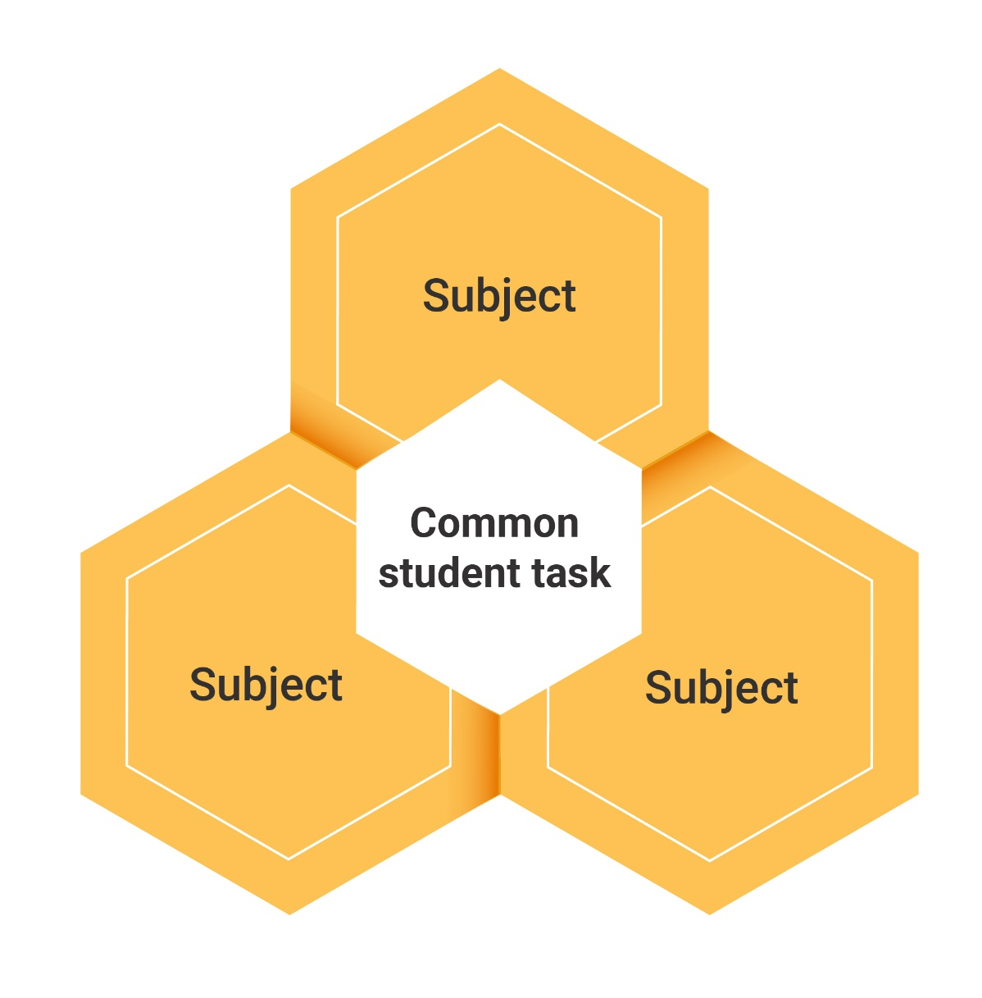

Assessing the common student task (cont’d)
Elements to be assessed can be chosen from:
- the identified purpose (Step 1) and what it is you have asked the students to investigate
- the aspects of the capabilities (Step 3 (ii)) – the Critical and Creative Thinking, Digital Literacy, Ethical Understanding, Literacy and Numeracy skills students are required to demonstrate to complete the task.
It is up to the teachers to decide if marks, grades or levels of competence are to be applied to the common student task.
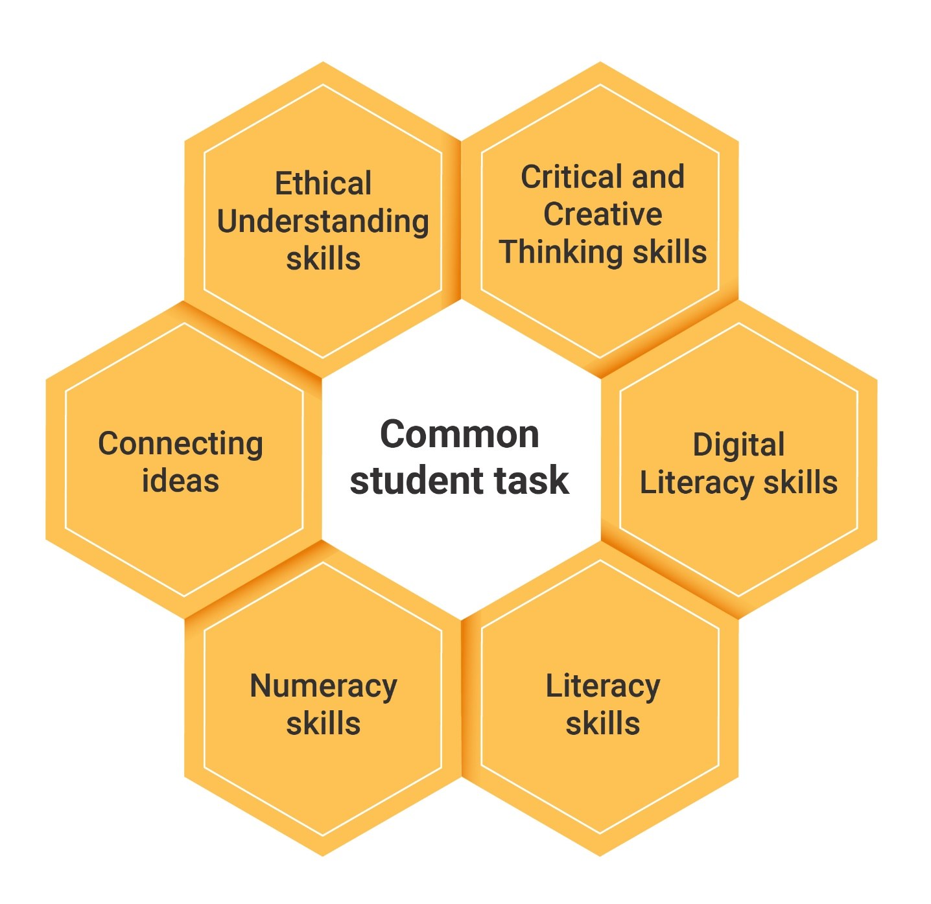
In the following example, teachers choose 4 elements in Step 1 as the elements they would assess from the common student task. In each case, teachers plan to explicitly teach the skills necessary for students to achieve each broad learning intention.

Sample (from a Sustainable action unit)
Outcomes chosen | What do we expect students to do? | How will this be assessed?
Access, analyse, evaluate and use information from primary and secondary sources, as well as all  3 subjects. |  | Information and communication package displayed at the expo day must include required information.  Will be assessed by “expert” panel on the expo day.  Ask visiting students to peer assess.
Communicate ideas and information about climate change and its local effects. | Give a short presentation to an expert panel. Ensure the package will inform the local community about the impact of, for example, global warming and rising sea levels on their community, and the sustainable action proposed. | Teachers and students construct criteria for a high-quality presentation.  An expert panel will assess the group’s work.
Work collaboratively with others to achieve individual and collective goals. | Work in small groups to complete the task. | Teachers will build group-work skills through:  - scaffolded activities to encourage work in pairs  - use of talking and listening activities.  Students self-assess their own performance in the group at the end of the project.
Be productive, creative and confident in the use of technology. | Design and make an information and communication package that incorporates the appropriate elements from technology. | Explicit teaching to demonstrate how to use the appropriate technology. Students are given criteria in the beginning.  External panel judges student work.

Suggested ways of assessing a common student task
- Collaborative teacher assessment of chosen elements of the common student task using moderation.
- Moderation involves teacher collaboration to establish shared criteria for what achievement looks like and whether or not the student or group has demonstrated evidence of it.
- Teachers can jointly construct these criteria with the students.
- A panel of teachers can then assess the student performance at the end. For example: what is a high-quality presentation? Teachers can establish a consistent set of criteria to apply to the student task, and/or brainstorm with students to create explicit criteria.
- Peer assessment of chosen elements of the common student task using peer assessment guidelines. For example, Year 5 students may be given a scaffold such as the “ladder of feedback” from Harvard University. Year 8 students can be briefed on the criteria for a high-quality presentation, view Year 9 or 10 work, then assess against the criteria.
- Student self-assessment of chosen elements of the common student task such as their:
- deep understanding of the connecting idea and the need, opportunity or problem they are
focusing on
- performance as part of a group; for example, students can use a logbook or wiki for the duration of the student task and reflect on the connecting idea throughout the project.

Complete the table that follows for your assessment of the common task.
Element of the common task we want to assess | What do we expect students to do? | How well do we expect them to do it? | How will we assess it?

Step 6: Plan teaching and learning activities

What learning experiences will develop the skills and knowledge you want students to have?
This section should:
- list the activities in which students will engage
- show the sequence of activities you will be getting the students to do in class. Include checkpoints along the way to assess students’ progress.
Considerations
- Include activities in your lessons that develop the identified aspects of the subject and the general capabilities.
- Model for students how to organise and plan tasks that extend over a long period of time.
- Use what works for this unit from your existing program; discard what does not.
- Include learning experiences that will enable students to demonstrate the targeted outcomes.
- Include teaching and learning experiences that will allow students to DO, rather than be told.
- Determine what resources you already have or will need.
- Determine what room changes and access to technology you will require.
- Identify the support and professional development you will need and how you will access it.
- Critique your planned activities using the STEM critiquing checklist (See resources, the Australian Curriculum: STEM Connections https://v9.australiancurriculum.edu.au/resources/curriculum-connections)

Use the table on the next page to record your plan.

Planning
Detail from achievement standards | Learning experiences | Assessment for learning
Select and enter these directly from your curriculum. Add extra detail relevant to the connecting idea and common task. | What do you want students to do? List the activities students will engage in. Show the sequence of activities. Include elements required for students to complete the task. | Plan formal and informal ways to evaluate student achievement of knowledge, understanding and skills.

Planning to teach aspects of Critical and Creative Thinking, Digital Literacy,
Ethical Understanding, Literacy and Numeracy
The table that follows can be used to plan for the explicit teaching of these aspects. (Cut and paste most of this from the previous step.)
Aspect | What do we expect students to do? | How well do we expect them to do? | Explicit teaching strategies
Critical and Creative Thinking
Digital Literacy
Ethical Understanding
Literacy

Numeracy

Term planner
Prior to teaching the unit, teachers should map out what is happening for the whole term. This will allow the team to:
- plan common activities such as fieldwork
- find areas of overlap
- allow for major school events
- plan for the presentation of the common task.
Use the table below to plan the whole sequence.
Week | Subject | Subject | Subject | Subject
1
2
3
4
5
6
7
8
9
10
11

Step 7: Reflect and evaluate

How will you know whether the project is achieving its aims?
Project leaders should plan time for effective reflection and evaluation during and after the unit of work.
During the unit, teachers will want to talk about how things are progressing and how certain students are developing. They will want to share ideas about the common student task.
After the unit, teams should re-visit their identified purpose (Step 1) and think about how to evaluate it.
For example, if improved student engagement was one identified purpose, how could you evaluate this? Feedback should be communicated to the school executive.
Before you begin teaching
- What aspects of the unit should be pre-and post-tested? For example, if necessary, aspects of literacy and numeracy can be assessed before and after the project. An attitudinal survey can provide helpful qualitative feedback.
- Are there any surveys, learning journals or other evaluation methods that should be produced prior to teaching?
Some questions to prompt discussion at the end of the unit
- Did students demonstrate deep understanding of the connecting idea? Were assessment methods effective in determining this?
- How well did students achieve in learning areas and on the common task?
Sources of information
- Teachers reflect on the process itself.
- Students self-reflect about what they have learnt about the connecting idea and other identified aims.
- Teachers can attend colleagues’ classes to view lessons that have been jointly prepared, with the aim of refining them for later use with other classes.
- Project leader reflects on the whole project, and feedback about their own effectiveness.
- Parents/carers and students can provide feedback through surveys.

Note: More formal evaluation methods may be required if the school is reporting to an external organisation.

Further reading
Academy of Technologies Sciences and Engineering (2022) Our STEM skilled future, An education roadmap for an innovative workforce, ATSE website, https://www.atse.org.au/what-we-do/strategic-advice/our-stem-skilled-future-an-education-roadmap-for-an-innovative-workforce/, accessed 25 November 2024.
Anderson J and Li Y (2020) Integrated Approaches to STEM Education: An International perspective, Springer Cham.
Australian Catholic University (2024) STEM education must go beyond robotics and coding, ACU website, https://www.acu.edu.au/about-acu/news/2024/may/stem-education-must-go-beyond-robotics-and-coding, accessed 25 November 2024.
Australian Government Department of Defence (2019) Moving Towards a High-tech Future for Defence, Workforce Strategic Vision underpinned by Science, Technology, Engineering and Mathematics 2019–2030, Department of Defence website, https://www.dst.defence.gov.au/news/2019/08/13/defence-envisions-high-tech-future-based-skilled-workforce, accessed 25 November 2024.
Australian Government Department of Education (2021) Introductory material – What is STEM?, National STEM education resources toolkit, Department of Education website, https://www.education.gov.au/australian-curriculum/national-stem-education-resources-toolkit/introductory-material-what-stem, accessed 25 November 2024.
Education Council (2015) National STEM School Education Strategy 2016–2026, Department of Education website, https://www.education.gov.au/australian-curriculum/support-science-technology-engineering-and-mathematics-stem/national-stem-school-education-strategy-2016-2026, accessed 25 November 2024.
English, LD (2016) “STEM education K–12: perspectives on integration”, International Journal of STEM Education: 6–13.
Fraser, S, Barnes, N, Kilpatrick, S, Guenther, J and Nutton, G (2021) “Considering Young People’s Dislocation from STEM Education: Looking Beyond the Narrow Focus of Teaching and Learning Practice Within School”, Frontiers in Education 6:678613. https://doi: 10.3389/feduc.2021.678613, accessed 4 December 2024.
Jones M, Geiger V, Falloon G, Fraser S, Beswick K, Holland-Twining B and Hatisaru V (2024) “Learning contexts and visions for STEM in schools”, International Journal of Science Education: 1–21, https://doi.org/10.1080/09500693.2024.2323032, accessed 25 November 2024.
Kelley TR and Knowles JG (2016) “A conceptual framework for integrated STEM education”, International Journal of STEM Education, 3(11), https://doi.org/10.1186/s40594-016-0046-z, accessed 25 November 2024.
Larmer J, Mergendoller J and Boss S (2015) Setting the Standard for Project-Based Learning: A Proven Approach to Rigorous Classroom Instruction, ASCD, Alexandria.
Lowrie T and Larkin L (2019) “Experience, represent, apply (ERA): a heuristic for digital engagement in the early years”, British Journal of Educational Technology, https://doi.org/10.1111/bjet.12789, accessed 25 November 2024.
Lowrie T, Leonard S and Fitzgerald R (2018) “STEM practices: a translational framework for large-scale STEM education design”, EDeR – Educational Design Research, 2(1):1–20, http://dx.doi.org/10.15460/eder.2.1.1243, accessed 25 November 2024.
Mann A (2014) “It’s who you meet: why employer contacts at school make a difference to the employment prospects of young adults”, Education and Employers, https://www.educationandemployers.org/wp-content/uploads/2014/06/its_who_you_meet_final_26_06_12.pdf, accessed 25 November 2024.
Moote J, Archer L, DeWitt J and MacLeod E (2020) “Science capital or STEM capital? Exploring relationships between science capital and technology, engineering, and maths aspirations and attitudes among young people aged 17/18”, Journal of Research in Science Teaching, 57(6): 10.1002/tea.21628, Science capital or STEM capital? Exploring relationships between science capital and technology, engineering, and maths aspirations and attitudes among young people aged 17/18 | Request PDF (researchgate.net), accessed 25 November 2024.
Office of the Chief Scientist (2024) Pathway to Diversity in STEM Review Final Recommendations, Department of Industry website, Pathway to Diversity in STEM Review (industry.gov.au) , accessed 25 November 2024.
Rosicka C (2016) From concept to classroom: translating STEM education research into practice, Australian Council for Education Research, Melbourne, https://research.acer.edu.au/cgi/viewcontent.cgi?article=1010&context=professional_dev, accessed 25 November 2024.
Shay M, Miller J, Thomson A, Cole A, Abdul Hameed S, Perkins R, Rashidi P, Hurley A, Ockerby Zoe, Harvey-Smith L and Williams LA (2023) Big Mob – STEM it Up research report, University of Queensland website, https://espace.library.uq.edu.au/view/UQ:9fddf34, accessed 25 November 2024.
Slavin RE (2024) Science, Technology, & Mathematics (STEM), Proven programs in education, Corwin, A Sage Company, California.
Strimel G (2014) “Engineering by Design: Preparing STEM Teachers for the 21st Century”, PATT conference proceedings, Technology education for the future: a play on sustainability, https://assets-002.noviams.com/novi-file-uploads/iteea/pubs/PATT27proceedingsNZDec2013-836793cd.pdf, accessed 25 November 2024.

