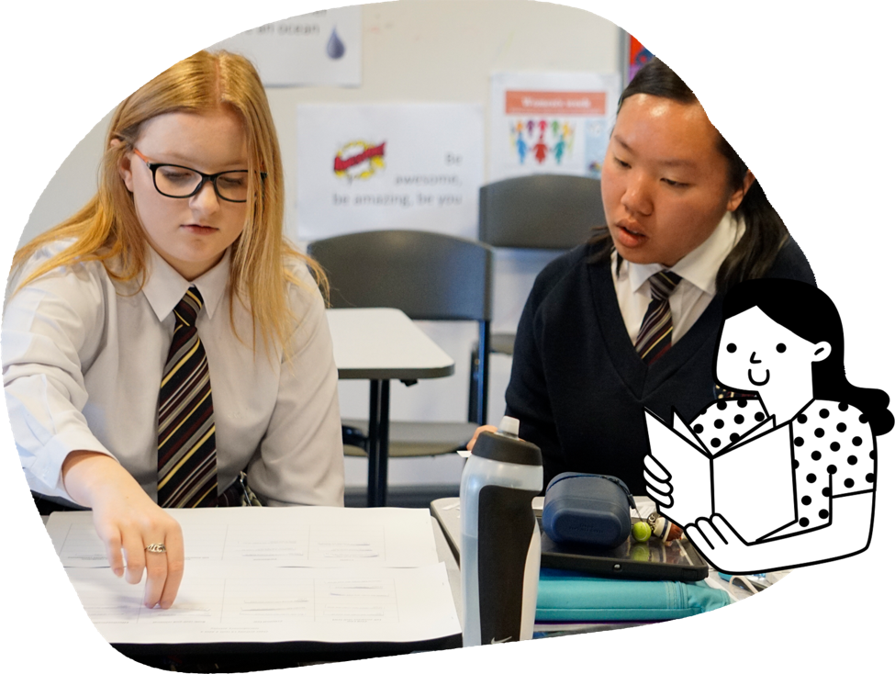
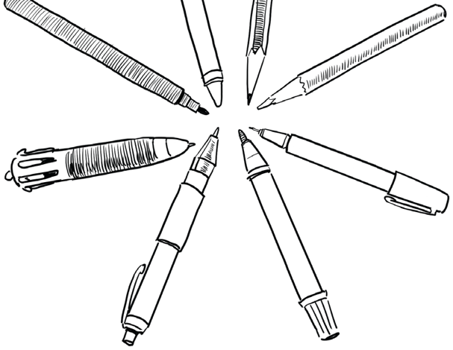
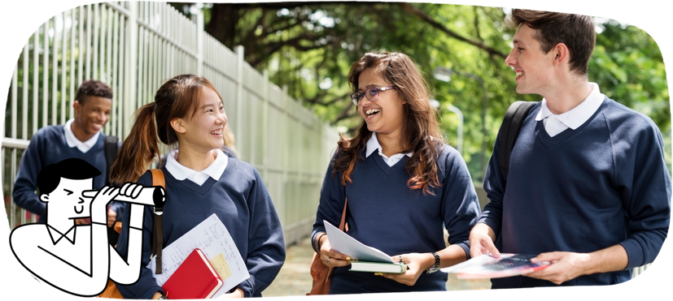

English
Students analyse and evaluate a range of texts such as poetry and novels. They create texts to communicate complex ideas by experimenting with language features, text structures and images.
Students learn to:
- engage with a range of texts that explore challenging themes and issues
- analyse the ways in which ideas are represented in texts
- analyse representation of people and places in literary texts by First Nations Australian, wide-ranging Australian and world authors
- discuss the ways authors select language features and vocabulary to create an effect
- substantiate ideas and opinions
- plan and create written and multimodal texts and presentations
- edit and refine their own work
- provide constructive feedback to peers.

In Years 9 and 10, learning across the curriculum prepares students for civic, social and economic participation outside of school. Students are provided with opportunities to make choices about learning and specialise in areas that interest them through elective (optional) subjects. At this point, students bring together their knowledge and experience to consider possible pathways for study in senior secondary school and vocational education.

Years 9 and 10
The Australian Curriculum is designed to develop successful learners; confident and creative individuals; and active and informed young people who are ready to take their place in society.
It sets the goals for what all students should learn as they progress through schooling – wherever they live in Australia and whatever school they attend.
There are 8 learning areas, which provide a modern curriculum for every student in Australia.
The curriculum includes 7 general capabilities intended to help prepare young Australians to learn, live and work in the 21st century.
There are 3 cross-curriculum priorities that also enrich the learning areas.
The Australian Curriculum is used flexibly by schools and teachers, who plan the learning for all their students while taking into account their local school community.
For more information about your child and their educational progress, talk to your school.
The Australian Curriculum
Information for parents and carers
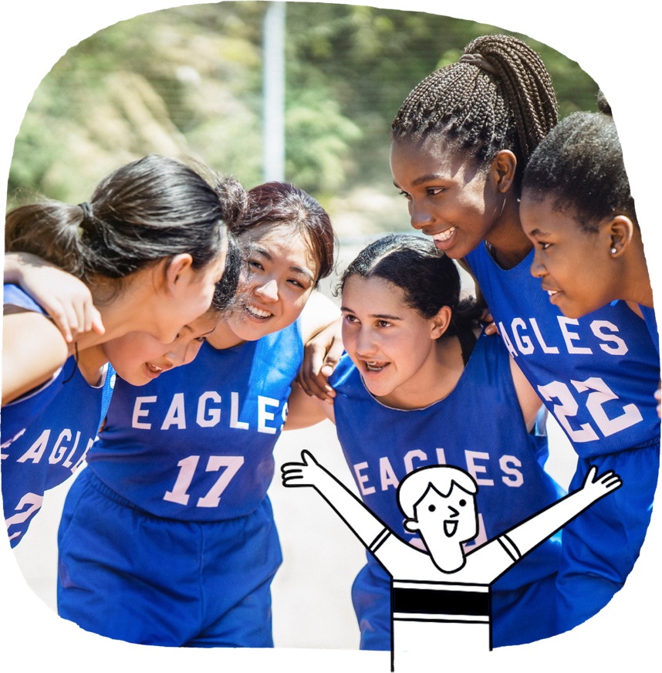
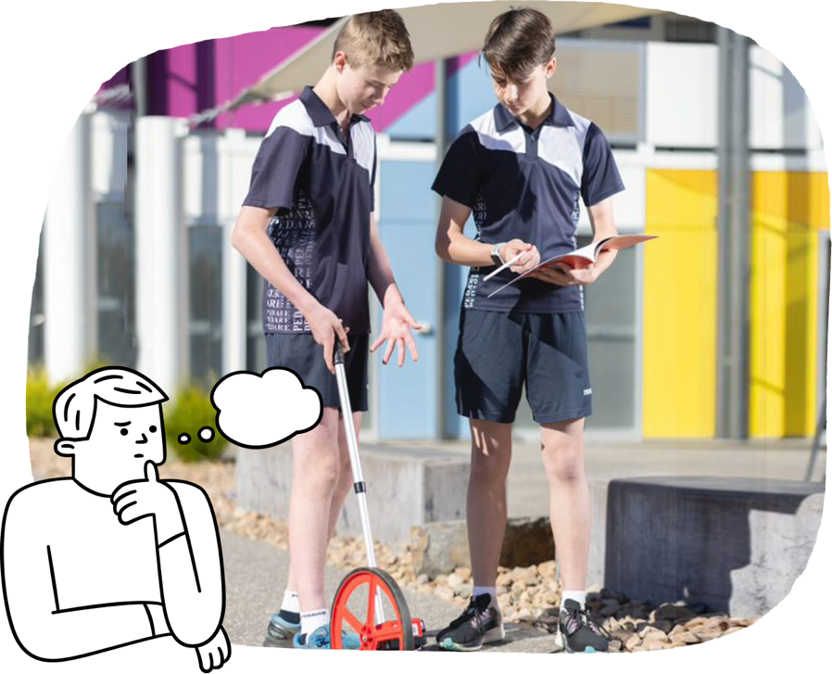
Students learn to:
- understand positive relationships and what should be done when a relationship is not respectful
- propose ways to promote inclusion in their communities
- judge whether sources of health information are reliable and useful
- analyse their own and others’ movement skills in a range of situations to enhance performance
- participate in physical activities designed to enhance health, wellbeing and fitness
- demonstrate fair play
- reflect on how ethical behaviour can influence physical activity outcomes.
Health and Physical Education
Students refine their understanding of how they can contribute to health and wellbeing. They adapt and improvise their movements to respond to different movement situations and challenges. Students refine and consolidate their leadership, teamwork and collaborative skills through participation in a range of physical activities.
Mathematics
Students extend their knowledge of algebra, graphing and geometry. They begin trigonometry of right-angled triangles. They work with probability and statistics. They are introduced to networks, error and logarithmic scales.
Students learn to:
- model and solve practical problems involving financial, spatial and proportional contexts
- solve problems involving right-angle trigonometry
- recognise linear and non-linear relationships and solve equations
- calculate areas and volumes of composite shapes and objects
- apply ratio and scale factors to similar figures
- create algorithms to investigate geometric theorems and formulate geometric proofs
- interpret and compare data sets in statistics when they plan, conduct and review statistical investigations
- explain the use of relative frequencies to estimate probabilities when conducting probability experiments and simulations.

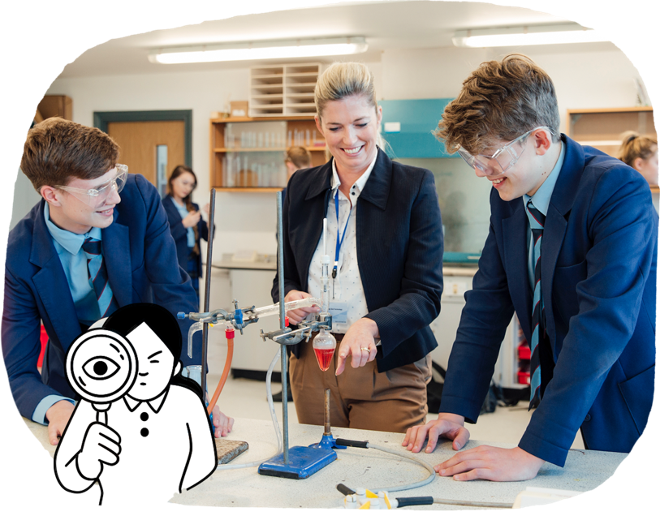
Humanities and Social Sciences
Students are engaged in deeper, more complex thinking. They use logic, ethical thinking and
self-reflection as they question events and issues in the world. While all students continue to study History, they may also choose to continue their learning of Geography, Civics and Citizenship or Economics and Business as elective subjects.
Students learn to:
- in History, investigate the ideals and developments
in Europe and other regions that shaped the modern globalised world, including wars, migration, rights movements, popular culture and environmental activism.

Languages
Students may choose to continue their learning of a language other than English.
Students learn to:
- initiate and sustain interactions with others
- understand and create a variety of spoken, written or multimodal texts
- apply language rules and conventions to interpret and create texts
- reflect on how their learning of the language influences their attitudes, beliefs and values.
Science
Students explore evidence for various scientific theories and develop viewpoints on the impact of scientific discoveries. Their investigations show increased attention to accuracy in measurement and collation of data, reliability of data and importance of evidence in their conclusions.
Students learn to:
- investigate body systems and ecosystems as examples of interdependent, interactive systems
- investigate changes in our genes that affect both our characteristics and evolutionary history
- deepen their understanding of changes in chemical systems that can be caused by changes at the atomic level
- investigate how the wave and particle theory can explain the behaviour of light
- deepen their understanding of the physical laws of motion
- critically analyse and evaluate claims and approaches used to solve problems, while considering ethics involved and how people’s lives might be affected
- critically consider the importance of science-based careers.

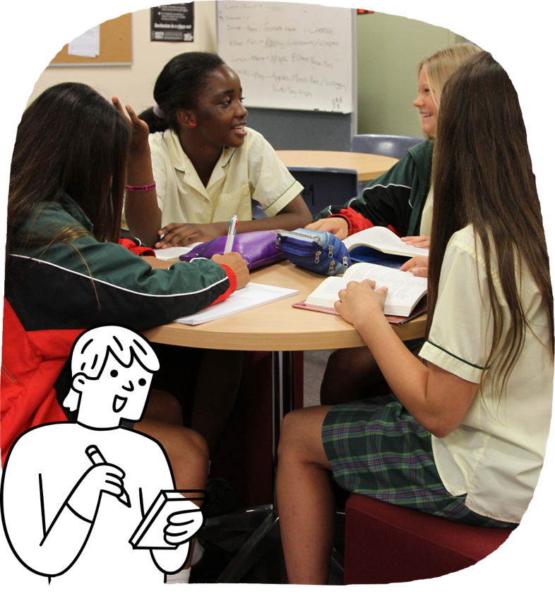

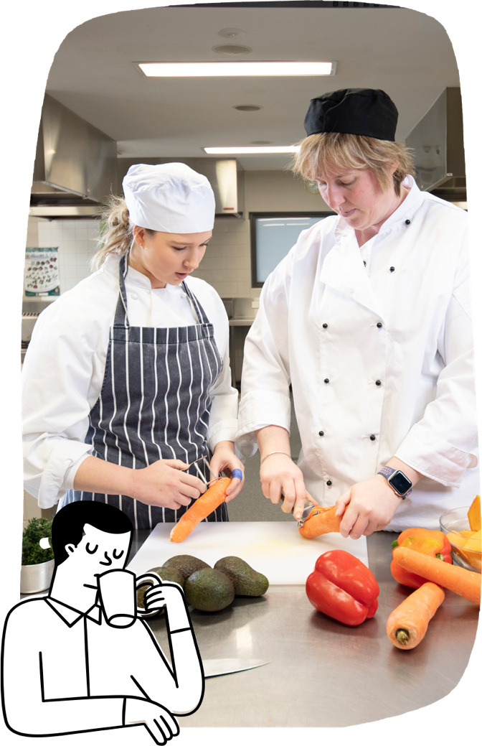
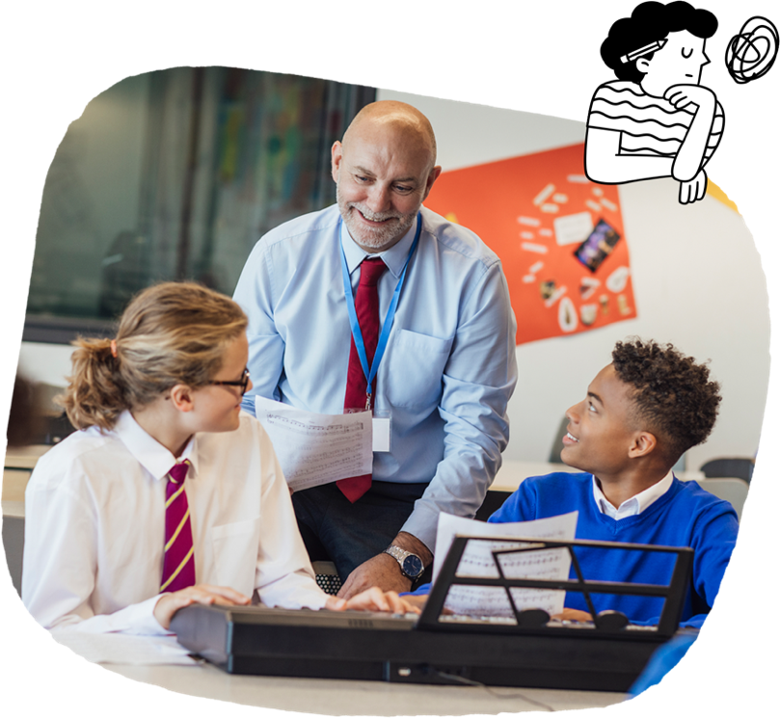
Students learn to:
- in Dance, select and manipulate choreographic devices such as unison or canon to communicate an intention
- in Drama, investigate ways that drama by First Nations Australians can celebrate and challenge aspects of Australian identity
- in Media Arts, use reflective strategies at different stages of the production process to
inform their creative choices
- in Music, rehearse and perform planned programs of music using relevant techniques and performance skills
- in Visual Arts, develop personal expression through experimenting with visual conventions and processes.
Students may choose an elective Technologies subject of interest.
In Design and Technologies, students learn to:
- understand the work that people in design and technologies occupations do and how they contribute to society
- produce designed solutions for one or more of the following contexts: engineering principles and systems; food and fibre production; food specialisations; materials and technologies specialisations
- communicate design ideas to a range of audiences, using digital tools where needed
- select and use tools, equipment, materials, systems and components creatively, competently and safely
- plan the production of solutions, considering the impact on people and the environment.
In Digital Technologies, students learn to:
- explore real-world problems, identify the needs of users and design a solution
- access, collect and interpret data for different purposes
- design a solution using an appropriate programming language
- explain how digital systems manage, control and secure data, and what the security risks might be
- manage projects using digital tools
- consider online safety and privacy within digital systems.
Technologies
The Arts
Students are creative and confident in their art making. They can analyse and evaluate arts works of others. They share their arts works with audiences in formalised ways. Students may choose an elective Arts subject of interest.

