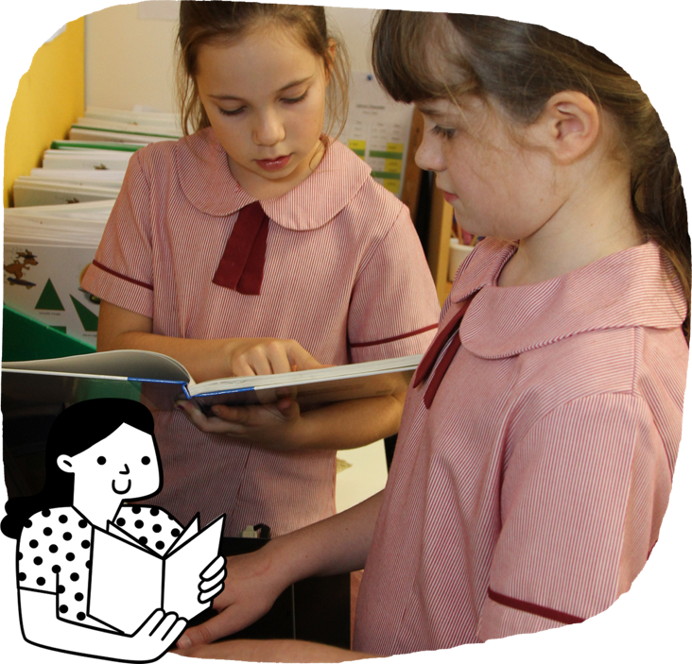
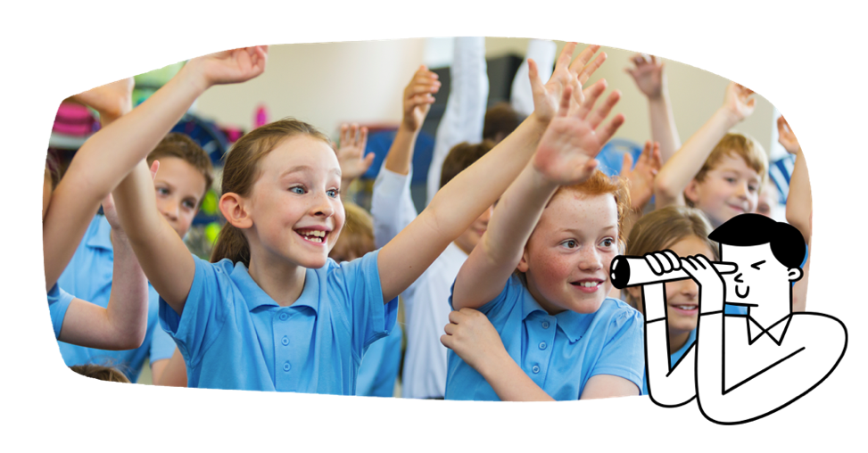

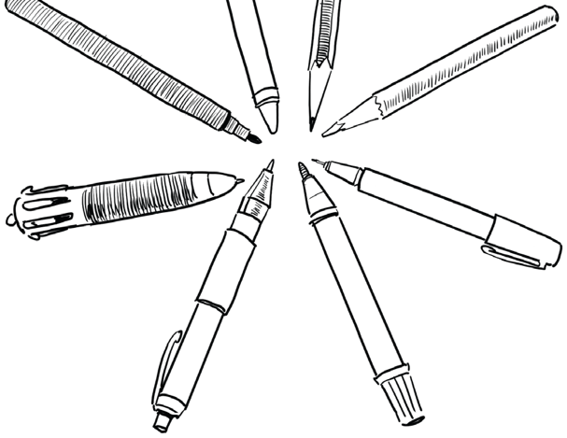
Students learn to:
- read and understand a range of imaginative, informative and persuasive texts
- create written and multimodal texts that tell stories, persuade and explain
- recognise that images add meaning to texts
- discuss characters, events and settings in texts by First Nations Australian, Australian and world authors and illustrators
- recognise different kinds of language used in texts for different audiences and purposes
- create texts using simple and compound sentences
- use accurate spelling and punctuation, and edit their own writing
- plan and create oral and multimodal presentations
- engage in discussions to share ideas, information and opinions.
English
Students read and write about familiar content that relates to other learning areas. Students read more difficult texts on their own, such as chapter books and non-fiction information texts.

In Years 3 and 4, students become more independent. They communicate with others more effectively. English and Mathematics continue to be a priority, and literacy and numeracy are developed across all learning areas. The curriculum further builds students’ essential knowledge and skills in literacy, consolidating learning to read and write.
The Australian Curriculum is designed to develop successful learners; confident and creative individuals; and active and informed young people who are ready to take their place in society.
It sets the goals for what all students should learn as they progress through schooling – wherever they live in Australia and whatever school they attend.
There are 8 learning areas, which provide a modern curriculum for every student in Australia.
The curriculum includes 7 general capabilities intended to help prepare young Australians to learn, live and work in the 21st century.
There are 3 cross-curriculum priorities that also enrich the learning areas.
The Australian Curriculum is used flexibly by schools and teachers, who plan the learning for all their students while taking into account their local school community.
For more information about your child and their educational progress, talk to your school.

The Australian Curriculum
Information for parents and carers
Years 3 and 4
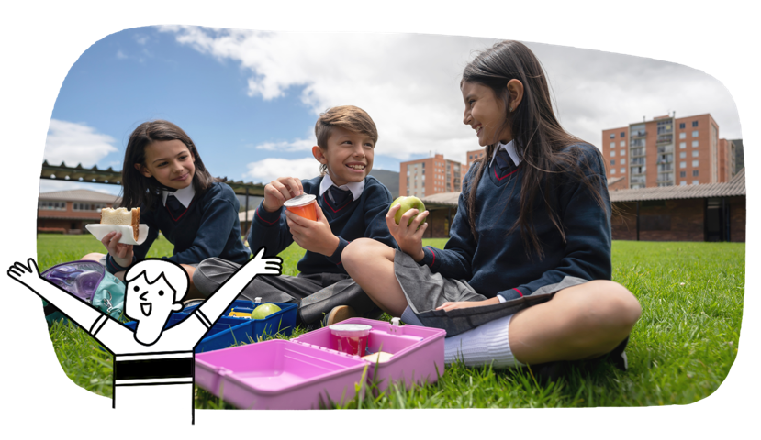
- explore the diversity of First Nations Australians and their continuous connection to Country/Place
- investigate the location of Australia's neighbouring countries and the similarities and differences between places
- understand the importance of environments and sustainability rules and laws
- understand how the local government makes decisions and serves their community
- explore the diversity of groups that they and others belong to, and the groups’ importance to identity.
- appreciate diverse people, cultures and environments in Australia and neighbouring countries
- appreciate how different individuals and groups have contributed to their communities, past and present
- explore significant events and symbols that are important to Australia's identity and diversity, including Australia Day, Anzac Day, NAIDOC Week and National Sorry Day
- investigate the causes of the establishment of the first British colony in Australia
in 1788
Humanities and Social Sciences
Students draw on their growing experience of the community and beyond. They use observations and information sources to develop understandings about history, geography, and civics and citizenship.
Students learn to:

Students learn to:
- build the skills to establish, manage and strengthen relationships
- rehearse and refine strategies for seeking, giving and denying permission respectfully
- understand different strategies and behaviours that keep them safe and healthy
- use and adapt movement skills in new situations
- understand the benefits of physical activity
- look for opportunities to be active in a range of natural and outdoor places
- support fair play and teamwork.
Health and Physical Education
Students learn about changes they experience as they grow up. They develop strategies for managing those changes and transitions. They develop their proficiency across a range of movement skills as they begin to transfer their skills to different situations.
- use metric units to measure temperature, length, mass and capacity of shapes and objects
- solve practical problems involving time
- use grid referenced maps
- create symmetrical geometric patterns and classify angles, shapes and objects
- conduct statistical investigations and repeated chance experiments, using digital tools.
- choose strategies to add, subtract, multiply and divide numbers
- represent the value of money and model problems involving money transactions
- understand and recall all 4 operation facts
- represent fractions on a number line
- use algorithms to explore number patterns
Mathematics
Students further develop their understanding of number, patterns and relationships, measurement and geometry. They represent fractions and decimals using concrete materials as they begin to conduct statistical investigations and repeated chance experiments.
Students learn to:

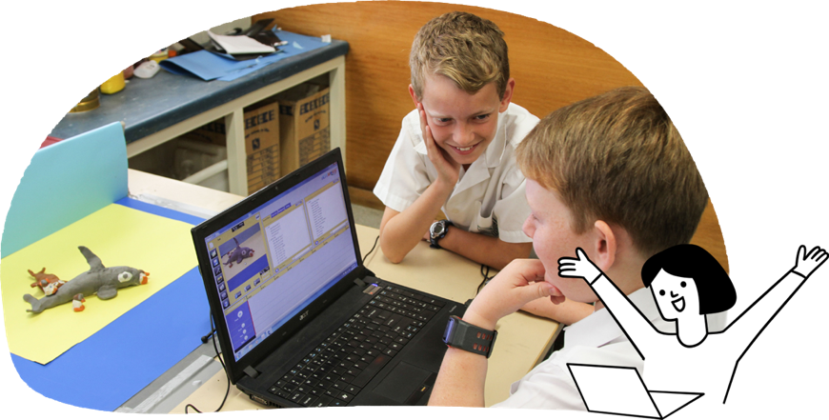
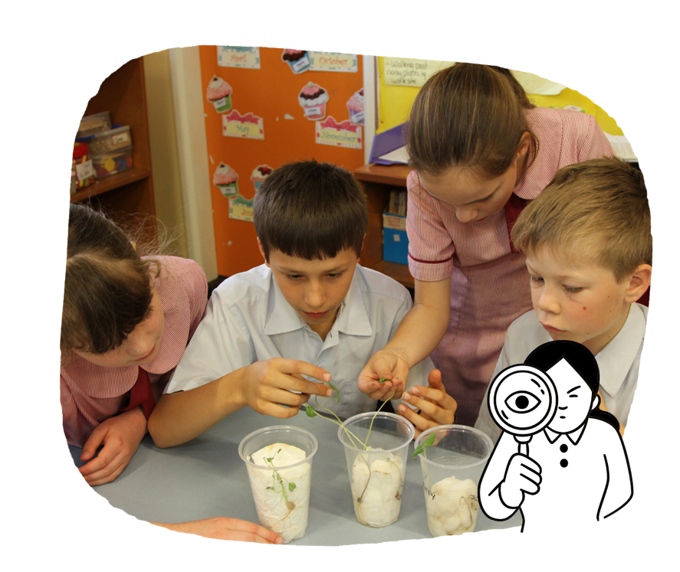
The Arts
Students participate independently or in groups to express and reflect their growing understanding of the world through different art forms. They further develop their technical skills in The Arts and explore how others create arts works. They explore how First Nations Australians use the arts to communicate their connection to Country/Place.
Students learn to:
- in Dance, create dances to tell stories or communicate personal perspectives
- in Drama, develop performances from stories or picture books
- in Media Arts, use technologies to change images, add words and record sounds to communicate ideas
- in Music, develop listening skills, and sing and explore instruments to create music
- in Visual Arts, look at an artist’s work and create their own, experimenting with materials such as paint, crayons, markers and colour pencils.

Technologies
Students build on concepts, skills and processes developed in earlier years of Design and Technologies, and Digital Technologies.
Students learn to:
- draw, label and model ideas when designing and producing solutions
- plan steps
- use a range of technologies to produce solutions and manage their time
- understand different types of data
- understand how to keep data protected
- understand safe behaviour when working online
- identify problems and solve them
- create a range of digital solutions, such as simple interactive games
- identify and use a range of digital systems and devices.

Languages
Students continue to build on their learning of a language other than English.
Students learn to:
- listen, respond and create in classroom routines, interactions and learning activities
- participate in classroom routines, interactions and learning activities by listening, responding and creating
- with modelling, learn language rules and conventions
- explore the relationship between culture and identity.

Science
Students develop their understanding about how science relates to their lives. They pose and answer questions and investigate in a more systematic way. They develop understanding of fair testing in order to explore relationships between system components.
Students learn to:
- observe heat as a form of energy
- investigate how heat effects a change of state
- observe properties of soils, rocks and minerals, and describe their importance
- explore key processes in the water cycle
- explore the action of forces on the motion of objects
- realise that living things form parts of ecosystems
- understand how scientific explanations can solve a problem.

