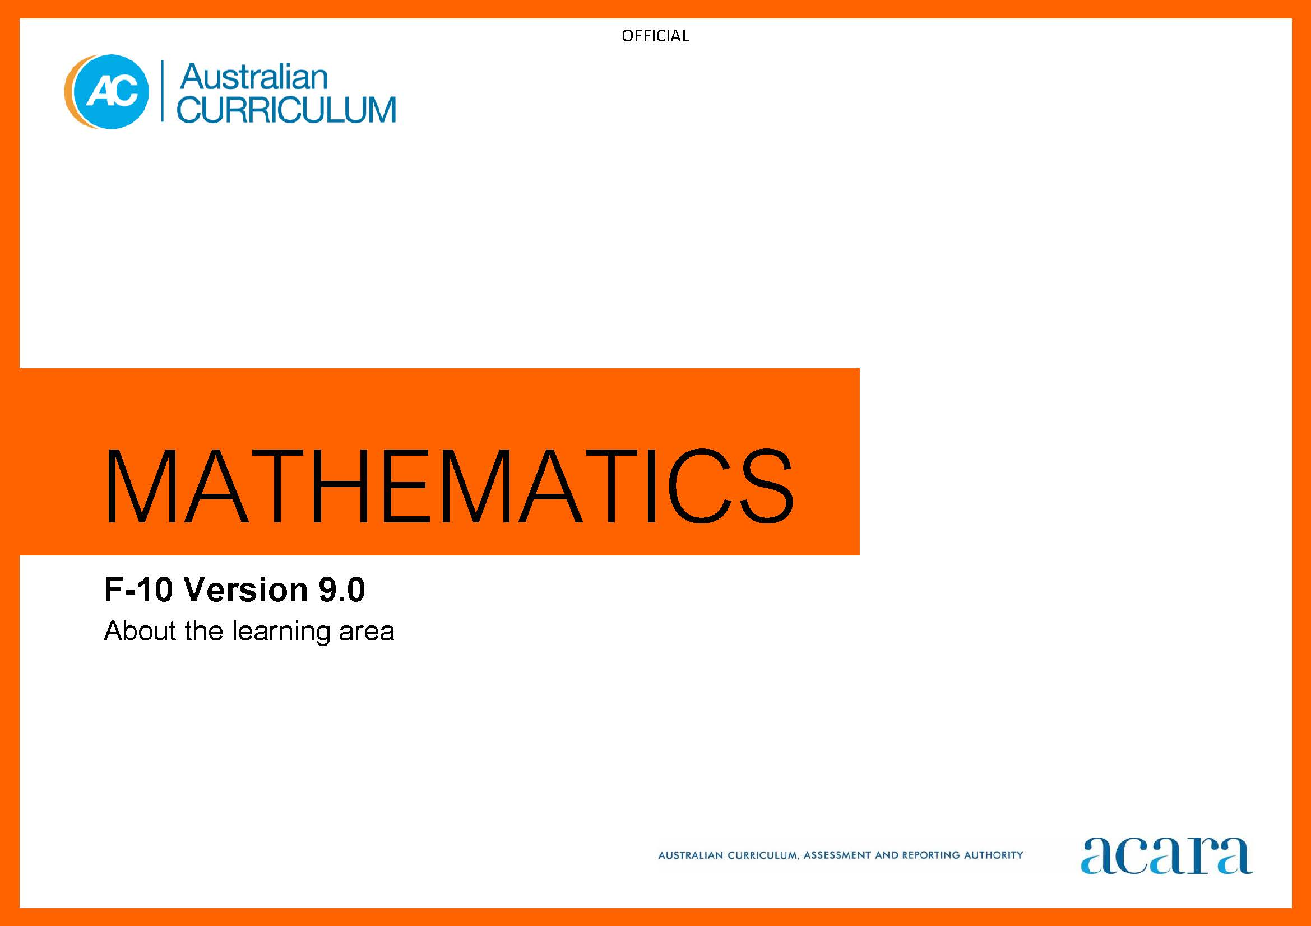

Copyright and Terms of Use Statement
© Australian Curriculum, Assessment and Reporting Authority 2022
The material published in this work is subject to copyright pursuant to the Copyright Act 1968 (Cth) and is owned by the Australian Curriculum, Assessment and Reporting Authority (ACARA) (except to the extent that copyright is held by another party, as indicated).
The viewing, downloading, displaying, printing, reproducing (such as by making photocopies) and distributing of these materials is permitted only to the extent permitted by, and is subject to the conditions imposed by, the terms and conditions of using the ACARA website (see, especially, clauses 2, 3 and 4 of those terms and conditions). The terms and conditions can be viewed at https://www.acara.edu.au/contact-us/copyright

TABLE OF CONTENTS
F–10 AUSTRALIAN CURRICULUM: MATHEMATICS 4
About the Learning Area 4
Introduction 4
Rationale 4
Aims 5
Structure 5
Key considerations 8
Key connections 12
Resources 16

F–10 AUSTRALIAN CURRICULUM: MATHEMATICS

About the Learning Area

Introduction
The Australian Curriculum: Mathematics has been developed on the basis that all students will study Mathematics in each year of schooling from Foundation to Year 10.

Rationale
The study of mathematics is central to the learning, development and prospects of all young Australians. Mathematics provides students with essential mathematical knowledge, skills, procedures and processes in number, algebra, measurement, space, statistics and probability. It develops the numeracy capabilities that all students need in their personal, work and civic lives, and provides the fundamentals on which mathematical specialties and professional applications of mathematics are built.
Mathematics has its own value and aesthetic, and the Mathematics curriculum develops students’ appreciation of the power of mathematical reasoning as they develop mastery of the content in mathematics. It provides students with learning opportunities to develop mathematical proficiency, including a sound understanding of and fluency with the concepts, skills, procedures and processes needed to interpret contexts, choose ways to approach situations using mathematics, and to reason and solve problems arising from these situations. The curriculum clarifies the links between the various aspects of mathematics as well as the relationship between mathematics and other disciplines.
Mathematical ideas have evolved across cultures over thousands of years and are continually developing. The modern world is influenced by ever expanding computational power, digital systems, automation, artificial intelligence, economics and a data driven society. This leads to the need for a capable Science, Technology, Engineering and Mathematics (STEM) workforce. Mathematics is integral to quantifying, thinking critically and making sense of the world. It is central to building students’ pattern recognition, visualisation, spatial reasoning and logical thinking. Interdisciplinary STEM learning can enhance students’ scientific and mathematical literacy, design and computational thinking, problem-solving and collaboration skills. Developing these competencies supports students in pursuing a variety of careers and occupations within STEM and other fields.
Mathematics provides opportunities for students to apply their mathematical understanding creatively and efficiently. It enables teachers to help students become self-motivated, confident learners through practice, inquiry, and active participation in relevant and challenging experiences.

Aims
Mathematics aims to ensure that students:
- become confident, proficient and effective users and communicators of mathematics, who can investigate, represent and interpret situations in their personal and work lives, think critically, and make choices as active, engaged, numerate citizens
- develop proficiency with mathematical concepts, skills, procedures and processes, and use them to demonstrate mastery in mathematics as they pose and solve problems, and reason with number, algebra, measurement, space, statistics and probability
- make connections between areas of mathematics and apply mathematics to model situations in various fields and disciplines
- foster a positive disposition towards mathematics, recognising it as an accessible and useful discipline to study
- acquire specialist mathematical knowledge and skills that underpin numeracy development and lead to further study in mathematics and other disciplines.

Structure
Mathematics is presented in year levels for each year from Foundation to Year 10. Content is organised under 6 interrelated strands:
- Number
- Algebra
- Measurement
- Space
- Statistics
- Probability.
The strands are illustrated in Figure 1.
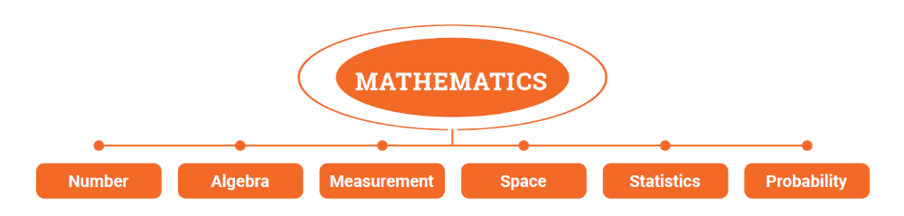
Figure 1: Mathematics content structure
An expectation of mathematical proficiency has been embedded into curriculum content across all strands to ensure that students develop mastery in mathematics through the development and application of increasingly sophisticated and refined mathematical understanding and fluency, reasoning, and problem-solving skills. The concepts, skills, procedures and processes essential to the learning of mathematics are organised under 6 interrelated strands, in a sequence of development that increases in depth and breadth across the years of schooling.
Natural connections exist between the content of these strands; for example, Number and Algebra build on an understanding of number systems and the properties of operations to describe relationships and formulate generalisations. Statistics and Probability have strong connections that rely on and build upon the important links between them. Measurement relates not only to Space but is foundational to all strands, enhancing their practical relevance. Combined with Number, it provides a means to quantify, compare, communicate and make meaning of situations. It is important that students develop the capability to identify and use the many connections that exist within and across the strands of Mathematics.
The 6 content strands also specify content aimed at progressively developing students’ knowledge and use of mathematical, statistical and computational thinking through the processes of mathematical modelling, computational thinking, statistical investigation, probability experiments and simulations. When students are actively engaged in learning experiences involving the mathematical processes, they draw upon and further develop their mathematical understanding, fluency, reasoning and problem-solving skills in an integrated way.

Strands
Number
The Number strand develops ways of working with mental constructs that deal with correspondence, magnitude and order, for which operations and their properties can be defined. Numbers have wide ranging application and specific uses in counting, measuring and other means of quantifying situations and objects. Number systems are constructed to deal with different contexts and problems involving finite and infinite, discrete and continuous sets. Developing number sense and the ability to work effectively with numbers is critical to being an active and productive citizen who is successful at work and in future learning, who is financially literate, and who engages with the world and other individuals.
Algebra
The Algebra strand develops ways of using symbols and symbolic representations to think and reason about relationships in both mathematical and real-world contexts. It provides a means for manipulating mathematical objects, recognising patterns and structures, making connections, understanding properties of operations and the concept of equivalence, abstracting information, working with variables, solving equations and generalising number and operation facts and relationships. Algebra connects symbolic, graphic and numeric representations. It deals with situations of generality, communicating abstract ideas applied in areas such as science, health, finance, sports, engineering, and building and construction.
Measurement
The Measurement strand develops ways of quantifying aspects of the human and physical world. Measures and units are defined and selected to be relevant and appropriate to the context. Measurement is used to answer questions, show results, demonstrate value, justify allocation of resources, evaluate performance, identify opportunities for improvement and manage results. Measurement underpins understanding, comparison and decision-making in many personal, societal, environmental, agricultural, industrial, health and economic contexts.
Space
The Space strand develops ways of visualising, representing and working with the location, direction, shape, placement, proximity and transformation of objects at macro, local and micro scales in natural and constructed worlds. It underpins the capacity to make pictures, diagrams, maps, projections, networks, models and graphics that enable the manipulation and analysis of shapes and objects through actions and the senses. This includes notions such as surface, region, boundary, curve, object, dimension, connectedness, symmetry, direction, congruence and similarity. These notions apply to art, design, architecture, planning, transportation, construction and manufacturing, physics, engineering, chemistry, biology and medicine.
Statistics
The Statistics strand develops ways of collecting understanding, and describing data and its distribution. Statistics provides a story, or a means to support or question an argument, and enables exploratory data analysis that underpins decision-making and informed judgement. Statistical literacy requires an understanding of statistical information and processes, including an awareness of data and the ability to estimate, interpret, evaluate and communicate with respect to variation in the real world. Statistical literacy provides a basis for critical scrutiny of an argument, the accuracy of representations, and the validity and reliability of inferences and claims. The effective use of data requires acknowledging and expecting variation in the collection, analysis and interpretation of data arising for categorical and numerical variables. Statistics is used in business, government, research, sport, healthcare and media for critical and informed evaluation of issues, arguments and decision-making.
Probability
The Probability strand develops ways of dealing with uncertainty and expectation, making predictions, and characterising the chance of events, or how likely events are to occur from both empirical and theoretical bases. It provides a means of considering, analysing and utilising the chance of events, and recognising random phenomena for which it is impossible to exactly determine the next observed outcome before it occurs. In contexts where chance plays a role, probability provides experimental and theoretical ways to quantify how likely it is that a particular event will occur or a proposition is the case. This enables students to understand contexts involving chance and to build mathematical models surrounding risk and decision-making in a range of areas of human endeavour. These include finance, science, business management, epidemiology, games of chance, computer science and artificial intelligence.

Key considerations
Proficiency in mathematics
Mathematics emphasises the importance of providing opportunities for students to develop proficiency in mathematics. It focuses on the development of increasingly sophisticated knowledge and understanding of mathematical concepts, fluency in representations and procedures, and sound mathematical reasoning and problem-solving skills. Proficiency in mathematics enables students to respond to familiar and unfamiliar situations by employing mathematical processes to solve problems efficiently and to make informed decisions. Proficiency in mathematics also enables students to reflect on and evaluate approaches, and verify that answers and results are reasonable in the context.
Understanding
Mathematics provides opportunities for students to build and refine a robust knowledge and understanding of mathematical concepts and procedures. This helps students make connections between related ideas, progressively draw upon their reasoning skills to adapt and transfer understanding of familiar applications to unfamiliar contexts, and cultivate new ideas. They develop an understanding of the relationship between the “why” and the “how” of mathematics. Students build conceptual understanding and procedural fluency when they connect related ideas, represent concepts in different ways, identify commonalities and differences between aspects of content, describe their thinking mathematically and interpret mathematical information.

Fluency
Mathematics provides opportunities for students to develop, practise and consolidate skills; choose appropriate procedures; carry out procedures flexibly, accurately, efficiently and appropriately; and apply knowledge and understanding of concepts readily. Students are fluent when they connect their conceptual understanding to learned strategies and procedures, choose and use computational strategies efficiently; when they recognise robust ways of answering questions; when they choose appropriate representations and approximations; when they understand and regularly apply definitions, facts and theorems; and when they can manipulate mathematical objects, expressions, relations and equations to find solutions to problems.
Reasoning
Mathematics emphasises mathematical reasoning as central to thinking and working mathematically and as a critical component of proficiency in mathematics. It guides students in developing an increasingly sophisticated capacity for logical thought and actions, such as analysing, proving, experimenting, modelling, evaluating, explaining, inferring, justifying and generalising. Students are reasoning mathematically when they explain their thinking, deduce and justify strategies used and conclusions reached, adapt the known to the unknown, transfer learning from one context to another, and prove that something is true or false. They are reasoning when they compare and contrast related ideas, and reflect upon and explain their choices.
Problem-solving
Mathematics recognises the importance of providing students with meaningful opportunities to use mathematics to solve problems from both mathematical and real-world contexts. Students engage in mathematical problem solving when they are presented with a problem situation for which they do not immediately know the answer, and they work through a process of planning, applying strategies and heuristics to find a solution to the problem, reviewing and analysing their solution. Problems can be routine, where there is only one possible solution, or non-routine, where the problem may have many valid solutions. Students learn how to make mathematical decisions as they draw on previously learnt concepts, skills, procedures and processes to solve problems, communicate solutions and justify the reasonableness of their approaches. Students are problem-solving when they identify problems; formulate situations mathematically; apply their mathematical understanding, fluency and reasoning skills to obtain mathematical solutions; evaluate, interpret and communicate their solutions in terms of the situation.
Mathematical processes
Mathematical processes refer to the thinking, reasoning, communicating, problem-solving and investigation process skills involved in working mathematically. Opportunities to learn process skills have been embedded into the Mathematics curriculum content across the strands, building in sophistication across the years of schooling. The mathematical processes of mathematical modelling, computational thinking, statistical investigation, probability experiments and simulations are mathematical problem-solving and investigation processes that students learn to use in mathematics, and that draw upon students’ mathematical process skills and proficiency in mathematics in an interconnected way.
Mathematical modelling
Students develop an understanding of mathematical modelling when they use mathematics to gain insight into and make predictions about real-world phenomena. Mathematical models are used to inform judgements and make decisions in personal, civic and work life. When using mathematical modelling to solve problems, students make assumptions, recognise, connect and apply mathematical structures. The modelling process utilises mathematics to formulate, analyse, solve, interpret, generalise and communicate their results in response to a real-world situation. Mathematical modelling is an essential dimension of the contemporary discipline of mathematics and is key to informed and participating citizenship.
Computational thinking
Students develop computational thinking through the application of its various components: decomposition, abstraction, pattern recognition, use of models and simulations, algorithms and generalisation. Computational thinking approaches involve experimental and logical analysis, empirical reasoning and computer-based simulations. The simulations can then be used to generate and test hypotheses and conjectures, identify patterns and key features (or counterexamples), and dynamically explore variation in the behaviour of structures, systems and scenarios.
Statistical investigation
Students develop the ability to conduct statistical investigations through informal exploration in the early years. Later they use guided processes, which progressively lead them to conduct and review their own statistical investigations and to critique others’ processes and conclusions. Statistical investigation deals with uncertainty and variability in categorical (nominal or ordinal) or numerical (discrete or continuous) data arising from observations, surveys or experiments and can be initiated by a specific question, a situation, or an issue.
Probability experiments and simulations
Students develop an understanding of experimentation through exploration and play-based learning in the early years. They progress to conducting chance experiments and probability simulations in the later years of primary. Experimentation and simulation in mathematics can involve the use of digital and other tools, often to generate large sets of data for consideration, drawing on the interconnections between Statistics and Probability. Experimenting in mathematics requires students to plan what to do and evaluate what they find out using mathematical reasoning.

Computation, algorithms and the use of digital tools in mathematics
The capacity to purposefully select and effectively use the functionality of a digital device, platform, software or digital resource is a key aspect of computational thinking in the Mathematics curriculum. Digital tools can be used effectively to learn and apply mathematics in and across all of the strands. The use of digital tools addresses elements of the Digital Literacy general capability. The functionalities may be accessed through hand-held devices such as calculators (arithmetic 4 operation, scientific, graphics, financial, CAS) and measurement tools (digital scales and other digital measuring devices), software on a computer or tablet (spreadsheet, dynamic geometry, statistical, financial, graphing, computer-algebra), an application on a personal device, virtual and augmented reality technologies or tools accessed from the internet or cloud. Different digital tools or platforms can carry out computations and implement algorithms using numerical, textual, statistical, probabilistic, financial, measurement, geometrical, graphical, logical and symbolic functionalities.
The term “computation” is used in mathematics to refer to operations, transformations, procedures and processes that are applied to mathematical objects to produce an output or result. A computation may be an arithmetic calculation; an algorithm; the graph of a relation, function, network or set of data; a set, list, sequence or table of values; a diagram or shape; or a solution to an algebraic equation.
The objects of computations may be sets of numbers, text, data, points, shapes and objects in space, images, diagrams, networks, or symbolic and logical expressions, including equations.
Some computations may be dynamic; that is, they enable parameters, conditions and constraints to be varied and the corresponding results to be progressively shown. Examples include the effect of varying an outlier on the mean of a data set, the behaviour of an algorithm under different sets of inputs, sorting or ordering the elements of a set, observing the relative frequency of an event as the number of experiments increases, manipulating a shape in 2 dimensions or an object in 3 dimensions and observing any symmetries, or transforming the graph of a function by varying defining parameters such as, changing the gradient of a linear function.
An algorithm is a precise description of the steps and decisions needed to solve a problem or a set of rules to follow in order to accomplish a task. Algorithms often involve iterative (repetitive) processes and can be represented as text, in diagrams, or symbolically such as flowcharts and pseudocode. As students develop a conceptual understanding of how an algorithm works and fluency with using algorithms appropriately, they can reason and solve problems using algorithms as part of a computational thinking process.
Protocols for engaging First Nations Australians
When planning teaching activities involving engagement with First Nations Australians, teachers should follow protocols that describe principles, procedures and behaviours for recognising and respecting First Nations Australians and their intellectual property. Teachers should use approved resources such as those that may be provided by their state or territory school system, or First Nations Australian education consultative groups, or other protocols accredited by First Nations Australians.
While the Australian Curriculum uses the terms “First Nations Australians” and “Australian First Nations Peoples”, there may be other terms that First Nations Australians of a particular area or location prefer. It is important to use the terms preferred in a particular area or location.
Meeting the needs of diverse learners
The Australian Curriculum values diversity by providing for multiple means of representation, action, expression and engagement, and allows schools the flexibility to respond to the diversity of learners within their community. All schools have a responsibility when implementing the Australian Curriculum to ensure that students’ learning is inclusive, and relevant to their experiences, abilities, and talents. For some students with diverse languages, cultures, abilities and talents it may be necessary to provide a range of curriculum adjustments so they can access age-equivalent content in the Australian Curriculum and participate in learning on the same basis as their peers.
Mathematics responds to the diversity of students in the mathematics classroom by connecting familiar experiences and objects in students’ lives. Familiar objects and situations add meaning to any mathematics exploration and help all students understand and use what they have learnt. Responding to student diversity also provides opportunities to deepen students’ understanding of mathematics and its applications. Strategies that could support the diverse needs of students in mathematics include providing:
- exposure to mathematical tasks to engage the intellect and interest of students
- classroom discourse that promotes the investigation and growth of mathematical ideas
- technology and other tools to access and pursue mathematical investigations and other problem-solving tasks
- experience with mathematical concepts using multisensory methods to stimulate thinking skills
- access to familiar objects to represent and solve mathematical problems; coins, blocks, counters, buttons or other small objects can be used to demonstrate concepts such as greater than, less than and equal to, counting, adding, subtracting, sharing, grouping and fractions
- scaffolding procedures and processes using step-by-step instruction, demonstrating how to solve mathematical problems.

Key connections
General capabilities
General capabilities equip young Australians with the knowledge, skills, behaviours and dispositions to live and work successfully. General capabilities support and deepen student engagement with learning area content and are best developed within the context of learning areas.
Opportunities to develop general capabilities in learning area content vary. While Literacy and Numeracy are fundamental to all learning areas, Numeracy development is core to the Mathematics curriculum. In addition, the general capabilities of most relevance and application to mathematics are Critical and Creative Thinking, Digital Literacy and Ethical Understanding. These general capabilities are identified in content descriptions when they are developed or applied through the mathematics content. They are also identified in content elaborations when they offer opportunities to add depth and richness to student learning.
Literacy
Mathematics focuses on developing the skills and understandings necessary for students to communicate their thinking, reasoning and solutions to problems using appropriate mathematical language, notation and symbology within the context of given situations. Students learn the vocabulary associated with mathematical concepts, skills, procedures and processes in number, algebra, space, measurement, statistics and probability. This vocabulary includes technical terminology and common words with specific meanings in a mathematical context. Students also learn that context affects the understanding of mathematical terminology, and that mathematical understandings are expressed using particular language forms and features. Students use their developing literacy skills to interpret and create a variety of texts that typically relate to mathematics. These range from calendars and maps to complex data displays and statistical reports. Students use literacy skills to understand and interpret contexts and problem situations, and formulate them into mathematical and statistical questions using the language features of mathematics and statistics. They pose and answer questions, discuss and collaborate in mathematical problem solving, and produce and justify solutions.
Numeracy
Mathematics has a more fundamental role in the development of numeracy compared to other learning areas. The Mathematics curriculum provides opportunities to apply mathematical understanding and skills in other learning areas and to real-world contexts. Financial mathematics, health and well-being are important contexts for the application of number, algebra, measurement and probability. In measurement and space, there is also an opportunity to apply understanding to design and construction. Today’s world is information driven; through statistics and probability, students can interpret and critically analyse data, and make informed judgements about events involving uncertainty.
Critical and Creative Thinking
In Mathematics, students develop critical and creative thinking as they learn to evaluate information, ideas and possibilities when seeking solutions. A core part of the Mathematics curriculum is engaging students in reasoning and thinking about solutions to problems and the strategies needed to find these solutions. Students are encouraged to be critical thinkers when justifying their choice of a computation strategy or developing relevant questions during a statistical investigation. They are encouraged to look for alternative ways to approach mathematical problems; for example, identifying when a problem is like a previous one, experimenting with new ideas or simplifying a problem to control or limit the number of variables.
Digital Literacy
In Mathematics, students develop an understanding of digital literacy and related skills when they investigate, create and communicate mathematical ideas and concepts using automated, interactive and multimodal technologies. They draw on digital literacy skills to perform computations; construct graphs; conduct probability simulations; collect, manage, analyse and interpret data; experiment mathematically; share and exchange information and ideas; and investigate concepts and relationships. Digital tools with numerical, financial, graphical, spatial, symbolic and statistical functionality, such as spreadsheets, graphing software, statistical software, dynamic geometry software and computer algebra software, can engage students, enable them to work on complex and sophisticated problems, and promote understanding of core concepts.
Ethical Understanding
In Mathematics, there are opportunities to explore, develop and apply ethical understanding in a range of contexts. Examples of these contexts are rational inquiry including sampling, collecting, analysing and interpreting data and statistics; being alert to intentional and accidental errors or distortions and questions of validity in propositions and inferences; finding inappropriate or inconsistent comparisons and misleading scales when exploring the importance of fair comparison; providing equitable solutions; and interrogating financial claims and sources.
Cross-curriculum priorities
Cross-curriculum priorities support the Australian Curriculum to be a relevant, contemporary and engaging curriculum that reflects national, regional and global contexts. Cross-curriculum priorities are incorporated through learning area content; they are not separate learning areas or subjects. They provide opportunities to enrich the content of the learning areas, where appropriate and authentic, allowing students to engage with and better understand their world.
Opportunities to apply cross-curriculum priorities to learning area content vary. All 3 cross-curriculum priorities have relevance and meaning to Mathematics. The cross-curriculum priorities are identified in content elaborations where they can offer opportunities to add depth and richness to student learning.
Aboriginal and Torres Strait Islander Histories and Cultures
In Mathematics, students can engage with and value the histories and cultures of Australian First Nations Peoples in relation to mathematics. First Nations Australians have complex kinship systems that connect all people to environmental systems, which is the hallmark of sustainability. Many First Nations Australians are adept at pattern recognition and algebraic thinking, which informs their cultural expressions, ways of caring for Country/Place and the development of material culture.
Content elaborations in Mathematics have been structured around identified themes in Australian First Nations Peoples’ mathematical thinking, understandings and processes, in contexts that can be taught across the content strands and through the year levels. They provide a rich, connected narrative by identifying contextual examples from around Australia.
Asia and Australia’s Engagement with Asia
Mathematics provides opportunities to promote students’ awareness of the significant contributions of Asian culture to the historical development and application of mathematical ideas and approaches. This is demonstrated in the use of mathematics in a range of contemporary contexts related to Asia, including art, design, trade and travel.
Mathematics provides content that builds understanding of Asia’s global significance; for example, the development of the Hindu-Arabic and Chinese numerals, number systems and related algorithms, and the use of tools such as abacuses and counting boards for calculation and solving equations. Asian architecture, art and design include key aspects of spatial reasoning and geometry, including symmetry, transformation, recurrence and tessellation.
Sustainability
In Mathematics, students develop skills in mathematical modelling, statistical investigation and analysis, which are essential for identifying and exploring sustainability issues and proposed solutions. Students can apply spatial reasoning, measurement, estimation, calculation and comparison to gauge the health of local ecosystems and to cost proposed actions for sustainability.
Mathematical understandings and skills are necessary to model, measure, monitor and quantify change in social, economic and ecological systems over time. Statistical analysis enables the prediction of probable futures based on findings and helps inform decision-making and actions that lead to preferred futures.
Learning areas
Mathematics provides opportunities to integrate and connect content to other learning areas, in particular, Science, Technologies, The Arts, Humanities and Social Sciences (HASS) and Health and Physical Education.
Mathematics and Science
Mathematics and Science share a focus on modelling, measurement, empirical reasoning, experimentation and investigation. In Science and Mathematics, students develop models to represent amounts, relationships, relative scales and patterns. They are introduced to measurement, first using informal units, then using formal units. Later, they consider issues of uncertainty and reliability in measurement. As students progress, they collect qualitative and quantitative data, which are analysed and represented in a range of forms. Students learn data analysis skills including identifying trends and patterns from numerical data and graphs.
Mathematics and Digital Technologies
Mathematics and Digital Technologies share a focus on computational and algorithmic thinking and data. The Mathematics curriculum supports students in gaining the knowledge and skills that underpin pattern recognition, data collection, interpretation and representation, which form the basis of statistical investigation. Digital Technologies focuses on how digital systems represent data. It develops students’ foundational understanding of algorithms in the early years, which Mathematics then builds upon. The implementation, design and creation of algorithms in Mathematics are an integral part of a computational approach to learning and experimenting in Mathematics; it complements Digital Technologies and supports the development of computational and algorithmic thinking skills.

Mathematics and Design and Technologies
Design and Technologies gives students opportunities to interpret and use mathematical knowledge and skills in a range of real-life situations. Students use number to quantify, measure and estimate; interpret and draw conclusions from statistics; measure and record throughout the process of generating ideas; develop, refine and test concepts; and cost and sequence when making products and managing projects. They use three-dimensional models, create accurate technical drawings, work with digital models and use computational thinking in decision-making processes when designing and creating best-fit solutions.
Mathematics and The Arts
Mathematics and The Arts share understandings about pattern, measurement and spatial reasoning. In Mathematics, students use this knowledge to solve problems and model solutions. In The Arts, the knowledge is applied when creating, interpreting, analysing and learning about art works. Mathematics and The Arts both give students opportunities to learn about, and learn through, observation of natural and constructed environments. Students can communicate their mathematical understandings through visual, sonic, dramatic and kinaesthetic forms of art. Students have opportunities to apply mathematical understanding when they use specific arts processes or practices; for example, using knowledge of measurement and spatial reasoning when creating an observational drawing, or choosing pathways and levels in Dance and Drama. In Music, students can apply knowledge of patterns and algorithms when composing.
Mathematics and Humanities and Social Sciences
Mathematics and Humanities and Social Sciences (HASS) share a focus on financial literacy and exploratory data analysis; this includes understanding the principles of financial management to make informed financial and business decisions. Mathematics draws on aspects of the HASS curriculum to provide rich contexts through which to teach and apply mathematics. Students learn to organise, interpret, analyse and present information about historical and civic events and developments in numerical and graphical form to make meaning of the past and present. They learn to use scaled timelines including those involving negative and positive numbers, calendars and dates to represent information on topics of historical significance and to illustrate the passing of time. In constructing and interpreting maps, students work with numerical concepts associated with grids, scale, distance, area and projections.
Mathematics and Health and Physical Education
In Health and Physical Education, students examine relationships between time and space in relation, in particular, to human bodies. There are strong links to mathematical concepts such as data, graphical representations, measurement, rates, ratios, percentages and proportions, in the analysis of nutritional information, movement and health- and skill-related fitness components. Health and Physical Education provides meaningful contexts and situations for students to engage in statistical investigations, mathematical modelling and other problem-solving tasks.

Resources
Curriculum documents including understanding the learning area, curriculum content in F–6 and 7–10, a scope and sequence representation, the glossary, and comparative information about Version 8.4 and Version 9.0 are available on the download page.

Optional content for post–Year 10 mathematics pathways
In Year 10, students will consider possible pathways to senior secondary mathematics study. Preparation for subsequent study of Mathematical Methods Units 1 and 2 can be supported by further development of aspects of mathematics content in Year 10 as a basis for building understanding that underpins formal treatment in Mathematical Methods. This resource provides some suggestions for teachers so they can support students to extend and enrich their mathematical study of the Year 10 curriculum in preparation for senior secondary mathematics. This document is available as a download

