Australian Curriculum:
Digital Technologies
Year 1–2
Sample assessment task
Cooling the school
Assessment focus: Australian Curriculum: Digital Technologies
(digital systems)

About this assessment task
This sample assessment task has been prepared to assist teachers with the implementation of the Australian Curriculum: Digital Technologies, with a focus on digital systems. It shows how aspects of the Digital Technologies curriculum related to digital systems can be assessed using contexts from other learning areas and subjects. These contexts may be content that students have recently completed or are learning concurrently. This approach should enhance the manageability of the curriculum while still providing a targeted focus on Digital Technologies.
Purpose
The sample task aims to:
- demonstrate meaningful curriculum links to:
- Digital Technologies curriculum:
    - achievement standard
    - content descriptions
    - content strands and sub-strands
    - core concepts (Technologies)
    - core concepts (Digital Technologies)
- general capabilities
- cross-curriculum priorities
- other learning areas. See Appendix 1 for specific links for this task.
- provide teacher support materials, suggested adjustments for students with diverse needs and resources. See Appendix 2.
- provide a template to create your own assessment task. See Appendix 3.
How to use this sample task
The sample task can be implemented as a standalone task or it can be used to inform planning
of a:
- unit of work that might accompany the sample task
- similar task and/or unit of work with a focus on digital systems.

Title: Cooling the school
Assessment focus: Australian Curriculum: Digital Technologies (Digital systems – identify and explore digital systems and their components for a purpose). Assessment opportunities for Mathematics are also included. This task is taught through a HASS (Geography focus) context. Depending on modifications made, opportunities may exist to link this task to Science, English, Literacy and Numeracy.
Band: Years 1–2
Context: Geography (Humanities and Social Sciences)
Duration: Dependent on how the task is to be implemented
Prior learning: Students will have:
- used and created a variety of simple maps that represent familiar places
- utilised a variety of geographical tools including maps, atlas, globe, digital maps 2D or 3D or both (apps or browser)
- learned that maps are a representation of a place and can be displayed in a variety of ways including standard or satellite
- identified that maps can detail a variety of surfaces including natural and built
- practised how to identify familiar features on standard and satellite maps
- used directional language to assist using printed and digital maps including: closer, further away, zoom in, zoom out, bird’s-eye view, aerial view
- learnt that shaded areas can keep areas cooler
- learnt that trees and plants are different in the amount of shade they can provide
- learned that digital maps are accessible using a variety of digital systems (tablet, smart phone, computer) that they would have at home and school
- explored a variety of familiar digital systems they interact with at home and school
- explored digital maps such as Google Maps or Scribble Maps using a digital system.
Task summary
The key inquiry question will be:
- How can we cool the school using the natural environment?
The focus questions will be:
- How can we find out how much shade there is at a location or at school?
- Can we provide more shade?
Overview
Discuss with students how the amount of shade in the school grounds can help keep the area cooler. This can also reduce the need for air-conditioning and make playing in the playground more comfortable. Students will access and annotate a map using a satellite image of the school ground or the early learning area and calculate the areas of natural shade compared with the remaining areas. The choice of image used can be downloaded by the teacher based on their school or use the school map template (Appendix 4). Teachers could even have a buddy class at the school collect the image by using a drone (if available). Students will be able to redesign the satellite image with an increase to tree cover that improves shaded areas while not impacting school use. For example, you wouldn’t cover the school oval in trees as it would make sport difficult but perhaps trees planted around jump pits and oval sidelines would be practical. Students will be able to explain how using simple digital systems can allow us to see changes to the shade cover area at schools.
Students will:
- identify how common digital systems (hardware and software) are used to meet a
specific purpose
- use a variety of digital systems to acquire, explore and sort data, and present
data creatively
- explore how common digital systems can be used safely for information
and communication
- use a range of geographic information systems (GIS) – Google Earth,
OpenStreetMap, etc
- create and organise ideas using digital tools and share this information with known people in a safe online environment.
- consider how to increase the shaded area of a range of locations familiar to them
- make recommendations as a class on how to increase the shade spaces in the school.
Task features
Students will be asked to complete the following formative and summative activities (this can be completed as a class, small groups, independently or a variety of these):
- Identify the different areas of the school grounds using a satellite image (buildings, hard surfaces, grassed areas, trees and shade structures).
- Count how many trees are on the school grounds using the map.
- Colour or stamp tree-shaded areas of a map – paper or digital version.
- Plan on how increased area could be shaded – create improved map.
- Compare the maps of other students.
- Identify ways a digital system could monitor improvements or changes.
- Present the map and improvement ideas to an audience (optional).

Background information
Teacher guidance and support
- Take students on a shade walk in the school and identify natural tree shade, constructed shade and non-shaded areas.
  - Identify low-level shade provided by plants that don’t provide shade for students.
- Guide students to counting trees in a known location by demonstrating on the digital whiteboard using a satellite image and placing an emoji or stamp on each tree, for example a local park.
- Refer to Figure 3, which was created using PowerPoint. Paste satellite image and insert icon to assist counting trees. Refer to the supporting resource, Cool your school (PowerPoint).
  - Identify possible locations for new trees that will offer shade while not impacting on the uses at the park.
- Discuss what type of digital systems could be used to monitor future tree growth.
  - Show students a drone that can take images (physical drone or video).
- Give students opportunities to develop their Digital Literacy skills by working with images and annotating them with digital ink or shapes.
  - Use the edit photo function or apps that allow photo editing, pasting and drawing. See Figure 1 and Figure 4.
  - Utilise software that allows students to add icons, for example PowerPoint, Word, Paint.
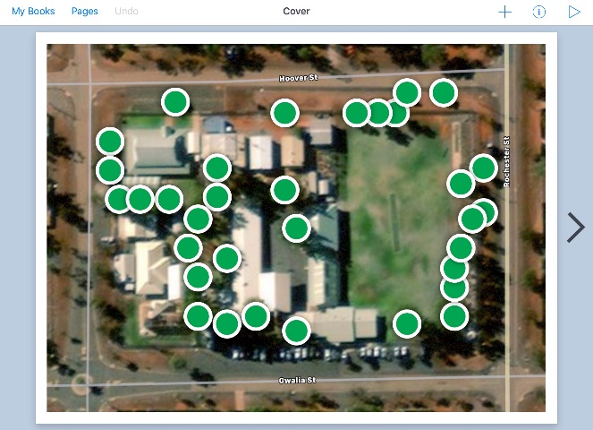
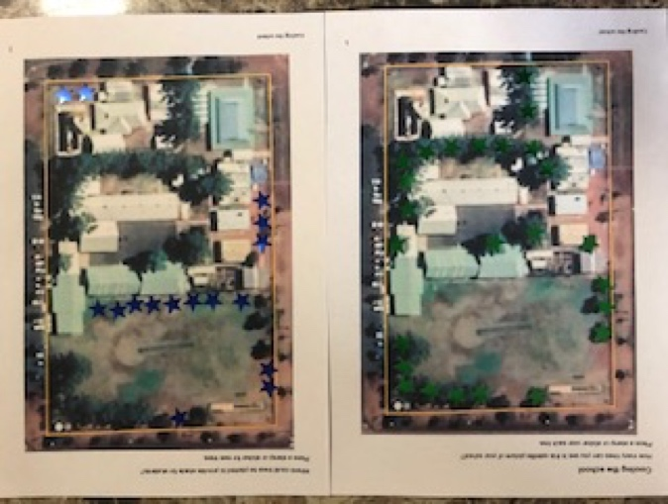

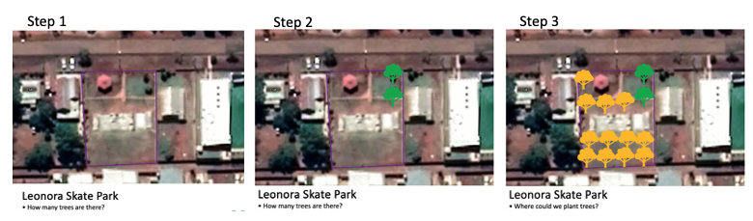
Maps – imagery: Google, ©2021 CNES / Airbus, Maxar Technologies
Tree images added using PowerPoint icons
Figure 3: Created with PowerPoint
Figure 2: Stickers on printout
Figure 1: Created with Book Creator app
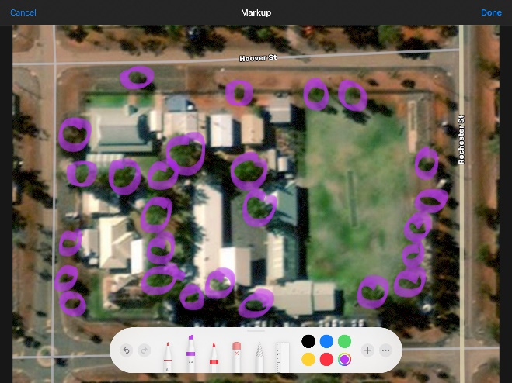
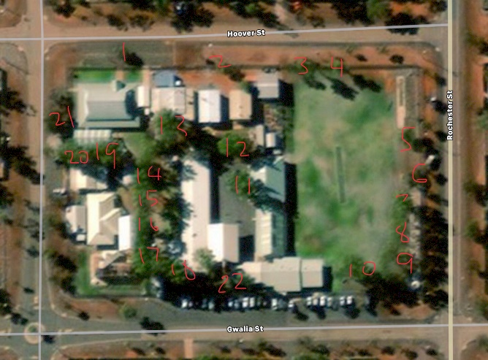
Maps – imagery: Google, ©2021 CNES / Airbus, Maxar Technologies
Tree images added using PowerPoint icons
Figure 4: Both images created using markup in iPad Photo app
Images CC 4.0 ACARA

An accompanying PowerPoint slide deck (Digital systems Years 1–2 presentation material) steps through a possible process for this task.
Here’s a guide to the icons you’ll see on the PowerPoint slides:


Presentation materials to teach content to students.

An assessment component which could be added to the assessment portfolio and is intended as formative assessment. Alternatively, you could hold a class discussion to gauge understanding of a topic.
Class discussions on a topic are encouraged as formative assessment.

Work which needs to be completed individually on a device and could be added to a portfolio or digital book as part of the summative task

The PowerPoint slide deck gives an overview with guiding questions following this sequence:
- Digital systems
- Using a digital system: Software and hardware including:
- Google Maps
- Types of maps (satellite, street)
- ScribbleMaps
- Compare the data
- Digital portfolio
- Purposeful audience.

Links to the Australian Curriculum
Table 1 and 2 show all the related Australian Curriculum version 9 links to this task. For a more in-depth exploration of the links to the curriculum, see Appendix 1.
Table 1: Links from the task to the Australian Curriculum: Digital Technologies (V 9.0)
Digital Technologies  Achievement standard  Aspects addressed by this task are highlighted. | By the end of Year 2 students show how simple digital solutions meet a need for known users. Students represent and process data in different ways. They follow and describe basic algorithms involving a sequence of steps and branching. With assistance, students access and use digital systems for a purpose. They use the basic features of common digital tools to create, locate and share content, and to collaborate, following agreed behaviours. Students recognise that digital tools may store their personal data online.
Strands  Sub-strands | Digital Technologies knowledge and understanding  - Digital systems  - Data representation  Digital Technologies processes and production skills  - Investigating and defining  - Evaluating  - Collaborating and managing
Content descriptions | - identify and explore digital systems and their components for a purpose AC9TDI2K01  - represent data as pictures, symbols, numbers and words AC9TDI2K02  - investigate simple problems for known users that can be solved with digital systems AC9TDI2P01  - discuss how existing digital systems satisfy identified needs for known users AC9TDI2P03  - use the basic features of common digital tools to create, locate and communicate content AC9TDI2P04  - use the basic features of common digital tools to share content and collaborate demonstrating agreed behaviours, guided by trusted adults AC9TDI2P05
Technologies core concepts | - Interactions and impact  - Technologies processes and production skills  - Data  - Systems  - Systems thinking  - Computational thinking | Digital Technologies core concepts | - Digital systems  - Data representation  - Abstraction  - Data acquisition*  - Data interpretation*
Technologies core concepts |  | General capabilities | - Digital Literacy  - Literacy  - Numeracy
Cross-curriculum priorities | - Sustainability | Learning area or subject connections | - HASS (Geography)  - Science  - English
*through Mathematics content descriptions

Table 2: Links from the task to the Australian Curriculum: Mathematics (V 9.0)
Mathematics  Year 1 Achievement standard  Aspects addressed by this task are highlighted. | By the end of Year 1, students connect number names, numerals and quantities, and order numbers to at least 120. They demonstrate how one- and two-digit numbers can be partitioned in different ways and that two-digit numbers can be partitioned into tens and ones. Students partition collections into equal groups and skip count in twos, fives or tens to quantify collections to at least 120. They model situations involving addition, subtraction, equal sharing and grouping, using a variety of calculation strategies. Students use numbers, symbols and objects to create skip counting and repeating patterns, identifying the repeating unit.  They compare and order objects and events based on the attributes of length, mass, capacity and duration, communicating reasoning. Students measure the length of shapes and objects using uniform informal units. They make, compare and classify shapes and objects using obvious features. Students use directions to move people and objects within a space.  They collect and record categorical data, create one-to-one displays, and compare and discuss the data using frequencies. Students identify and describe outcomes of familiar chance events.
Year 2 Achievement standard  Aspects addressed by this task are highlighted. | By the end of Year 2, students order and represent numbers to at least 1000, apply knowledge of place value to partition, rearrange and rename two- and three-digit numbers in terms of their parts, and regroup partitioned numbers to assist in calculations. They model additive situations, including money transactions, and solve practical problems involving addition and subtraction, using number sentences and choosing calculation strategies. Students model multiplicative situations and solve problems involving multiplication and division using equal groups, arrays and repeated addition. They identify and represent part-whole relationships of halves, quarters and eighths in measurement contexts. Students describe and continue patterns that increase and decrease additively by a fixed amount, and identify missing elements in the pattern.  They use uniform informal units to measure and compare shapes and objects. Students determine the number of days between events using a calendar and read time on an analog clock to the hour, half hour and quarter hour. They compare and classify shapes, describing features using formal spatial terms. Students locate and identify relative positions of features in two-dimensional representations and move position by following directions and pathways.  They use a range of methods to collect, record, represent and interpret categorical data in response to questions. Students list and order the likelihood of outcomes for everyday events.
Strands | - Space (Year 2)  - Statistics
Year 1 Content descriptions | - acquire and record data in various ways including using digital tools, objects, images, drawings, lists, tally marks and symbols AC9M1ST01  - represent collected categorical data using one-to-one displays and digital tools where appropriate; quantify and compare the data using frequencies and discuss the findings AC9M1ST02
Year 2 Content descriptions | - locate positions and identify relative positions of key features of a familiar space represented in two-dimensions; move positions by following directions and pathways AC9M2SP02  - acquire categorical data sets through surveys, observation, experiment and using digital tools; sort data into relevant categories and display data using lists and tables AC9M2ST01  - create different graphical representations of data using software where appropriate; compare the different representations, identify and describe common and distinctive features in response to questions AC9M2ST02

Assessment planner
Achievement standard  (relevant aspect of the achievement standard to be assessed) | Student evidence  (what student evidence will be considered to judge if the achievement standard aspect has been met)
Digital Technologies
Students show how simple digital solutions meet a need for known users | - Students identify ways that digital maps can assist with viewing areas from above for a purpose
With assistance, students access and use digital systems for a purpose. Students represent and process data in different ways. | - Students mark the location of trees that could increase shaded areas, using digital maps and drawing tools  - Students use features that clearly show the difference between existing trees and potential tree plantings
They use the basic features of common digital tools to create, locate and share content, and to collaborate, following agreed behaviours. | - Students share with another class, families, school administration or local government their findings and plan using a digital system
Mathematics
Year 1  They collect and record categorical data, create one-to-one displays, and compare and discuss the data using frequencies.  Year 2  Students locate and identify relative positions of features in two-dimensional representations. They use a range of methods to collect, record, represent and interpret categorical data in response to questions. | - Students locate existing trees through observation on a satellite map and mark them on the map

Assessment rubric
The rubric below shows only Digital Technologies and Mathematics. Note: There are opportunities to include Geography, English, Literacy and Numeracy in the assessment.
Digital Technologies | Above standard  Students: | At standard  Students: | Below standard  Students:
Students show how simple digital solutions meet a need for known users. With assistance, students access and use digital systems for a purpose.
Digital systems | show how a range of digital solutions (including digital maps) and understand their purpose | show how simple digital solutions such as online maps meet a need for people they know | list a familiar digital solution
Digital systems | describe how familiar digital systems such as GPS are used by people in their community to perform typical tasks (e.g. firefighters use GPS to locate addresses they need to attend) | describe how familiar digital systems such as in-car GPS support needs at home and school | with guidance, list familiar digital systems
Digital systems | independently use digital mapping software for a purpose | use digital mapping software for a purpose with guidance | use digital mapping software with guidance
Students represent and process data in different ways.
Data representation | independently represent a range of data on a digital map using symbols and text | represent data on a digital map using symbols | with guidance, represent some data on a map
They use the basic features of common digital tools to create, locate and share content, and to collaborate, following agreed behaviours.
Evaluating and collaborating and managing | independently use familiar digital systems to share information with others (e.g. share online map of school with others and how it has been marked to indicate where more trees should be located) | use familiar digital systems to share information with others with guidance (e.g. share online map of school with others and how it has been marked to indicate where more trees should be located) | share information with others (e.g. tell another student about online map of school)
Mathematics | Above standard  Students: | At standard  Students: | Below standard  Students:
They collect and record categorical data, create one-to-one displays, and compare and discuss the data using frequencies.
Statistics  Year 1 | use digital systems independently to gather data by observing and counting plants in their school environment and independently marking them on digital maps | gather data by observing and counting plants in their school environment and marking them on digital maps | with guidance, locate plants in their school environment
Statistics  Year 1 | answer simple questions by classifying, grouping and sorting data (e.g. which plants in the school are better for shade – shrubs or trees?) | explore data by classifying, grouping and sorting (e.g. sort shrubs and trees) | with guidance, sort some data such as circling trees on a digital map
They use a range of methods to collect, record, represent and interpret categorical data in response to questions.
Statistics  Year 2 | use digital systems independently to gather data by observing and counting plants in their school environment, recording quantities in a variety of ways including tables and independently marking them on digital maps | gather data by observing and counting and recording quantity of plants in their school environment and marking them on digital maps | with guidance, locate plants in their school environment
Statistics  Year 2 | answer simple questions by classifying, grouping and sorting and interpreting data (e.g. which plants in the school are better for shade – shrubs or trees?) | explore data by classifying, grouping and sorting (e.g. sort shrubs and trees) | with guidance, sort some data such as circling trees on a map
Students locate and identify relative positions of features in two-dimensional representations.
Space  Year 2 | independently mark plants in different locations around their school environment them on digital maps | mark plants in their school environment them on digital maps | with guidance, mark plants in their school environment on a map

Appendix 1
Australian Curriculum links (in detail)

Links to the Australian Curriculum
Digital Technologies V 9.0
Achievement standard
By the end of Year 2 students show how simple digital solutions meet a need for known users. Students represent and process data in different ways. They follow and describe basic algorithms involving a sequence of steps and branching. With assistance, students access and use digital systems for a purpose. They use the basic features of common digital tools to create, locate and share content, and to collaborate, following agreed behaviours. Students recognise that digital tools may store their personal data online.
Content descriptions
identify and explore digital systems and their components for a purpose AC9TDI2K01
represent data as pictures, symbols, numbers and words AC9TDI2K02
investigate simple problems for known users that can be solved with digital systems AC9TDI2P01
discuss how existing digital systems satisfy identified needs for known users AC9TDI2P03
use the basic features of common digital tools to create, locate and communicate content AC9TDI2P04
use the basic features of common digital tools to share content and collaborate demonstrating agreed behaviours, guided by trusted adults AC9TDI2P05

Mathematics V 9.0
Year 1 Achievement standard
By the end of Year 1, students connect number names, numerals and quantities, and order numbers to at least 120. They demonstrate how one- and two-digit numbers can be partitioned in different ways and that two-digit numbers can be partitioned into tens and ones. Students partition collections into equal groups and skip count in twos, fives or tens to quantify collections to at least 120. They model situations involving addition, subtraction, equal sharing and grouping, using a variety of calculation strategies. Students use numbers, symbols and objects to create skip counting and repeating patterns, identifying the repeating unit.
They compare and order objects and events based on the attributes of length, mass, capacity and duration, communicating reasoning. Students measure the length of shapes and objects using uniform informal units. They make, compare and classify shapes and objects using obvious features. Students use directions to move people and objects within a space.
They collect and record categorical data, create one-to-one displays, and compare and discuss the data using frequencies. Students identify and describe outcomes of familiar chance events.

Year 1 Content descriptions
acquire and record data in various ways including using digital tools, objects, images, drawings, lists, tally marks and symbols AC9M1ST01
represent collected categorical data using one-to-one displays and digital tools where appropriate; quantify and compare the data using frequencies and discuss the findings AC9M1ST02

Year 2 Achievement standard
By the end of Year 2, students order and represent numbers to at least 1000, apply knowledge of place value to partition, rearrange and rename two- and three-digit numbers in terms of their parts, and regroup partitioned numbers to assist in calculations. They model additive situations, including money transactions, and solve practical problems involving addition and subtraction, using number sentences and choosing calculation strategies. Students model multiplicative situations and solve problems involving multiplication and division using equal groups, arrays and repeated addition. They identify and represent part-whole relationships of halves, quarters and eighths in measurement contexts. Students describe and continue patterns that increase and decrease additively by a fixed amount, and identify missing elements in the pattern.
They use uniform informal units to measure and compare shapes and objects. Students determine the number of days between events using a calendar and read time on an analog clock to the hour, half hour and quarter hour. They compare and classify shapes, describing features using formal spatial terms. Students locate and identify relative positions of features in two-dimensional representations and move position by following directions and pathways.
They use a range of methods to collect, record, represent and interpret categorical data in response to questions. Students list and order the likelihood of outcomes for everyday events.
Year 2 Content descriptions
locate positions and identify relative positions of key features of a familiar space represented in two-dimensions; move positions by following directions and pathways AC9M2SP02
acquire categorical data sets through surveys, observation, experiment and using digital tools; sort data into relevant categories and display data using lists and tables AC9M2ST01
create different graphical representations of data using software where appropriate; compare the different representations, identify and describe common and distinctive features in response to questions AC9M2ST02

Content strands and sub-strands (V 9.0)
Digital Technologies knowledge and understanding |  | Digital Technologies processes and production skills
Digital systems | X | - Acquiring, managing and analysing data* | X
Representation of data | X | Creating digital solutions by:
 |  | - Investigating and defining | X
 |  | - Generating and designing | X
 |  | - Producing and implementing
 |  | - Evaluating | X
 |  | - Collaborating and managing | X
 |  | - Privacy and security
*through Mathematics content descriptions

Links to Technologies core concepts (V 9.0)
Creating preferred futures | Creating preferred futures is the overarching core concept. It involves identifying compelling visions of the future and making considered design decisions taking into account diversity; ethics; and economic, environmental and social sustainability factors. This overarching core concept is developed through the Technologies core concepts. | X
Systems | Systems comprise the structure, properties, behaviour and interactivity of people and components (inputs, processes and outputs) within and between natural, managed, constructed and digital environments. | X
Data | Data can be acquired, interpreted and represented to help inform decision-making and can be manipulated, stored and communicated by digital systems. | X
Interactions and impact | Interactions and impact need to be considered when creating solutions; this involves examining the relationships between components of technologies systems, sustainability and the effects of design decisions on users. | X
Systems thinking | Systems thinking helps people to think holistically about the interactions and interconnections that shape the behaviour of systems. | X
Computational thinking | Computational thinking helps people to organise data logically by breaking down problems into parts; defining abstract concepts; and designing and using algorithms, patterns and models. | X
Design thinking | Design thinking helps people to empathise and understand needs, opportunities and problems; generate, iterate and represent innovative, user-centred ideas; and analyse and evaluate those ideas.
Technologies processes and production skills | Technologies processes and production skills help people to safely create solutions for a range of purposes and involve investigating and defining, generating and designing, producing and implementing, evaluating, and collaborating and managing.
Project management skills | Project management skills help people to successfully and efficiently plan, manage and complete projects to meet identified design criteria.
Enterprise skills and innovation | Enterprise skills and innovation helps people to identify opportunities to take action and create change; follow through on initiatives; and generate new ideas, processes and solutions. | X

Links to the Digital Technologies core concepts (V 9.0)
The core concepts that underpin the Digital Technologies curriculum establish a way of thinking about problems, opportunities and digital systems and provide a framework for knowledge and practice.
digital systems | processing data in binary, made up of hardware, controlled by software, and connected to form networks  - Recognise and name digital systems. For example, camera app, online mapping website.  - Play with and use digital systems in meaningful ways. For example, use online maps to locate the school.  - Use digital technologies to manipulate data and present a product. For example, share location of plants in the school or early learning area by placing symbols on a map. | X
data representation | data being represented and structured symbolically for storage, use and communication, by people and in digital systems  - Use digital technologies to manipulate data and present a product. For example, share location of plants in the school or early learning area by placing symbols on a map. | X
data acquisition* | numerical, categorical or structured values acquired or calculated to create information  - Students understand that we use systems like online maps to access information | X
data interpretation* | extracting meaning from data  - Students understand that using information from online maps helps us learn about our environment. | X
abstraction | reducing complexity by hiding details so that the main idea, problem or solution can be defined and focus can be on a manageable number of aspects
specification | defining a problem precisely and clearly, identifying the requirements, and breaking the problem into manageable pieces
algorithms | the precise sequences of steps and decisions needed to solve a problem, often involving iterative (repeated) processes
implementation | the automation of an algorithm, typically by writing a computer program or using appropriate software
privacy and security | the protection of data when it is stored or transmitted through digital systems
*through Mathematics content

Cross-curriculum priorities Read more…
Aboriginal and Torres Strait Islander histories and cultures | Asia and Australia’s engagement with Asia | Sustainability
 |  | X

General capabilities (V 9.0) Read more…
Literacy | Numeracy | Digital Literacy | Critical and Creative Thinking | Ethical Understanding | Personal and Social Capability | Intercultural Understanding
X | X | X

Links to Digital Literacy continuum (V 9.0): Level 2
Depending on the year level this activity is being used with, adjust content to the appropriate level;
for example, Level 1, 2, 3.
Practising digital safety and wellbeing
Manage online safety
- use online tools that are age appropriate or only under supervision, seeking help from trusted adults when feeling unsafe
Manage digital privacy and identity
- recognise that online tools (website and apps) store their personal data which may give an impression of them
Manage digital wellbeing
- follow agreed rules for the healthy use of digital tools and apply them at school and home
Investigating
Locate information  - locate information through search engines and in documents by applying search terms, and select relevant information | X
Acquire and collate data  - collect data by counting, measuring and observing with familiar digital tools | X
Interpret data  - classify and group data using familiar digital tools to answer simple questions | X
Creating and exchanging
Plan
- use simple digital tools to contribute to a basic plan to complete a task
Create, communicate and collaborate  - experiment with the features of familiar digital tools to create content | X
Respect intellectual property
- recognise ownership of products that others produce or that are produced collaboratively
Managing and operating
Manage content  - save and retrieve content with an agreed name | X
Protect content
- save and access content in their individual school account
Select and operate tools  - use familiar digital tools to complete tasks and consolidate learning, attempt to solve a problem before seeking help | X

Links to the Humanities and Social Sciences (HASS) learning area (V 9.0)
HASS (Geography focus)
Year 1
Knowledge and Understanding
Geography | the natural, managed and constructed features of local places, and their location AC9HS1K03
Inquiry and skills
Questioning and researching | develop questions about objects, people, places and events in the past and present  AC9HS1S01
Questioning and researching | collect, sort and record information and data from observations and from provided sources, including unscaled timelines and labelled maps or models AC9HS1S02
Interpreting, analysing and evaluating | interpret information and data from observations and provided sources, including the comparison of objects from the past and present AC9HS1S03
Interpreting, analysing and evaluating | discuss perspectives related to objects, people, places and events AC9HS1S04
Concluding and decision-making | draw conclusions and make proposals AC9HS1S05
Communicating | communicate observations, information and findings using terms related to the past and to places AC9HS1S06
Year 1 achievement standard
By the end of Year 1, students identify continuity and change in family structures, roles and significant aspects of daily life. They identify the location and nature of the natural, managed and constructed features of local places, the ways places change, and how they can be cared for by people.
Students develop questions and collect, sort and record information and data from observations and provided sources. They interpret information and discuss perspectives.
Year 2
Knowledge and Understanding
Geography | how places can be spatially represented in geographical divisions from local to regional to state/territory, and how people and places are interconnected across those scales AC9HS2K03
Inquiry and skills
Questioning and researching | develop questions about objects, people, places and events in the past and present  AC9HS2S01
Questioning and researching | collect, sort and record information and data from observations and from provided sources, including unscaled timelines and labelled maps or models AC9HS2S02
Interpreting, analysing and evaluating | interpret information and data from observations and provided sources, including the comparison of objects from the past and present AC9HS2S03
Interpreting, analysing and evaluating | discuss perspectives related to objects, people, places and events AC9HS2S04
Concluding and decision-making | draw conclusions and make proposals AC9HS2S05
Communicating | communicate observations, information and findings using terms related to the past and to places AC9HS2S06
Year 2 achievement standard
By the end of Year 2, students identify the significance of a local person, group, place and/or building. They identify the effects of changes in technology on people’s lives. Students identify that those places can be spatially represented in different geographical divisions. They identify how people and places are interconnected both at local and broader scales.

Appendix 2

Support materials

Things to think about
Rich questions and discussion starters
Students with diverse needs

Resources

Support materials

Things to think about

Lessons ideas prior to assessment
- Going on a ‘digital systems in the home’ hunt. Children take photos with a mobile device (smart phone, tablet, digital camera) or digital systems around the house. (Assets: photographs and video footage). Identify if these ‘digital systems’ can access digital maps.
- Investigate Google Earth as a class on the interactive whiteboard or shared classroom screen. Locate the school, the local park or even the closest beach or significant landmark. Students can investigate Google Earth themselves on computers or mobile devices.
- Use a variety of simple maps that represent familiar places. Students could code Bee-Bots to start at a point on a map and proceed to a destination. Students could explain their code using directional language.
- Use a digital thermometer to calculate the temperature of shaded areas compared with unshaded areas of the school. Collect a number of temperature readings to compare. Students can be guided to think about why the temperature may be higher or lower; for example, a large area of concrete with no shade may be higher in temperature than the nearby grassy area with no shade – why is that?
- In addition to item 4, students could use arbitrary terms to describe the brightness of shaded areas compared with unshaded areas. Collect data from a range of locations – compare this data with the temperatures collected. Does more shade (less brightness) match lower temperatures? You could use the free app, Arduino Science Journal, which can measure brightness in real time and display it as data. This can help students’ thinking that shaded areas can keep the place cooler. Refer to Science Buddies: Exploring Light with a Sensor App to learn how. www.sciencebuddies.org/blog/google-science-journal-app-tutorial-part4-light-sensor
- Invite a local plant expert (nursery owner, city council gardener, First Nations Australian with ‘On Country’ knowledge or even a grandparent who enjoys gardening) to discuss the differences between trees and other plants. This could be a good opportunity to also link in discussions about native vegetation. This will guide students’ knowledge that trees and plants are different in the amount of shade they can provide.

Rich questions and discussion starters
The key inquiry question will be:
- How can we cool the school using the natural environment?
The focus questions will be:
- How can we find out how much shade there is at a location or at school?
- Can we provide more shade?
Some discussion starters could be:
- How do we get shade?
- What are the differences between trees and other plants?
- How could we use a digital map to find out how much shade there is at school?
- Can the digital map then help us increase the amount of shade?
During the teaching and learning cycle, sample questions could include:
Comprehension:
- Can you tell me one digital system you have seen or used at home or in the classroom?
- What is software? Can you point to it? How do you use it? And so on.
- What is hardware? Can you point to it? How do you use it? And so on.
Application:
- How can you use a digital map to find out how much shade is in our school?
Analysis:
- Why did we use a satellite map to count trees and calculate shade?
- Why did you decide on planting that many trees?
- Why would we prefer shade from trees?
Synthesis:
- How can using a digital map help us cool the school?
Evaluation:
- How would you judge the accuracy of the data (trees counted on school grounds) we have collected via a digital map?
Creative thinking:
- What could be invented to automatically count trees?
- What can we do to increase the natural shade in our school?

Students with diverse needs
Students may need simplified, scaffolded support materials. Adjustments to this task might include:
- placing students in groups with students who can support them with encouraging questions and ideas during the analysis and design phase
- grouping students with peer-mentors who can support their literacy or numeracy needs (including training students who find the task too easy to be effective peer-mentors)
- having students with literacy support needs answer questions using video or recorded voice rather than writing or typing
- using teacher assistants to support literacy demands of a task to enable student to show evidence of digital technologies learning
- checking in at frequent intervals to determine student’s understanding of the task
- focusing on what a student can do rather than what they cannot when giving feedback.
Use professional judgement to provide rapid support when students are struggling with a task due to its literacy or numeracy demands.
See also: Improving literacy in lower primary

Students might need opportunities for extension.
Adjustments for such students might include:
- Independently use the digital maps to create their own map.
- Create a presentation of the information to inform the school administration, local council or wider community of the benefits of more natural shade.
- Give students mentorship training and have them support other students with encouraging questions and ideas.
Change the approach to delivery of this task if a student is disengaged or is finding activities too easy or too hard.

Resources
- Arduino Science Journal app (formerly known as Google Science Journal) available from: https://apps.apple.com/us/app/arduino-science-journal/id1518014927 and play.google.com/store/apps/details?id=cc.arduino.sciencejournal
- PowerPoint (teacher or student use) – Digital Systems F–2 presentation material
- PowerPoint – Cool your school
- Appendix 4 – School map template – Count trees – unplugged activity (Word document)

Weblinks
- Australian Geography Teachers Association (AGTA), 2019, Geographical Education, AGTA, vol. 32. www.agta.asn.au/Resources/GeographicalEducation/geoged-v32-2019.php
- Caldis, S & Kleeman, G, 2019, ‘Geography and STEM’, Geographical Education, AGTA, vol. 32. https://agta.au/wp-content/uploads/2023/05/Geographical-Education-Vol-32-2019.pdf#page=5
- Digan, S, 2019, ‘Integrating GIS in experiential fieldwork’, Geographical Education, AGTA, vol. 32. https://agta.au/wp-content/uploads/2023/05/Geographical-Education-Vol-32-2019.pdf#page=26
- ESRI Australia – GIS for schools www.esriaustralia.com.au/gis-for-schools
- Google Maps and Google Earth Education www.google.com/earth/education
- National Geographic introduction to GIS https://education.nationalgeographic.org/resource/introduction-to-gis/
- National Geographic Mapmaker mapmaker.nationalgeographic.org/
- National Map: an online map-based tool to allow easy access to spatial data from Australian government agencies.www.nationalmap.gov.au
- Robertson, M, Maude, A & Kriewaldt, J, 2019, ‘Aligning mapping skills with digitally connected childhoods to advance the development of spatial cognition and ways of thinking in primary school geography’, Geographical Education, AGTA, vol. 32. https://agta.au/wp-content/uploads/2023/05/Geographical-Education-Vol-32-2019.pdf#page=15
- Scribble Maps www.scribblemaps.com
- She Maps drone and Geospatial information www.shemaps.com and https://shemaps.com/mapping-competition-teacher-resources/

Appendix 3

Digital systems task planning template
This template is a suggested step-by-step approach that teachers might use to consider whether all or any of these links apply to an assessment task they develop themselves to better reflect the learning needs of their students and the context of their classroom and school.

Planning template suggested approach
Below is a broad outline of how to use the assessment task planning template on the following pages. It reflects the work of Wiggins and McTighe (2012) on Understanding by Design, which features a backward design approach.

- Begin with Digital Technologies:
  - determine the aspects of the achievement standard that will be the focus of the task
  - highlight the relevant aspects of the standard
  - identify what knowledge and skills students will need in order to demonstrate the achievement standards (content descriptions)
  - identify the strands and sub-strands that will need to be addressed.
- Indicate the core concepts of Digital Technologies that will be addressed and how.
- Scan the Australian Curriculum to find meaningful connections between:
  - learning areas (two learning areas helps keep learning focused; avoid more than three)
  - general capabilities
  - cross-curriculum priorities.
For example, connections could be established on the grounds of:
  - common core concepts, such as data/design/ways of thinking
  - common words, such as ‘create’, ‘communicate’ and ‘control’
  - contexts, from learning areas such as Science, HASS, HPE, The Arts.
- Indicate what general capabilities and cross-curriculum priorities can be meaningfully addressed in the assessment task.
- Construct a task that allows for discrimination in performance and includes:
  - title
  - band level
  - duration
  - task summary, including prior learning
  - achievement standards and content descriptions
  - task
  - assessment rubric.
Search for xxxx and replace with your own text.

Title: xxxx
Assessment focus: Australian Curriculum: Digital Technologies
(Digital systems – identify and explore digital systems and their components for a purpose). Assessment opportunities for Mathematics are also included.
This task is also linked to xxxx. Depending on modifications made, opportunities may exist to link this task to xxxx and/or xxxx.
Band: 1–2
Context: xxxx
Duration: xxxx
Prior learning: Students will have:
- xxxx

Task summary
Students will:
- xxxx
Digital Technologies V 9.0
Achievement standard
By the end of Year 2 students show how simple digital solutions meet a need for known users. Students represent and process data in different ways. They follow and describe basic algorithms involving a sequence of steps and branching. With assistance, students access and use digital systems for a purpose. They use the basic features of common digital tools to create, locate and share content, and to collaborate, following agreed behaviours. Students recognise that digital tools may store their personal data online.

Content descriptions
identify and explore digital systems and their components for a purpose AC9TDI2K01
represent data as pictures, symbols, numbers and words AC9TDI2K02
investigate simple problems for known users that can be solved with digital systems AC9TDI2P01
discuss how existing digital systems satisfy identified needs for known users AC9TDI2P03
use the basic features of common digital tools to create, locate and communicate content AC9TDI2P04
use the basic features of common digital tools to share content and collaborate demonstrating agreed behaviours, guided by trusted adults AC9TDI2P05
access their school account with a recorded username and password AC9TDI2P06
discuss that some websites and apps store their personal data online AC9TDI2P07

Mathematics V 9.0
Year 1 Achievement standard
By the end of Year 1, students connect number names, numerals and quantities, and order numbers to at least 120. They demonstrate how one- and two-digit numbers can be partitioned in different ways and that two-digit numbers can be partitioned into tens and ones. Students partition collections into equal groups and skip count in twos, fives or tens to quantify collections to at least 120. They model situations involving addition, subtraction, equal sharing and grouping, using a variety of calculation strategies. Students use numbers, symbols and objects to create skip counting and repeating patterns, identifying the repeating unit.
They compare and order objects and events based on the attributes of length, mass, capacity and duration, communicating reasoning. Students measure the length of shapes and objects using uniform informal units. They make, compare and classify shapes and objects using obvious features. Students use directions to move people and objects within a space.
They collect and record categorical data, create one-to-one displays, and compare and discuss the data using frequencies. Students identify and describe outcomes of familiar chance events.

Year 1 Content descriptions
acquire and record data in various ways including using digital tools, objects, images, drawings, lists, tally marks and symbols AC9M1ST01
represent collected categorical data using one-to-one displays and digital tools where appropriate; quantify and compare the data using frequencies and discuss the findings AC9M1ST02

Year 2 Achievement standard
By the end of Year 2, students order and represent numbers to at least 1000, apply knowledge of place value to partition, rearrange and rename two- and three-digit numbers in terms of their parts, and regroup partitioned numbers to assist in calculations. They model additive situations, including money transactions, and solve practical problems involving addition and subtraction, using number sentences and choosing calculation strategies. Students model multiplicative situations and solve problems involving multiplication and division using equal groups, arrays and repeated addition. They identify and represent part-whole relationships of halves, quarters and eighths in measurement contexts. Students describe and continue patterns that increase and decrease additively by a fixed amount, and identify missing elements in the pattern.
They use uniform informal units to measure and compare shapes and objects. Students determine the number of days between events using a calendar and read time on an analog clock to the hour, half hour and quarter hour. They compare and classify shapes, describing features using formal spatial terms. Students locate and identify relative positions of features in two-dimensional representations and move position by following directions and pathways.
They use a range of methods to collect, record, represent and interpret categorical data in response to questions. Students list and order the likelihood of outcomes for everyday events.
Year 2 Content descriptions
locate positions and identify relative positions of key features of a familiar space represented in two-dimensions; move positions by following directions and pathways AC9M2SP02
acquire categorical data sets through surveys, observation, experiment and using digital tools; sort data into relevant categories and display data using lists and tables AC9M2ST01
create different graphical representations of data using software where appropriate; compare the different representations, identify and describe common and distinctive features in response to questions AC9M2ST02

Content strands and sub-strands (V 9.0) [X any that apply]
Digital Technologies knowledge and understanding |  | Digital Technologies processes and production skills
Digital systems |  | - Acquiring, managing and analysing data*
Representation of data |  | Creating digital solutions by:
 |  | - Investigating and defining
 |  | - Generating and designing
 |  | - Producing and implementing
 |  | - Evaluating
 |  | - Collaborating and managing
 |  | - Privacy and security
*through Mathematics content descriptions

Links to Technologies core concepts (V 9.0) [X all that apply]
Creating preferred futures | Creating preferred futures is the overarching core concept. It involves identifying compelling visions of the future and making considered design decisions taking into account diversity; ethics; and economic, environmental and social sustainability factors. This overarching core concept is developed through the Technologies core concepts.
Systems | Systems comprise the structure, properties, behaviour and interactivity of people and components (inputs, processes and outputs) within and between natural, managed, constructed and digital environments.
Data | Data can be acquired, interpreted and represented to help inform decision-making and can be manipulated, stored and communicated by digital systems.
Interactions and impact | Interactions and impact need to be considered when creating solutions; this involves examining the relationships between components of technologies systems, sustainability and the effects of design decisions on users.
Systems thinking | Systems thinking helps people to think holistically about the interactions and interconnections that shape the behaviour of systems.
Computational thinking | Computational thinking helps people to organise data logically by breaking down problems into parts; defining abstract concepts; and designing and using algorithms, patterns and models.
Design thinking | Design thinking helps people to empathise and understand needs, opportunities and problems; generate, iterate and represent innovative, user-centred ideas; and analyse and evaluate those ideas.
Technologies processes and production skills | Technologies processes and production skills help people to safely create solutions for a range of purposes and involve investigating and defining, generating and designing, producing and implementing, evaluating, and collaborating and managing.
Project management skills | Project management skills help people to successfully and efficiently plan, manage and complete projects to meet identified design criteria.
Enterprise skills and innovation | Enterprise skills and innovation helps people to identify opportunities to take action and create change; follow through on initiatives; and generate new ideas, processes and solutions.

Links to the Digital Technologies core concepts (V 9.0)
[X any that apply and insert ideas about how they could be addressed]
The core concepts that underpin the Digital Technologies curriculum establish a way of thinking about problems, opportunities and digital systems and provide a framework for knowledge and practice. (Colour coding is based on the v8.4 Australian Computing Academy scheme.)
digital systems | processing data in binary, made up of hardware, controlled by software, and connected to form networks
data representation | data being represented and structured symbolically for storage, use and communication, by people and in digital systems
data acquisition* | numerical, categorical or structured values acquired or calculated to create information
data interpretation* | extracting meaning from data
abstraction | reducing complexity by hiding details so that the main idea, problem or solution can be defined and focus can be on a manageable number of aspects
specification | defining a problem precisely and clearly, identifying the requirements, and breaking the problem into manageable pieces
algorithms | the precise sequences of steps and decisions needed to solve a problem, often involving iterative (repeated) processes
implementation | the automation of an algorithm, typically by writing a computer program or using appropriate software
privacy and security | the protection of data when it is stored or transmitted through digital systems
*Through Mathematics content

Cross-curriculum priorities [X any that apply] Read more…
Aboriginal and Torres Strait Islander histories and cultures | Asia and Australia’s engagement with Asia | Sustainability

General capabilities (V 9.0) [X any that apply] Read more…
Literacy | Numeracy | Digital Literacy | Critical and Creative Thinking | Ethical Understanding | Personal and Social Capability | Intercultural Understanding

Links to Digital Literacy continuum (V 9.0): Level [insert] [X any that apply]
Depending on the year level this activity is being used with, adjust content to the appropriate level.
Practising digital safety and wellbeing
Manage online safety

Manage digital privacy and identity

Manage digital wellbeing

Investigating
Locate information

Acquire and collate data

Interpret data

Creating and exchanging
Plan

Create, communicate and collaborate

Respect intellectual property

Managing and operating
Manage content

Protect content

Select and operate tools

Appendix 4

School map template
This template is intended for offline use if students are unable to access online tools to annotate a map.

Appendix 4 – School map template – Count trees
How many trees can you see in this satellite picture of a school?
Place a stamp or sticker over each tree.
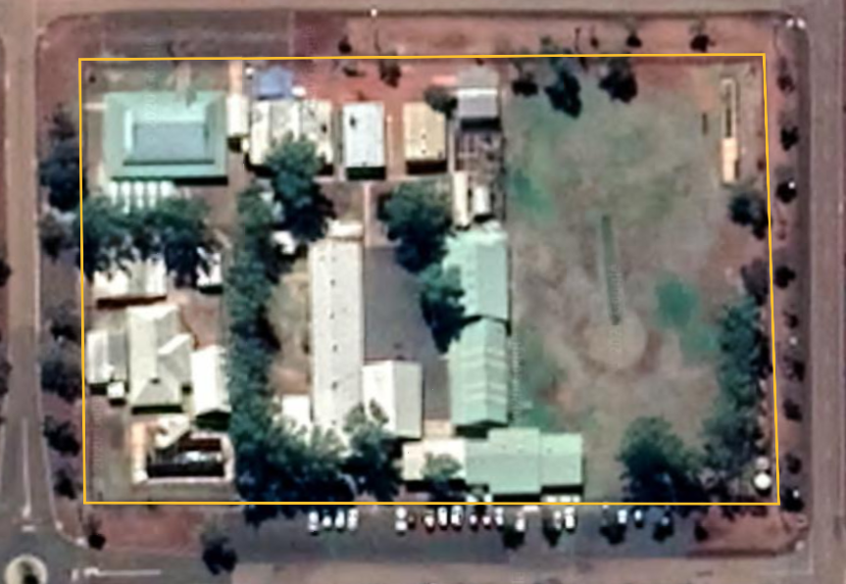
Imagery: Google, ©2021 CNES / Airbus, Maxar Technologies
Where could trees be planted to provide shade for students?
Place a stamp or sticker for new trees.
Imagery: Google, ©2021 CNES / Airbus, Maxar Technologies

