

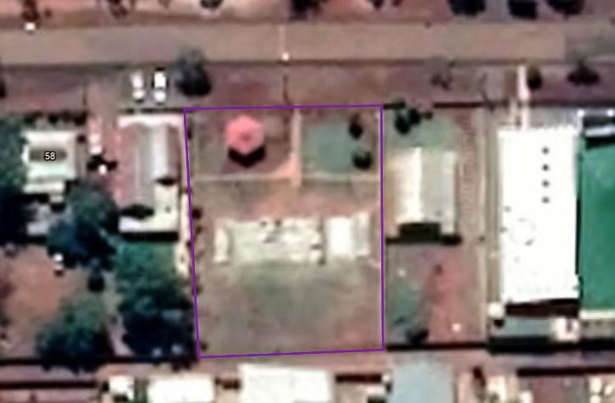
imagery: Google, ©2021 CNES / Airbus, Maxar Technologies

Leonora Skate Park

s are there?
• How many tree

Leonora Skate Park


are there?
• How many trees
imagery: Google, ©2021 CNES / Airbus, Maxar Technologies Tree images added using PowerPoint icons



Leonora Skate Park

plant trees?
• Where could we
imagery: Google, ©2021 CNES / Airbus, Maxar Technologies Tree images added using PowerPoint icons

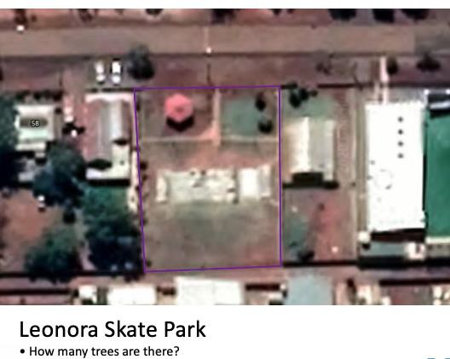
Step 1

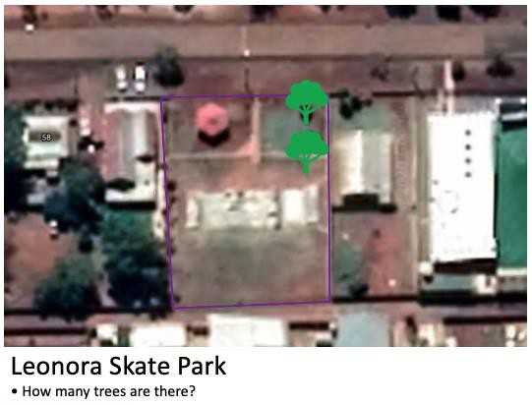
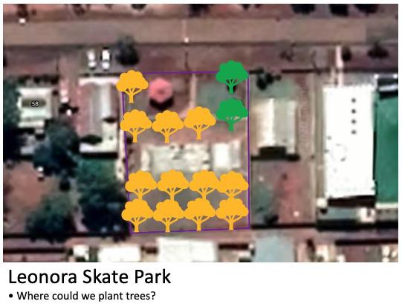
Step 2 Step 3

Maps – imagery: Google, ©2021 CNES / Airbus, Maxar Technologies
Tree images added using PowerPoint icons

