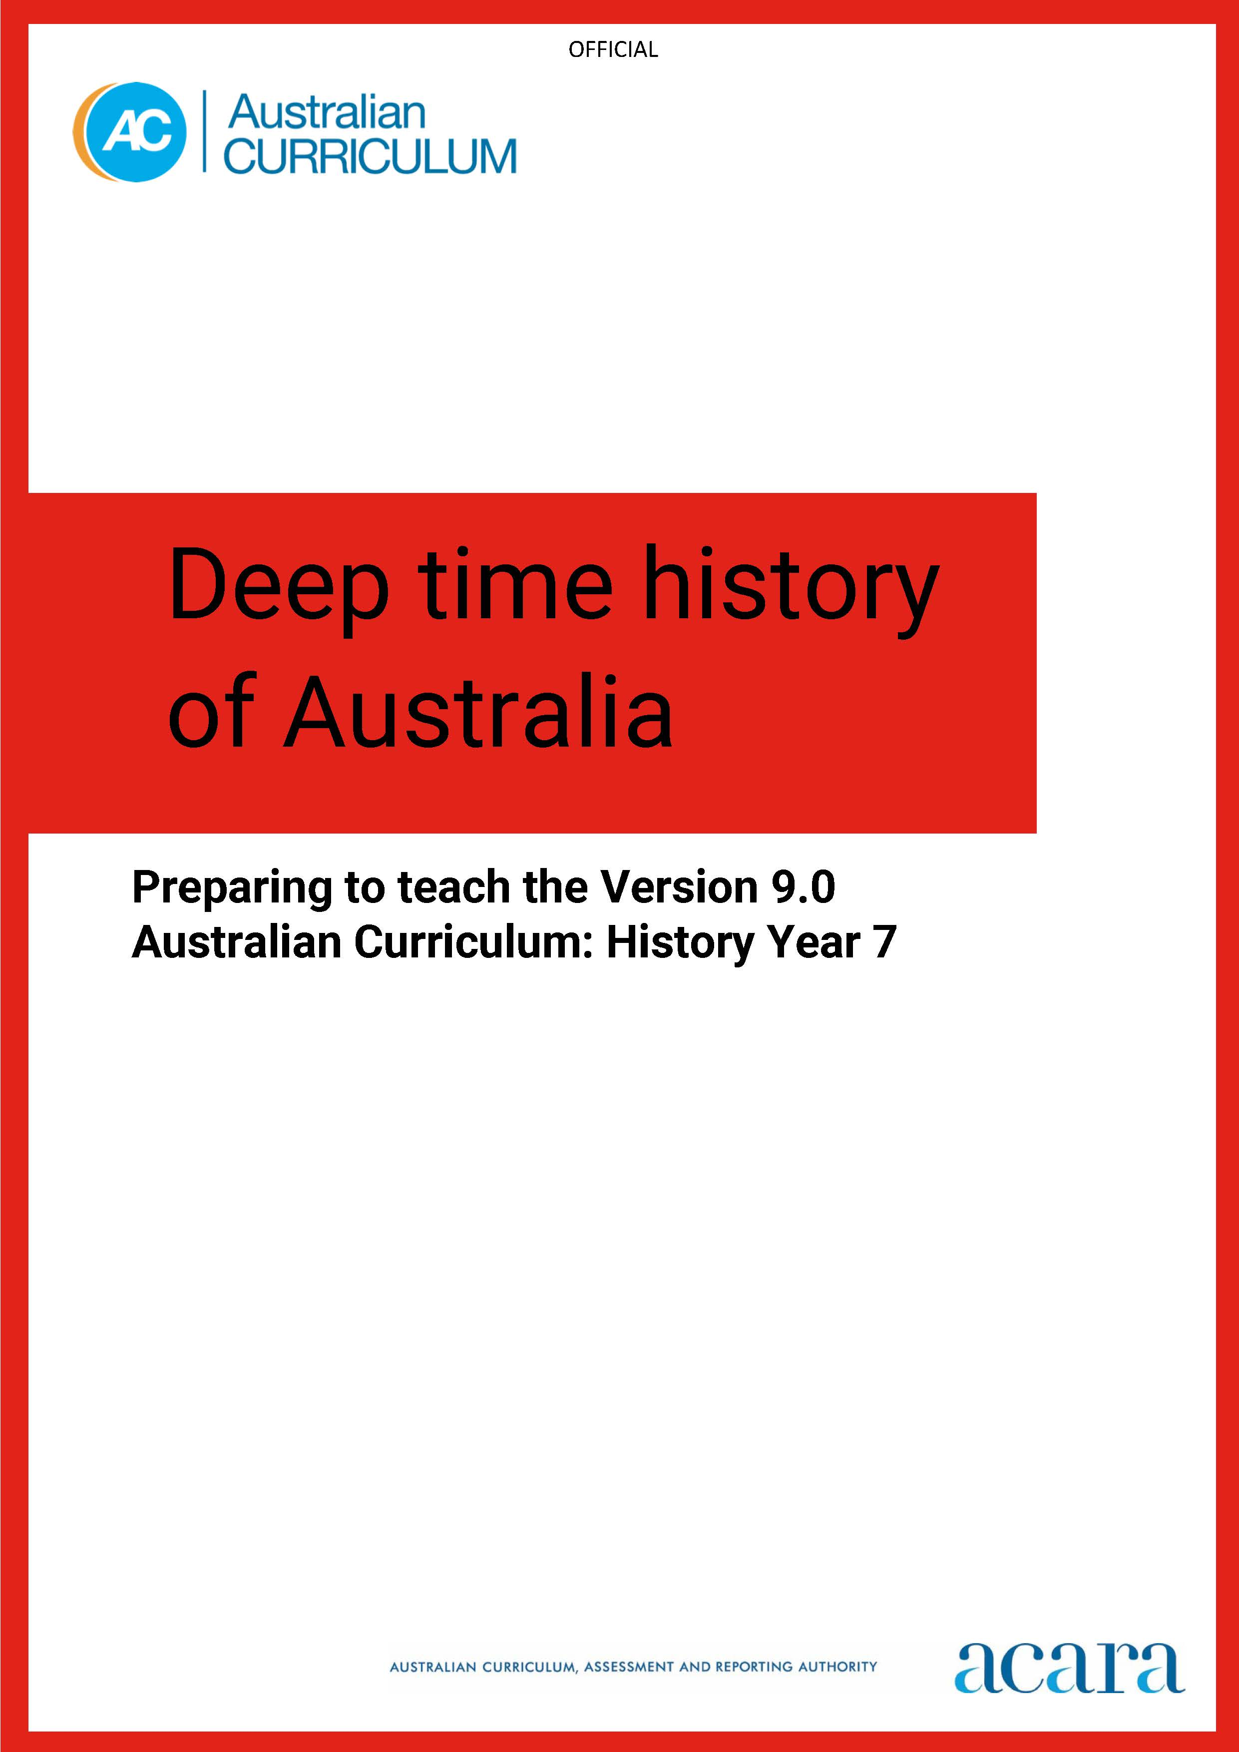

Preparing to teach the Version 9.0 Australian Curriculum: History FOR Year 7

Deep time history of Australia sub-strand

Purpose
The Version 9.0 Australian Curriculum: History for Year 7 includes the sub-strand Deep time history of Australia. This resource is designed to support teachers to develop their teaching and learning program to address the knowledge and understandings in the Deep time history of Australia sub-strand and the most relevant skills described in the Skills strand.
This resource should be seen as the starting point, acting as a stimulus to get you thinking about the curriculum content to be covered as you plan for implementation.
It is recognised that the best approach to developing your teaching and learning plan is to work with your local First Nations Peoples.

What is deep time history of Australia?
Deep time history is a study of early First Nations Peoples of Australia, a period defined by the development of cultural practices and organised societies. It is a framework to describe immense scales of geological time used by geologists, archaeologists and anthropologists to investigate the past lives of First Nations Peoples.
The Year 7 Deep time history of Australia sub-strand ensures that Aboriginal and Torres Strait Islander Peoples’ 65,000 years of connection to this place is taught to all young people.

Themes
This resource has been designed around 3 themes. These themes support teachers to organise the knowledge, understanding and skills described in the content descriptions and achievement standard into a coherent sequence of lessons.
The themes are:
- We are here – this examines the creation stories, and timelines of arrival and connection to locations across Sahul.
- We survive change – this examines the survival knowledges used to adjust and thrive during environmental changes happening over extensive timeframes.
- Our Cultures continue – this examines the ongoing use of technological and ecological knowledge systems.
Refer to Attachment 1, which maps the 3 themes against the 7 Knowledge and understanding content descriptions, the 3 most relevant Skills content descriptions and the related extracts from the achievement standard.

Teacher considerations
Teachers may experience some nervousness about teaching this content. Students have been taught about other ancient cultures in History for a long time, and teachers have been comfortable to cover this content. When teaching about deep time history of Australia, you are on the land that you are talking about and the First Nations Peoples of Australia are the longest living continuous culture in the world, so they are here. This presents many opportunities, but it also brings some additional responsibilities. Teachers need to be confident that what they are teaching is authentic. A significant consideration in teaching Deep time history of Australia is asking about how this information has been shared and passed down from one generation to the next.
The guide provides 2 clear ways to consider the knowledge systems (or knowledge to be shared):
- Cultural knowledge is the responsibility of the local Indigenous community knowledge custodians and it is therefore essential that, when covering this content, teachers are using materials endorsed by First Nations Peoples. Teachers can source this information from across various organisations and websites. It is the teacher’s responsibility to ask if there are local knowledges and voices to incorporate.
- Archaeological knowledge is also the responsibility of the local Indigenous community knowledge custodians. Teachers can access and examine the archaeological and scientific information from various organisations and websites. They should also check that this has endorsement of the local knowledge custodians.
This guide provides teachers with a curated list of resources that are developed and endorsed by First Nations Australians. This list is not exhaustive, and teachers are encouraged to source further resources appropriate to their location and context. There will be times when you may not be able to access local deep time histories and cultural knowledges. This resource provides several diverse examples from across Australia. You can implement these examples into your teaching unit. You can also share these examples with local First Nations community members to assist with building a relationship to learn and implement permissible local knowledges and stories. Strategies to authenticate resources such as websites and other sources will be provided in additional professional learning modules.
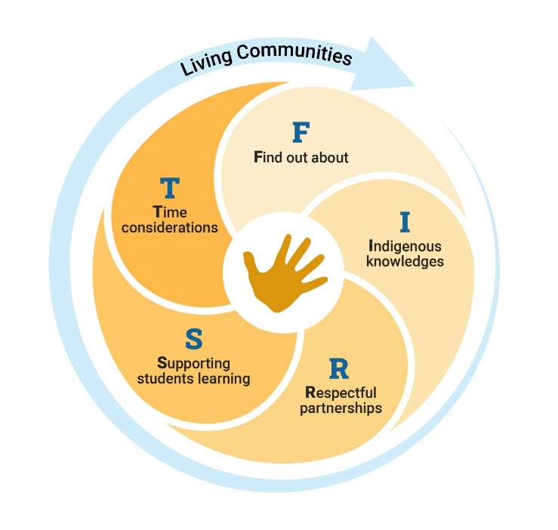
For more information about developing partnerships with local First Nations Australian community members, consider the FIRST Framework developed by ACARA. This Framework contains 5 stages and there are considerations for each stage:
F – Find out about
I – Indigenous knowledges and voices
R – Respectful partnerships
S – Supporting student learning
T – Time
The FIRST stages are not always sequential, but each does need to be considered. All good partnerships take time, but the rewards are many.
It is important to get started and acknowledge that you will continue to learn and grow in confidence as you develop stronger partnerships with the local First Nations community.

Using the information provided, and creating your teaching and learning program
Some teachers may be unsure where to start in developing a teaching and learning program for Deep time history of Australia. This guide provides an outline of things to consider when planning and highlights a wide range of freely available resources that could be used with students. These resources could also act as valuable background information for teachers, to support and extend understandings and help shape the next steps. Skills identified in this resource are not exhaustive but provide teachers with suggestions to consider when planning specifically for this content. You can address remaining skills content with other content in Year 7 Knowledge and understanding sub-strands.
These resources have been selected because they have been developed with or endorsed by First Nations Australians. Some teachers have expressed concern that they are not knowledgeable about the content, and that is exactly why this resource has been developed. There is a unique opportunity for teachers in delivering this content. You can connect your students with the longest living continuous cultures in the world – First Nations Australians – and students can learn knowledge that has been passed down thousands of generations and is still important today.
Teaching about Deep time history of Australia is best when it uses your local context. This is the ideal approach, but it does take time. If this is the first time an individual teacher or the school is reaching out to work with First Nations Australians in the local community, consider using the FIRST framework to develop a respectful reciprocal partnership with local Indigenous knowledge custodians. Be curious; step outside your comfort zone.

Considerations for planning and implementation
The following resources will support you to develop a deeper understanding of deep time history and to be confident when you plan and teach this content to students.
Year 7 History Deep time history of Australia themes
Considerations for planning and implementation of the theme “We are here”
Theme: We are here
This theme examines 2 areas:
- the cultural understanding of creation held by Aboriginal Peoples and Torres Strait Islander Peoples of Australia
- the archaeological knowledge about the arrival of Aboriginal Peoples and Torres Strait Islander Peoples on the continent.
Strand: Knowledge and understanding | Sub-strand: Deep time history of Australia
Achievement standard aspect  By the end of Year 7, students describe the historical significance of the ancient past and the histories of early First Nations Peoples of Australia.  Content descriptions  theories and historical interpretations about early human evolution and migration, such as the theory that people moved out of Africa and the causes of migration to other parts of the world, including Australia AC9HH7K01  theories about the causes and effects of the arrival of early First Nations Australians on the Australian continent and their migration routes across the continent AC9HH7K02 | Cultural considerations:  For many First Nations Peoples, creation stories explain how they were created by ancestral beings and/or formed on and by Country. Students can explore examples of creation stories from your local community.  Here are 2 examples from the Kulin nation in Victoria and the Torres Strait (Zenadth Kes) in Queensland, of how Aboriginal Peoples and Torres Strait Islander Peoples view their creation stories.  - In Victoria, the Kulin nation have the Bunjil creation story. In Kirrit Barrett – This Place, an ABC Indigenous video, Wadawurrung man Barry Gilson shares the story of Kirrit Barrett (or Black Hill). It explains how Bunjil created the first 2 humans in the Kulin nation.  - The stars of Tagai story tells the creation story and explores the ongoing connection to the land, sea and stars for Zenadth Kes people (Torres Strait Islanders). Read this synopsis of the Tagai story from the National Film and Sound Archive of Australia Mabo website. It provides a short overview of the Tagai story, which offers opportunities to learn more about the story of Tagai and Torres Strait Islander astronomy.  Archaeological considerations:  Another consideration is to examine the scientific knowledge about the theory of human evolution, the migration of people across the globe and the arrival of First Nations Peoples to the land mass that we now call Australia. Using this approach, students can explore archaeological sites across Australia.  - The ABC iView series called The Human Revolution provides evolutional evidence and migration theories. Episode 2 also describes the Mungo Woman and Man, telling the story of practice of cultural ceremonies for over 42,000 years.  - The National Museum of Australia provides resources about human evolution, the first migrations out of Africa and the journey across the Asian continent to Sahul (the landmass that consisted of mainland Australia and Tasmania, and New Guinea).
Strand: Skills | Sub-strand: Questioning and researching
Achievement standard aspect  By the end of Year 7, students develop questions about the past.  Content descriptions  develop historical questions about the past to inform historical inquiry AC9HH7S01 | Considerations  Work with students to develop questions about the cultural stories and archaeological information from local, state/ territory or national sites.

Year 7 History Deep time history of Australia themes
Considerations for planning and implementation of the theme “We survive change”
Theme: We survive change
This theme examines 2 areas:
- the survival knowledges systems used by First Nations Peoples to adjust and thrive during environmental changes happening over extensive timeframes.
- the scientific evidence that First Nations Peoples lived through environmental changes during the ice age and sea level changes.
Strand: Knowledge and understanding | Sub-strand: Deep time history of Australia
Achievement standard aspects  By the end of Year 7, students describe the historical significance of the ancient past and the histories of early First Nations Peoples of Australia.  They identify the causes and effects of events, developments and achievements connected to groups and individuals in Australia and other societies from the ancient past.  Content descriptions  how First Nations Australians are the world’s oldest continuing cultures, displaying evidence of both continuity and change over deep time AC9HH7K03  how First Nations Australians have responded to environmental processes and changes over time AC9HH7K04 | Cultural considerations:  For many First Nations Peoples, stories explain how they survive environmental change; for example, the ancient sea level changes, ice age periods, and other significant environmental and social changes.  The following stories provide students with examples of how First Nations Peoples view historical and environmental changes:  - Archaeologists Nunn and Reid (2015) share examples of Aboriginal and Torres Strait Islander oral histories and accounts of sea level changes. Examine the paper written by Nunn and Reid (2016) Aboriginal memories of coastal drowning and the Sea level presentation (P Nunn) to learn more about the oral histories accounts.  - Different communities use trade routes, technological tools and knowledge systems such as songlines to survive environmental changes, especially sea level changes, ice age adaptation, local calendar creations and harsh drought conditions.  - Learn about Songlines as navigational methods of remembering Country and in some cases survival knowledge. Watch the SBS Songlines on Screen to learn more about songlines. Various Nations used these to tell stories of connection to Country during drought and since the ice age. For example, studies of a remote island cave show how the coast was used at different sea levels. The importance of maintaining songlines is examined in the documentary What can we learn from Indigenous Australians and their 60,000 years caring for country?, which explains the importance of learning and passing on knowledge of resources, places and stories to others and future generations.  Archaeological considerations:  The scientific knowledge about sea level changes and the ice age on First Nations Australians is evident in various archaeological findings. These examples demonstrate the survival knowledge of First Nations Peoples in Sahul and across what is now called Australia.  - Explore the history of lutruwita and truwana (Tasmania) and its connection and separation to the mainland due to the impact of sea level changes.  - Explore the environmental changes at Lake Mungo (New South Wales) and the lifestyle of the community living near the ancient lake, including the footprints of people chasing prey here.  - Examine the National Museum of Australia’s (NMA) Digital Classroom resources about the environmental changes and their impact on Aboriginal and Torres Strait Islander Peoples. Visit the NMA classroom for more resources and learning activities.  - Fish traps and cultural burning archaeological sites provide evidence of developing systems, tools and structures to support survival amid environment challenges. These include, but are not limited to, examples of fish or eel traps (like Budj Bim) and cultural burning to care for Country.
Strand: Skills | Sub-strand: Questioning and researching
Achievement standard aspect  [Students] locate and identify primary and secondary sources as evidence in historical inquiry.  Content descriptions  locate and identify primary and secondary sources to use in historical inquiry AC9HH7S02 | Considerations  What evidence is used to locate and identify primary and secondary sources about Aboriginal and Torres Strait Islander knowledge systems?  How are cultural locations, objects and stories described and explained from a cultural and archaeological interpretation?  How do researchers consult with First Nations communities when working on Country/Place?  Who can we ask to find out what is allowed to be shared, discussed and presented and the required permission process?

Year 7 History Deep time history of Australia themes
Considerations for planning and implementation of the theme “Our Cultures continue”
Theme: Our Cultures continue
This theme examines:
- how First Nations Australians are the world’s oldest continuing cultures from evidence of the ongoing use of technological and ecological knowledge systems.
Strand: Knowledge and understanding | Sub-strand: Deep time history of Australia
Achievement standard aspect  [Students] sequence events and developments to describe causes and effects, and continuities and changes across societies and periods of time. They describe the perspectives, attitudes and values of the past in sources. They identify and describe historical interpretations about significant events and people.  Content descriptions  the technological achievements of early First Nations Australians, and how these developed in different places and contributed to daily life, and land and water source management AC9HH7K05  the social organisation and cultural practices of early First Nations Australians, and their continuity and change over time  AC9HH7K06  the cultural obligations of First Nations Australians about significant heritage sites, including ancestral remains, material culture and artefacts, and the role of collaboration between First Nations Australians and other individuals and groups to ensure cultural preservation  AC9HH7K07 | Cultural considerations:  For many First Nations Peoples, surviving environmental and other changes using connections to Country/Place and cultural tools ensures that knowledges are passed from one generation to the next. The cultural tools of songlines, oral and other methods of storytelling (painting, dancing, carvings, petroglyphs), astronomy, kinship systems and totems provide many ways to make certain knowledge is respected and transmitted across generations.  The following examples show students ways in which First Nations Peoples use cultural knowledge systems:  - Cultural burning practices or cool burning provide both methods of caring for Country and learning technological means of soil and habitat regeneration. Watch this video of cultural burning at Tathra, NSW to see how methods of cool burning are restoring the environment.  - Environmental management methods of caring for Country and Sea Country use songlines, stories and astronomical stories to transfer knowledge across generations. Read about Australia’s Aboriginal astronomers and the Torres Strait story of Tagai and the meaning of the constellation. In both examples, examine how the changes to the sky knowledge influence the practices of Aboriginal and Torres Strait Islander Peoples.  - The repatriation of ancestral remains, and secret/sacred objects and artefacts is an important value of caring for heritage and connection to culture. Learn more about repatriation of artefacts and Elders, and about objects yet to be returned.  Archaeological considerations:  The scientific knowledge from archaeological sites demonstrates the diversity of knowledge systems used across Aboriginal communities and Torres Strait Islander communities. Management of water and production of food are both important for survival but also for sustainable practices of caring for Country.  The following examples show students ways in which First Nations Peoples use various forms of managing water and Country:  - The Budj Bim fish traps and Brewarrina fish traps and surrounding cultural sites demonstrate ways that management of water, fish and eels were daily practices that sustained communities over many years. Other forms of fishing techniques were used as well.  - From Tasmania to the far north of Australia, coastal fish traps have been constructed to use the tidal system to catch fish and other marine animals. These sites were maintained over many generations, according to archaeological research.
Strand: Skills | Sub-strand: Historical perspectives and interpretations
Achievement standard aspects  [Students] sequence events and developments to describe causes and effects, and continuities and changes across societies and periods of time.  Content descriptions  describe causes and effects, and explain continuities and changes AC9HH7S05 | Considerations  Develop questions to discuss with First Nations Peoples about methods they use to share continuities and changes across societies (communities) and periods of time.  How do First Nations Peoples describe cultural practices, objects and stories? What are the different methods of passing this knowledge on to other generations?  How are these methods aligned with archaeological research?  How does intergenerational First Nations knowledge and archaeological research complement knowledge about continuities and changes in First Nation histories and cultures? Consider the causes and effects of these continuities and changes to First Nation Peoples over time.

Attachment 1

Year 7 History – Deep time history of Australia

ALIGNING THE cURRICULUM AND THE THEMES
Achievement standard aspects | Theme 1:  We are here | Theme 2:  We survive change | Theme 3:  Our cultures continue
Knowledge and understanding aspects
By the end of Year 7, students describe the historical significance of the ancient past and the histories of early First Nations Peoples of Australia. | ü | ü
They identify the causes and effects of events, developments and achievements connected to groups and individuals in Australia and other societies from the ancient past. |  | ü | ü
Students describe the social, religious, cultural, economic, environmental and/or political aspects related to changes and continuities in these societies. |  |  | ü
Students explain the importance of heritage sites connected to Australia and other societies from the ancient past. |  |  | ü
Skills aspects
By the end of Year 7, students develop questions about the past. | ü
They locate and identify primary and secondary sources as evidence in historical inquiry. |  | ü
They sequence events and developments to describe causes and effects, and continuities and changes across societies and periods of time. |  |  | ü

Content descriptions – related to this topic | Theme 1:  We are here | Theme 2:  We survive change | Theme 3:  Our cultures continue
Strand: Knowledge and understanding Sub-strand: Deep time history of Australia
theories and historical interpretations about early human evolution and migration, such as the theory that people moved out of Africa and the causes of migration to other parts of the world, including Australia AC9HH7K01 | ü
theories about the causes and effects of the arrival of early First Nations Australians on the Australian continent and their migration routes across the continent AC9HH7K02 | ü
how First Nations Australians are the world’s oldest continuing cultures, displaying evidence of both continuity and change over deep time AC9HH7K03 |  | ü
how First Nations Australians have responded to environmental processes and changes over time AC9HH7K04 |  | ü
the technological achievements of early First Nations Australians, and how these developed in different places and contributed to daily life, and land and water source management AC9HH7K05 |  |  | ü
the social organisation and cultural practices of early First Nations Australians, and their continuity and change over time AC9HH7K06 |  |  | ü
the cultural obligations of First Nations Australians about significant heritage sites, including ancestral remains, material culture and artefacts, and the role of collaboration between First Nations Australians and other individuals and groups to ensure cultural preservation AC9HH7K07 |  |  | ü
Skills strand
develop historical questions about the past to inform historical inquiry AC9HH7S01 | ü
locate and identify primary and secondary sources to use in historical inquiry AC9HH7S02 |  | ü
describe causes and effects, and explain continuities and changes AC9HH7S05 |  |  | ü

