Facilitator notes – Using the Australian Curriculum
This presentation provides an overview of the intent and structure of the Australian Curriculum. It will support school and curriculum leaders to identify opportunities to strengthen teacher capability and guide whole-school implementation of the Australian Curriculum.
The Reflect–Act–Evaluate cycle provides a framework through which participants can examine current approaches to curriculum implementation and plan for change.

Session objectives
- Share current knowledge and expertise of all parts of the curriculum.
- Identify opportunities to strengthen teacher knowledge and understanding of the Australian Curriculum.
- Collaborate on a whole-school approach to using the Australian Curriculum.

Considerations
- What good practices already exist in your school as part of planning using the Australian Curriculum?
- What are your priorities for change or improvement?

Pre-reading for facilitator
Review the:
- advice and downloads in the Using the Australian Curriculum aspect
- Planning, teaching, assessing and reporting page

Handouts for individuals
Personal reflection

Whole group recording documents
Using the Australian Curriculum: Planning for action

Slide 1: Instructions for facilitators  On screen  Instructions for facilitators  - Review the facilitator notes and make any necessary changes to the PowerPoint slides.    - Discussion points through the presentation will be identified using the icon. When planning the presentation, consider the timing of the whole presentation, including time required for discussions.  - This presentation uses 3 videos as stimulus for reflection and discussion. Consider the timing of these videos when planning the presentation.  - The three dimensions of the Australian Curriculum (5:08 minutes)  - General capabilities (4:24 minutes)  - Cross-curriculum priorities (3:33 minutes) | 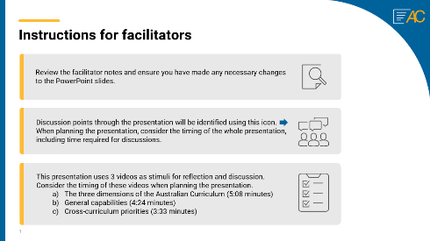
Slide 2: Title slide  On screen  Whole-school planning graphic: Using the Australian Curriculum  Speaker notes  This presentation is an overview of the Australian Curriculum learning areas, general capabilities and cross-curriculum priorities. | 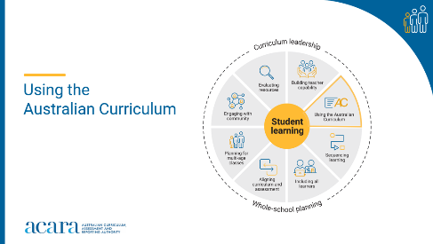
Slide 3: Outcomes  To prepare for this part of the presentation, review the text on screen and adapt for your school context.  On screen  By the end of this workshop, we will have:  - reflected on what we know about the Australian Curriculum  - identified how we are using all parts of the curriculum in planning  - proposed actions for change or improvement.  Speaker notes  Clarifying expected learning up front helps keep discussions focused and supports good decision-making. | 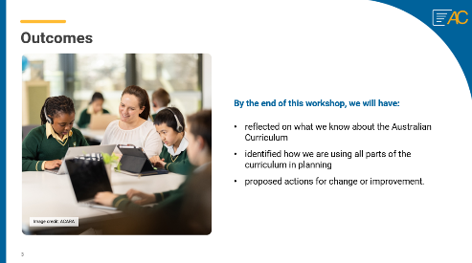
Slide 4: Reflect–Act–Evaluate  On screen  - Reflect: identify current practice and needs.  - Act: use insights from the reflect phase to determine actions to be taken.  - Evaluate: identify the measures for evaluation and schedule evaluation points.  Speaker notes  Explain to participants that the presentation will focus on the Reflect–Act–Evaluate cycle.  This is an opportunity for all participants to:  provide their insight into current practice  contribute to and enact whole-school plans  offer their observations and feedback in the evaluation process. | 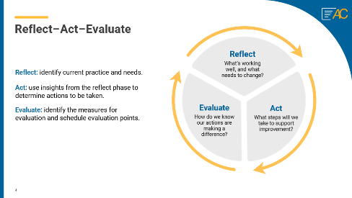
Slide 5: The Australian Curriculum  On screen  The three dimensions of the Australian Curriculum video  Speaker notes  The Australian Curriculum is 3-dimensional; it includes learning areas, general capabilities and cross-curriculum priorities. Together, these set out the essential knowledge, understanding and skills all young Australians need so they will be able to learn, contribute and shape their world now and in the future. | 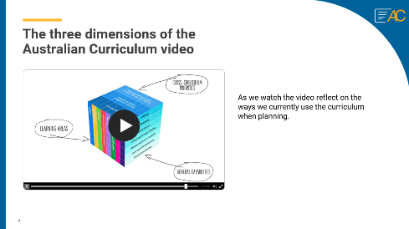

Slide 6: The Australian Curriculum  Think–Pair–Share  To prepare for this part of the presentation review the text on screen and adapt for your school context.  On screen  Prompts  - Reflect on the ways we use the curriculum and consider where we might like to improve our knowledge and expertise.  - How well does our current curriculum planning reflect the intent and structure of the Australian Curriculum?  Think–Pair–Share instructions  Speaker notes  After watching the Australian Curriculum video use the Think–Pair–Share activity to support participants to reflect on the ways they use the curriculum. Ask participants to consider where they might like to improve their curriculum knowledge and expertise.  Sharing may consist of only one idea or statement from each group for larger teams or using digital tools to record responses.  Activity  Think–Pair–Share: how to use it  Participants:  - Think independently about a prompt or problem.  - Pair up and discuss their ideas with a colleague.  - Share their ideas with the group. | 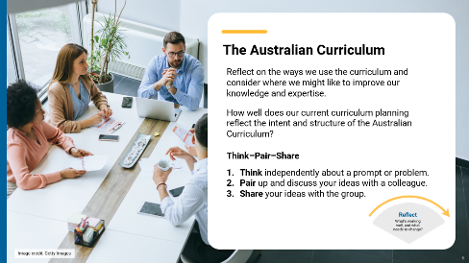

Slide 7: The learning areas  On screen  Curriculum elements graphic and activity instructions.  Speaker notes  Understanding the elements of the curriculum for each learning area and how they might be used effectively supports successful planning for teaching and learning.  - The description for each year level provides an overview of the learning students should experience.  - The achievement standards and content descriptions are the essential parts of the learning area curriculum and form the basis for teaching, learning and assessment.  - The content elaborations are optional suggestions and possible illustrations of ways the content descriptions might be taught.  Discussion  In small groups, discuss how each element currently influences the decision-making process when planning using the Australian Curriculum. | 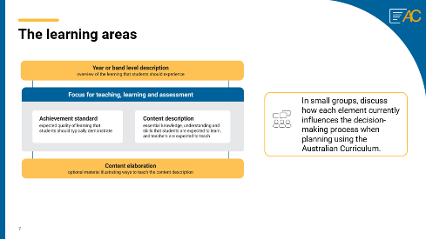
Slide 8: Understanding this learning area  To prepare for this part of the presentation, review and adapt the text on screen for your school context.  On screen  - How would you use the information in ‘Understand this learning area’ when planning for teaching and learning?  - How are your current teaching and learning programs delivering on the aims of the learning area?  Speaker notes  Participants read and reflect on the ‘Understand this learning area’ section for a familiar learning area. This information can be found when accessing the curriculum content for each learning area on the Australian Curriculum website.  Use the questions on screen or create your own to prompt discussion and reflection.  Discussion  Participants discuss their reflections in small groups, with an option to share their observations with the wider group. | 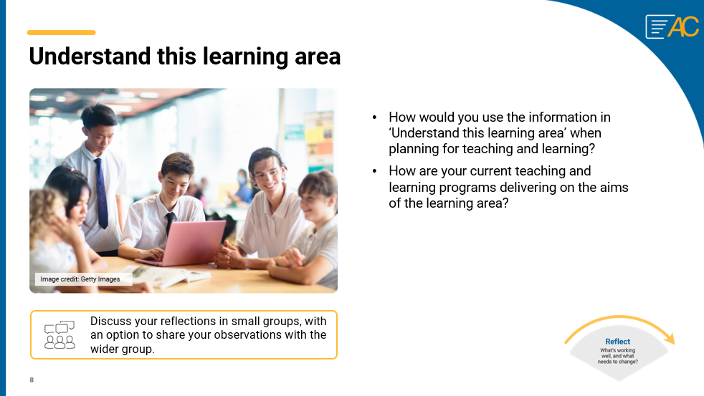
Slide 9: General capabilities video  On screen  General capabilities video link  Speaker notes  The general capabilities establish knowledge, skills, behaviours and dispositions that will support students to become lifelong learners who can effectively navigate the world of work and their future.  Participants watch the general capabilities video and consider the examples of the relationships and connections between the learning areas and the general capabilities provided in the video.  Duration: 4:24 minutes  This link will open in a separate browser.  Discussion  Encourage participants to suggest ways they might use the connections between the learning areas and the general capabilities when planning. | 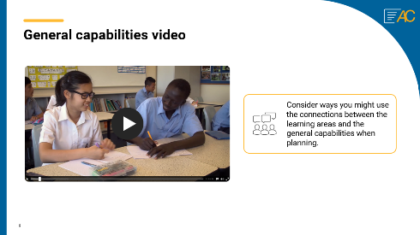
Slide 10: Cross-curriculum priorities video  On screen  Cross-curriculum priorities video link  Speaker notes  Cross-curriculum priorities support the Australian Curriculum to be a relevant, contemporary and engaging curriculum that reflects national, regional and global contexts.  Participants watch the cross-curriculum priorities video and consider the examples of the relationships and connections between the learning areas and the cross-curriculum priorities provided in the video.  Duration: 3:33 minutes  This link will open in a sperate browser.  Discussion  Encourage participants to suggest ways they might use the connections between the learning areas and the cross-curriculum priorities when planning. | 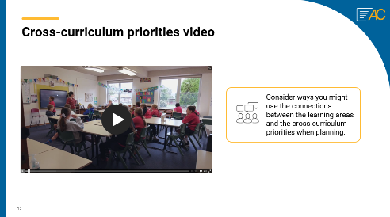
Slide 11: Planning for action  On screen  What are 3 actions that could improve the way we use the Australian Curriculum when planning?  Activity instructions  Speaker notes  This session will support participants to contribute to and collaborate on actions for change or improvement.  Provide participants with sticky notes to record their responses to the posed question.  After participants have had time to reflect and record their responses, review the suggestions and identify common themes or categories.  - Are there common ideas or approaches for improvement? What are they?  - How might the identified categories influence a whole-school approach to curriculum implementation?  Activity  Using the question on screen as a prompt  - Write one idea per sticky note.  - Ask participants to post their ideas on a large surface, like a wall or a board.  - Work in groups to sort ideas into categories of similar actions.  - Review the categories created. | 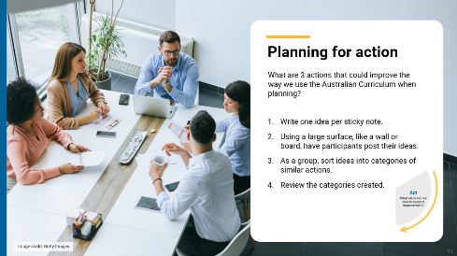

Slide 12: Prioritising actions  On screen  Dot voting instructions  Speaker notes  As a group, review and prioritise actions from the previous activity. Use the dot voting activity to ask participants to prioritise actions. Use the highest ranked actions as the basis for creating an action plan for your implementation approach.  Activity  Dot voting – How to use it:  Display the actions identified in the previous activity in an area accessible to participants. This may be on a wall or a table. Ask participants to indicate which action they would undertake by using dots to vote for their preferred options.  Participants indicate their preferences using dots:  - 3 dots for their 1st preference  - 2 dots for their 2nd preference  - 1 dot for their 3rd preference.  Note: Dots may be replaced with ticks or marks.  The activity could be varied so that participants add a sticky note to their preferred option with a concise explanation for why it is their preference. | 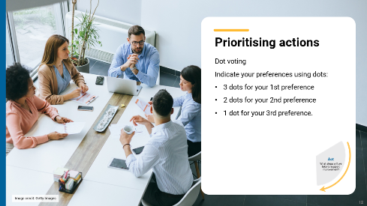
Slide 13: Action plan – actions, responsibilities and timelines  On screen  What actions will we implement?  Speaker notes  Use the prioritised actions from the previous activity to start planning the whole-school approach. Use existing planning documents or complete the relevant columns in the action plan to:  - describe what actions will be undertaken  - allocate responsibilities  - schedule actions over a specific timeframe  - identify what resources are needed.  Discussion  As a whole group, consider the priority actions. Allocate roles through self-nomination or distribution of activities to teams within the school. Support participants to discuss the timing of each action with consideration of existing commitments.  Consider how other priorities might also be included in the plan. | 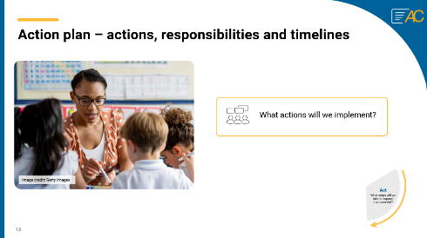
Slide 14: Action Plan – evidence and evaluation  On screen  How will we reflect on our approach and evaluate its effectiveness over time?  Think–Pair–Share instructions  Speaker notes  Use the Think–Pair–Share activity to support participants to contribute to the evaluation planning process.  Use the Action planning document to describe:  - what success will look like  - what evidence will need to be gathered  - what the review and evaluation cycle will look like in your school.  Activity  Think–Pair–Share: how to use it  Participants:  - Think independently about a prompt or problem.  - Pair up and discuss their ideas with a colleague.  - Share their ideas with the group.  Once sharing has been completed, use contributions to record evaluation approaches in the action plan. Consider what resources will be used as you put the plan into action and record. | 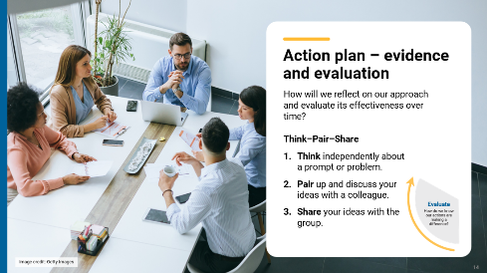
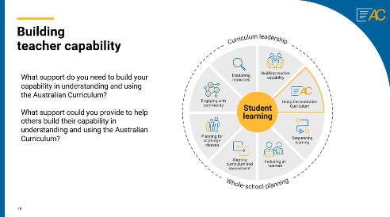
Slide 15: Building teacher capability – personal reflection

On screen

Whole-school planning graphic: Using the Australian Curriculum

What support do you need to build your capability in understanding and using the Australian Curriculum? ​

What support could you provide to help others build their capability in understanding and using the Australian Curriculum?

Speaker notes
When planning to implement the curriculum, it is important to consider how all aspects of curriculum implementation are interconnected and what support teachers need.
Reflection
Ask participants to reflect on the information provided in the session and identify their strengths and areas where they need additional support. These reflections may form part of discussions with team leaders on individual goal setting. They can support identifying areas that may be the focus for future professional learning.
Slide 16: Thank you  On screen  For more resources visit the Resources page on the Australian Curriculum website.  ACARA uses images sourced under licence from third parties. It is a condition of access to this presentation that you do not allow for any party to copy, in whole or in part any image from this presentation. For all other copyright enquiries contact ACARA through the online enquiry form and select ‘copyright’. | 

