Facilitator notes – Sequencing learning
This presentation provides an overview of a whole-school approach to sequencing learning. It will support school and curriculum leaders to identify opportunities to strengthen teacher capability and guide whole-school implementation of the Australian Curriculum.
The Reflect–Act–Evaluate cycle provides a framework through which participants can examine current approaches to curriculum implementation and plan for change.

Session objectives
- Reflect on current approaches to sequencing learning within and across learning areas.
- Consider a whole-school approach to sequencing learning.
- Propose actions for change or improvement.

Considerations
- What existing good practices exist in relation to sequencing learning in and across learning areas?
- Are current approaches undertaken by individuals or is there a coordinated whole-school approach?
- What are our priorities for change or improvement?

Pre-reading for facilitator
Review the advice and downloads in the Sequencing learning aspect.

Handouts for individuals
Sequencing learning reflection
A whole-school approach to sequencing learning

Whole group recording documents
Sequencing learning: Planning for action

Slide 1: Instructions for facilitators  On screen  Instructions for facilitators  - Review the facilitator notes and ensure you have made any necessary changes to the PowerPoint slides.    - Discussion points through the presentation will be identified using the icon. When planning the presentation, consider time required for discussions and the timing of the whole presentation.  - This presentation includes a review of a whole-school approach to sequencing learning. Consider whether the participants may need the information to review before the presentation, as it includes advice and resources developed by AITSL and AERO. | 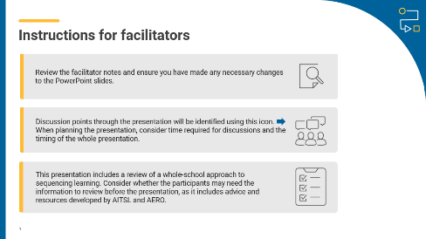
Slide 2: Title slide  On screen  Whole-school planning graphic: Sequencing learning | 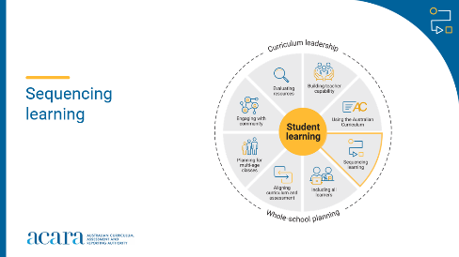
Slide 3: Outcomes  To prepare for this part of the presentation review the text on screen and adjust or adapt for your school context  On screen  By the end of this workshop, we will be able to:  - reflect on current approaches to sequencing learning within and across learning areas  - consider a whole-school approach to sequencing learning  - propose actions for change or improvement.  Speaker notes  Clarifying expected learning up front helps keep discussions focused and supports good decision-making. | 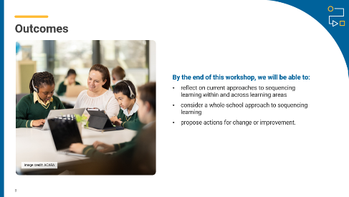
Slide 4: Reflect–Act–Evaluate  On screen  - Reflect: identify current practice and needs.  - Act: use insights from the reflect phase to determine actions to be taken.  - Evaluate: identify the measures for evaluation and schedule evaluation points.  Speaker notes  Explain to participants that the presentation will focus on the Reflect–Act–Evaluate cycle.  This is an opportunity for all participants to:  - provide their insight into current practice  - contribute to and enact whole-school plans  - offer their observations and feedback in the evaluation process. | 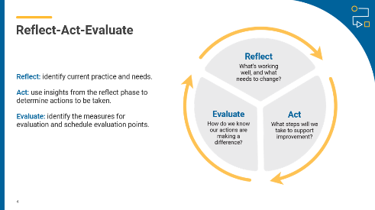
Slide 5: Sequencing learning  On screen  What does the effective sequencing of learning look like at our school?  Do we review yearly learning sequences by considering:  - the aims of each learning area  - why certain content is taught at specific times  - how different learning areas or subjects connect  - where the order is essential and where flexibility is possible?  Activity instructions  Speaker notes  Support participants to reflect on current approaches to sequencing learning. When reviewing responses, consider if any common challenges or strengths have been identified by the group.  Note: to prepare for this activity, select a question to be displayed on screen or create a question as a focus for reflection on current practice. Examples have been provided.  Activity  Popcorn: how to use it  A fast-paced group strategy where everyone contributes ideas aloud in real time.  - Present a problem or question.  - Give a minute for silent reflection.  - Invite participants to share (one at a time) while 1 or 2 people record.  - Stop when ideas slow down, then review and discuss.  - Review responses as a whole group to identify themes.  Note: to prepare for this activity, select a question to be displayed on screen or create a question as a focus for reflection on current practice. Examples have been provided. | 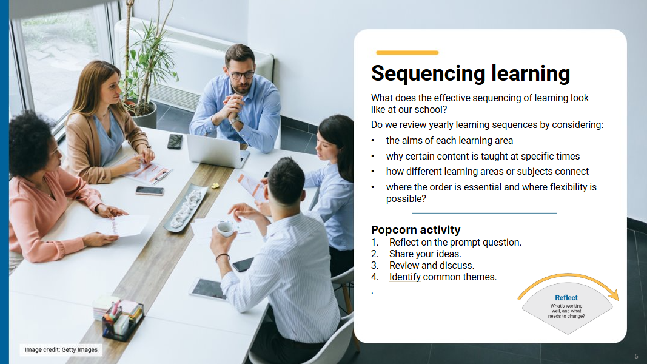

Slide 6: A whole-school approach to sequencing learning  On screen  Activity instructions  Speaker notes  In pairs or small groups, ask participants to review the “Whole-school approach to sequencing learning”. As they make their way through the material, ask them to use the compass points prompts to record their thinking or discussions. Allow 20–30 minutes for review and discussion as the process includes links to resources and advice developed by AITSL and AERO.  Bring the group back together and work through each compass point, encouraging participants to share their observations and discussions. Record observations in a shared space where all participants can review and reflect on common ideas and themes.  Activity  Compass points: how to use it  - E = Excited  What excites you about this idea or propositions? What’s the upside?  - W = Worrisome  What do you find worrisome about this idea or proposition? What’s the downside?  - N = Need to know  What else do you need to know or find out about this idea or proposition? What additional information would help you to evaluate things?  - S = Stance or Suggestion for moving forward  What is your current stance or opinion on the idea or proposition? How might you move forward in your evaluation of this idea or proposition?  A thinking routine from Project Zero, Harvard Graduate School of Education | 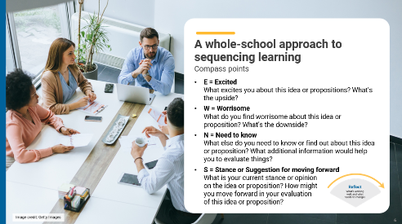

Slide 7: Prioritising actions  On screen  What are 3 actions that could improve the way we sequence learning across the school?  Activity instructions  Speaker notes  Use the diamond 9 activity to support participants to identify and prioritise actions. Use the highest ranked actions as the basis for creating an action plan for your implementation approach.  Activity  Using the Diamond 9 approach, provide participants with opportunities to share their individual ideas. Group common ideas to prioritise actions.  Diamond 9: how to use it  - Individual brainstorm: each participant writes down their priorities or solutions on sticky notes. Optional: use different coloured sticky notes to show levels of priority.  - Group sharing: place all sticky notes on a wall or table so everyone can see them. This allows for easy comparison and discussion.  - Theme and merge: as a group, sort the sticky notes into themes by grouping similar ideas. Blend overlapping ideas into shared statements.  - Rank the themes: use the Diamond 9 layout  Top row (3) – highest priorities  Middle row (3) – medium priorities  Bottom row (3) – lower priorities  Discuss and agree on placement as a group.  Curriculum design toolkit activity from Education Scotland | 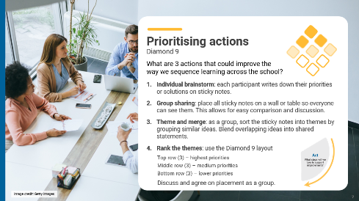

Slide 8: Action plan – actions, responsibilities and timelines  On screen  What actions will we implement?  Speaker notes  Use the prioritised actions from the previous activity to start planning the whole-school approach. Use existing planning documents or complete the relevant columns in the action plan to:  - describe what actions will be undertaken  - allocate responsibilities  - schedule actions over a specific timeframe  - identify what resources are needed.  Discussion  As a whole group, consider the top priority actions. Allocate roles through self-nomination or allocation of activities to teams within the school. Support participants to discuss the timing of each action with consideration of existing commitments. Consider how other priorities identified might also be included in the plan. | 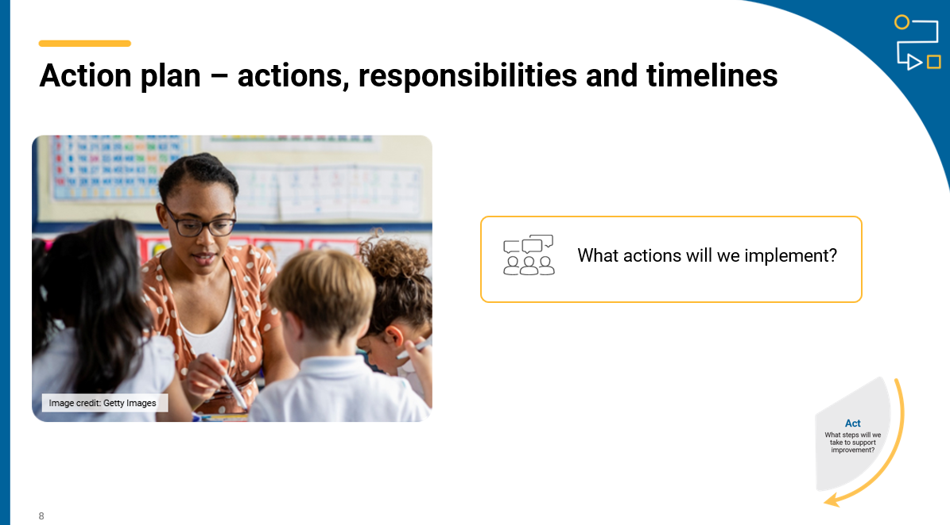
Slide 9: Action plan - evidence and evaluation  On screen  How will we reflect on our approach and evaluate its effectiveness over time?  Think-Pair-Share instructions  Speaker notes  Use the Think–Pair–Share activity to support participants to contribute to the evaluation planning process.  Use the Action planning document to describe:  - what success will look like  - what evidence will need to be gathered  - what the review and evaluation cycle will look like in your school.  Activity  Think–Pair–Share: how to use it  - Participants think independently about a prompt or problem.  - Participants pair up and discuss their ideas with a colleague.  - Participants share their ideas with the group.  Once sharing has been completed, use contributions to record evaluation approaches in the action plan. Consider what resources will be used as you put the plan into action and record. | 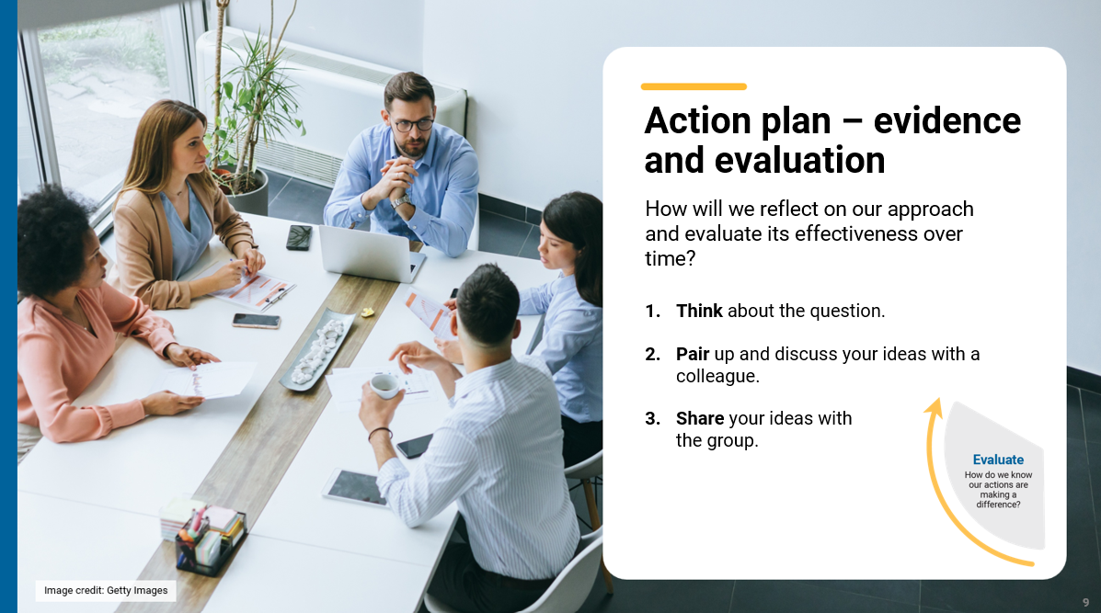
Slide 10: Building teacher capability - personal reflection  On screen  Whole-school planning graphic: Using the Australian Curriculum  What support do you need to build your capability when sequencing learning? ​  What support could you provide to help others build their capability when sequencing learning?  Speaker notes  When planning to implement the curriculum, it is important to consider how all aspects of curriculum implementation are interconnected and what support teachers need.  Reflection  Ask participants to reflect on the information provided in the session and identify their strengths and areas where they need additional support. These reflections may form part of discussions with team leaders on individual goal setting. They can support identifying areas that may be the focus for future professional learning. | 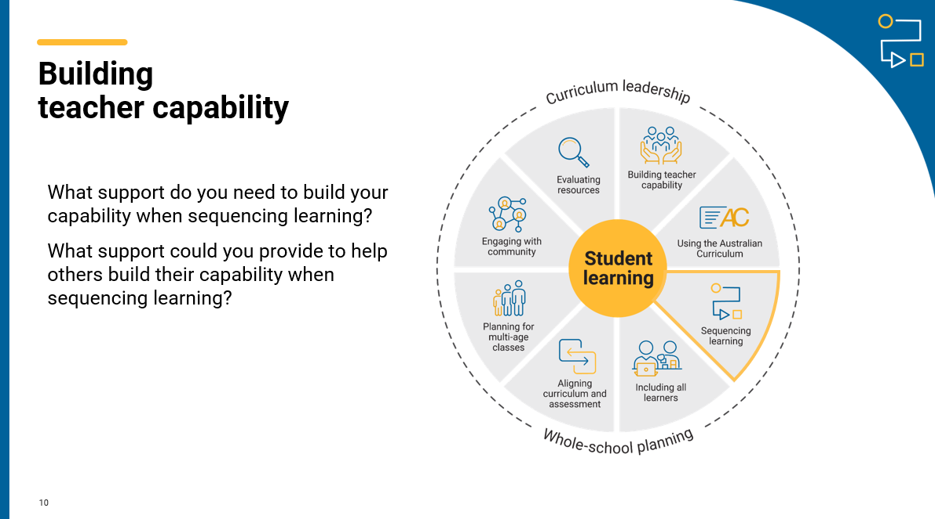
Slide 11: Thank you  On screen  For more resources visit the Resources page on the Australian Curriculum website.  ACARA uses images sourced under licence from third parties. It is a condition of access to this presentation that you do not allow for any party to copy, in whole or in part any image from this presentation. For all other copyright enquiries contact ACARA through the online enquiry form and select ‘copyright’. | 

