Facilitator notes – Planning for multi-age classes
This presentation provides an overview of approaches to planning for multi-age classes. It will support school and curriculum leaders to identify opportunities to strengthen teacher capability and guide whole-school implementation of the Australian Curriculum.
The Reflect–Act–Evaluate cycle provides a framework through which participants can examine current approaches to curriculum implementation and plan for change.

Session objectives
- Deepen understanding of 3 models of curriculum planning for multi-age classes.
- Determine how to plan for multi-age classes within your school context.
- Collaborate on a whole-school approach to planning for multi-age classes.
- Identify opportunities to strengthen teacher knowledge and understanding of effective approaches to planning for multi-age classes.

Considerations
- What is our whole-school approach to curriculum implementation?
- Which multi-age model/s best suit our school?
- What are our priorities for change or improvement?

Pre-reading for facilitator
Review the:
- advice and downloads in the Planning for multi-age classes aspect
- Planning for multi-age classes research summary
- Process for whole-school curriculum planning for multi-age classes.

Handouts for individuals

Overview of curriculum planning models for multi-age classes

Forth Primary School whole-school curriculum planning A/B model

Process for whole-school curriculum planning for multi-age classes.

Planning for multi-age classes reflection

Whole group recording documents
Planning for multi-age classes

Slide 1: Instructions for facilitators  On screen  Instructions for facilitators  - Review the facilitator notes and make any necessary changes to the PowerPoint slides.    - Discussion points through the presentation will be identified using the icon. When planning the presentation, consider the timing of the whole presentation, including time for discussions.  - Prepare participants by having them review the Process for whole-school curriculum planning for multi-age classes. | 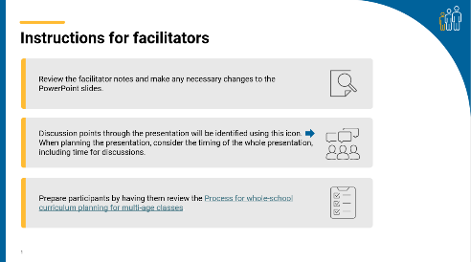
Slide 2: Title slide  On screen  Whole-school planning graphic: Planning for multi-age classes  Speaker notes  This presentation is an overview of 3 models of whole-school curriculum planning for multi-age classes. | 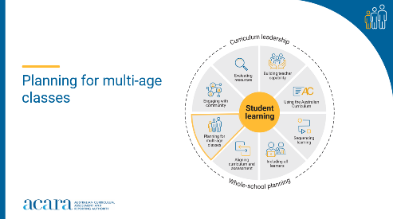
Slide 3: Outcomes  To prepare for this part of the presentation, review and adapt the text on screen for your school context.  On screen  By the end of this workshop, we will have:  - deepened our knowledge of 3 models of curriculum planning in multi-age classes  - identified the multi-age planning model that we will implement or the multi-age curriculum planning model currently in use  - proposed actions for change or improvement.  Speaker notes  Clarifying expected learning up front helps keep discussions focused and supports good decision-making. | 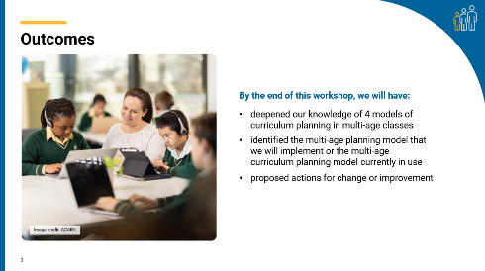
Slide 4: Reflect–Act–Evaluate  On screen  - Reflect: identify current practice and needs.  - Act: use insights from the reflect phase to determine actions to be taken.  - Evaluate: identify the measures for evaluation and schedule evaluation points.  Speaker notes  Explain to participants that the presentation will focus on the Reflect–Act–Evaluate cycle.  This is an opportunity for all participants to:  - provide insight into their current practice  - contribute to and enact whole-school plans  - offer their observations and feedback during the evaluation process. | 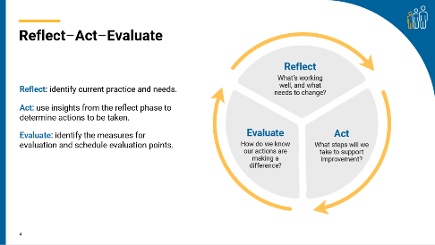
Slide 5: Reflect and share  To prepare for this activity, select a question to be displayed on screen or create a question as a focus for reflection on your current practice.  On screen  - What’s one thing you enjoy about and/or see as a positive of multi-age teaching?  - What’s one thing our school does well within multi-age classrooms?  Speaker notes  Support participants to reflect on the benefits of multi-age classes in your context. Use the popcorn activity or a similar strategy to encourage participants to share ideas.  Activity  Popcorn – How to use it:  A fast-paced group strategy where everyone contributes ideas aloud in real time.  - Present a problem or question.  - Give a minute for silent reflection.  - Invite participants to share (one at a time) while 1 or 2 people record.  - Stop when ideas slow down, then review and discuss.  - Review responses as a whole group to identify themes. | 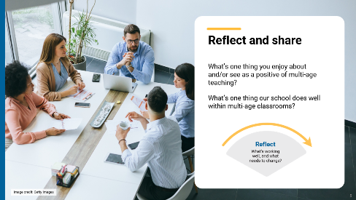
Slide 6: Multi-age models  On screen  3 models of curriculum planning for multi-age classes  - Conceptual threads model  - A/B model  - Split model  Speaker notes  Handout: Overview of curriculum planning models for multi-age classes  Planning for multi-age classes is complex. There are several approaches a school can take to implement the Australian Curriculum in a multi-age context. These are proposed as models for curriculum planning and implementation.  Discussion  As you work through the next 3 slides, ask participants to identify approaches that are used in your context. There may be more than one model that is used, so it may be appropriate to identify more than one option. Ask participants to reflect at the end of each model on whether this is a current practice, one they would like to explore further or one that is not suitable for your context. Encourage participants to use the handout to make notes or jot down ideas to share. | 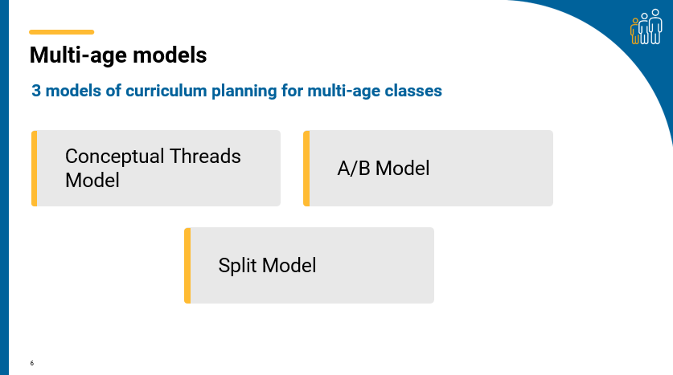
Slide 7: Conceptual threads model video  On screen  Conceptual threads model video link  Duration: 5:28 minutes  This link will open in a separate browser.  Speaker notes  Before presenting, review conceptual threads model information in the Planning for multi-age classes aspect.  The term “conceptual threads” identifies the clear statements that show how concepts within the Australian Curriculum are connected across multiple year levels in a specific learning area. Conceptual threads are like bridges that connect concepts from a learning area across different year levels, making learning more coherent and meaningful.  Discussion  As participants watch the video, ask them to note down what they consider to be the benefits of this approach and what they would need to consider if implementing this approach in their context. In small groups, discuss observations and reflections on existing practice or make notes on the overview document. | 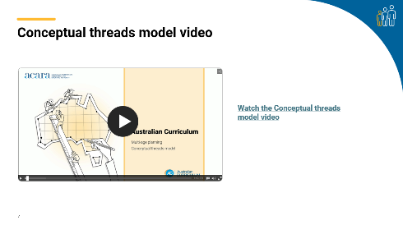
Slide 8: A/B model  On screen  The A/B model considers all learning areas, and content is taught and assessed over a 2-year cycle.  Speaker notes  Before presenting, review the A/B model information in the Planning for multi-age classes aspect.  This model teaches learning areas over a 2-year period. Three key identifying features are presented.  - Achievement standards and associated content descriptions are grouped together, taught and assessed across this 2-year span.  - Sequencing of the curriculum is essential – content and skills are presented in a carefully structured order that connects to and builds upon what students have already learnt. Refer to the Sequencing learning aspect for further guidance on approaches to sequencing learning.  - Health and Physical Education, The Arts, Technologies and Languages are organised into 2-year band levels from Year 1 to Year 10, supporting the A/B model.  Discussion  Handout: Example whole-school curriculum planning A/B model – Forth Primary School  Review the plan in small groups. Discuss the features of this model and how it might apply in your setting. Have participants share observations and reflections on existing practice or make notes on the overview document. | 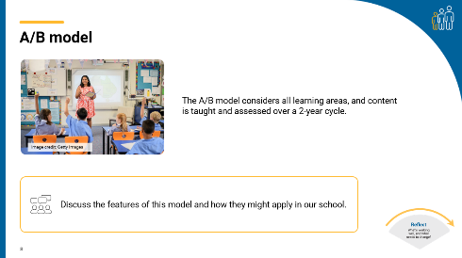

Slide 9: Split models  On screen  Multi-age classes – Split models graphic  Speaker notes  Before presenting, review the split model information in the Planning for multi-age classes aspect. Explain the split model approach to the group.  There are 2 examples to be considered:  - split model: English/Mathematics  - split model: Science/HASS.  Students are grouped separately depending on the focus learning areas in the split model approach selected.  Split model: English/Mathematics  In the split model English/Mathematics, students are grouped separately for English and Mathematics based on their enrolled year level. During these dedicated blocks, students are taught English and Mathematics in year level groups. Science and HASS are taught within multi-age classes.  Split model: Science/HASS  In the split model Science/HASS, students are grouped separately for Science and HASS based on their enrolled year level. During these dedicated blocks, students are taught Science and HASS in year level groups. English and Mathematics are taught within multi-age classes.  The split model can be effectively combined with the conceptual threads and A/B models.  Discussion  In small groups, participants discuss this approach and identify the benefits and challenges of implementing this model in your school. Ask participants to share back discussion points or make notes on the overview document from the previous activity.  Optional: Use a PMI chart or similar template to support participants to record their thinking. | 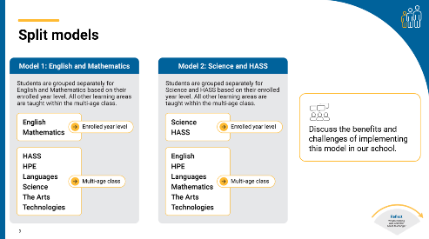
Slide 10: Process for whole-school curriculum planning for multi-age classes  On screen  - Pre-planning  - Using the achievement standards  - Using the content descriptions  - Sequencing learning  - Aligning curriculum and assessment  - Reflecting and evaluating  Speaker notes  Ask participants to consider the steps outlined in the process for whole-school curriculum planning for multi-age classes and identify where practices described in the document already exist within the school. This reflection will assist in preparing participants with ideas and suggestions for the action planning activities.  Handout  Process for whole-school curriculum planning for multi-age classes.  Discussion  Ask participants to consider if there are any areas of school practice that might be refined. Invite participants to share their ideas with the broader group. | 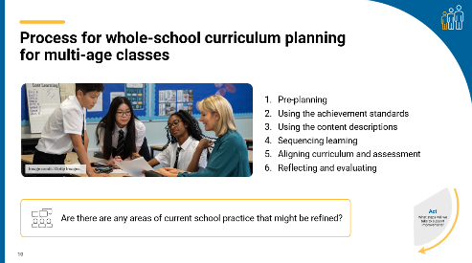
Slide 11: Current approach  On screen  Which model might best fit our school’s needs and context?  Speaker notes  Multi-age classrooms are complex and require careful consideration of the curriculum when planning. Reflecting on current practice and proposed models will enable participants to identify their strengths and areas that may need attention when implementing the Australian Curriculum in a multi-age setting.  Discussion  Ask participants discuss their notes or reflections on each model in small groups. Each group then identifies the model or models they feel would be most effective in your school. Each group provides 2 reasons they feel the selected model/s would be the most effective and presents their thinking back to the whole group.  As a whole group, discuss the ideas presented and reach consensus on a model or models that will be the focus for implementation. If the model identified is currently in place, consider where further refinements to current practice could be used. | 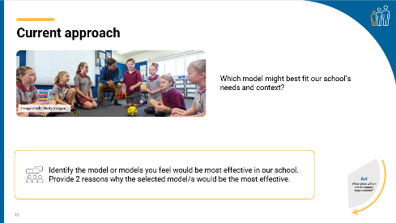
Slide 12: Planning for action  To prepare for this activity, select a question to be displayed on screen or create a question suitable for your school context.  On screen  - How will we ensure multi-age classes cover the curriculum without gaps or unnecessary repetition?  - How will we design effective learning sequences for multi-age classes?  - How will we ensure our approaches to assessment are aligned to the curriculum?  - How will we record whole-school planning using our chosen model?  Speaker notes  Provide participants with sticky notes to record their responses to the posed question.  After participants have had time to reflect and record their responses, review the suggestions and identify common themes or categories.  - Are there common ideas or approaches for improvement? What are they?  - How might the identified categories influence a whole-school approach to curriculum implementation?  Activity  - Write one idea per sticky note.  - Using a large surface, like a wall or board, have participants post their ideas.  - As a group, sort ideas into categories of similar actions.  - Review the categories created. | 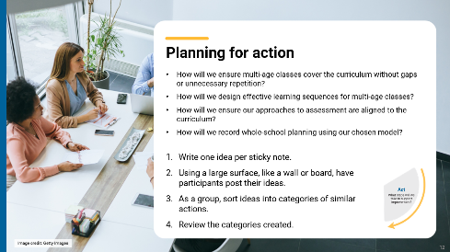

Slide 13: Prioritising actions  On screen  Dot voting instructions  Speaker notes  As a group, review and prioritise actions from the previous activity. Use the dot voting activity to support participants to prioritise actions. Use the highest ranked actions as the basis for creating an action plan for your implementation approach.  Activity  Dot voting – How to use it:  Display the actions identified in the previous activity in an area accessible to participants. This may be on a wall or a table. Ask participants to indicate which action they would undertake by using dots to vote for their preferred options.  Participants indicate their preferences using dots:  - 3 dots for their 1st preference  - 2 dots for their 2nd preference  - 1 dot for their 3rd preference.  Note: Dots may be replaced with ticks or marks.  The activity could be varied so that participants add a sticky note to their preferred option with a concise explanation for why it is their preference. | 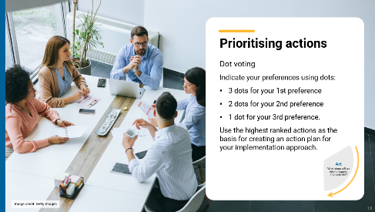
Slide 14: Action plan – actions, responsibilities and timelines  On screen  What actions will we implement?  Speakers’ notes  Use the prioritised actions from the previous activity to start planning the whole-school approach. Use existing planning documents or complete the relevant columns in the action plan provided to:  - describe what actions will be undertaken  - allocate responsibilities  - schedule actions over a specific timeframe  - identify what resources are needed.  Discussion  As a group, consider the priority actions. Allocate roles through self-nomination or allocation of activities to teams within the school. Support participants to discuss the timing of each action with consideration of existing commitments. Consider how other priorities might also be included in the plan. | 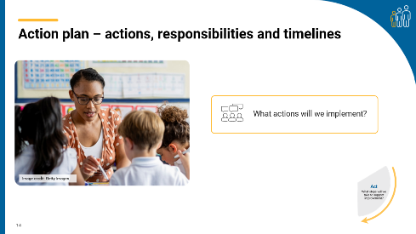
Slide 15: Action plan – evidence and evaluation  On screen  How will we reflect on our approach and evaluate its effectiveness over time?  Think–Pair–Share instructions  Speaker notes  Use the Think–Pair–Share activity to support participants to contribute to the evaluation planning process.  Use the Action planning document to describe:  - what success will look like  - what evidence will need to be gathered  - what the review and evaluation cycle will look like in your school.  Activity  Think–Pair–Share: how to use it  Participants:  - Think independently about a prompt or problem.  - Pair up and discuss their ideas with a colleague.  - Share their ideas with the group.  Consider what resources will be used as you put the plan into action and record. | 

Slide 16: Building teacher capability – personal reflection  On screen  Whole-school planning graphic: Planning for multi-age classes  What support do you need to build your capability in planning for multi-age classes? ​  What support could you provide to help others build their capability in planning for multi-age classes?  Speaker notes  Teachers’ individual and collective capability is key to a successful whole-school approach to curriculum implementation. When planning to implement the curriculum, it is important to consider how all aspects of curriculum implementation are interconnected and what support teachers need.  Handout  Reflection record  Reflection  Ask participants to reflect on the information provided in the session and identify their strengths and areas where they need additional support.  These reflections may form part of discussions with team leaders on individual goal setting. They can support identifying areas that may be the focus for future professional learning. | 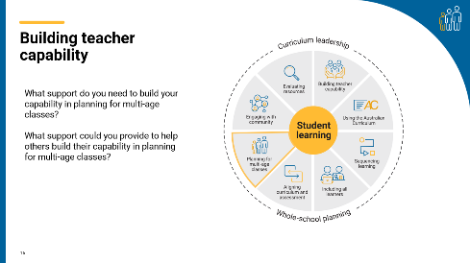
Slide 17: Thank you  On screen  For more resources visit the Resources page on the Australian Curriculum website.  ACARA uses images sourced under licence from third parties. It is a condition of access to this presentation that you do not allow for any party to copy, in whole or in part any image from this presentation. For all other copyright enquiries contact ACARA through the online enquiry form and select ‘copyright’. | 

