Facilitator notes – Including all learners
This presentation provides an overview of approaches to using the Australian Curriculum when planning for all learners. It will support school and curriculum leaders to identify opportunities to strengthen teacher capability and guide whole-school implementation of the Australian Curriculum.

The Reflect–Act–Evaluate cycle provides a framework through which participants can examine current approaches to curriculum implementation and plan for change.

Session objectives
This presentation supports participants to:
- Reflect on how the curriculum is currently used to plan for all learners.
- Examine how the CASE model supports inclusive curriculum planning.
- Review the Meeting the needs of diverse learners advice for each learning area.
- Identify the connections between learning areas and the Personal and Social capability.
- Collaborate on approaches to strengthening whole-school planning for all learners.

Considerations
- What good practices already exist when using the curriculum to plan for all learners?
- How is the curriculum being used to support student belonging and wellbeing?
- What are our priorities for change or improvement?

Pre-reading for facilitator
Review the:
- advice and downloads in the Including all learners aspect
- Planning for diversity page in the Student Diversity section of the Australian Curriculum website
- Jurisdiction and sector resources for your context
- Personal and social capability.

Handouts for individuals
Personal reflection

Whole group recording documents
Including all learners: Planning for action

Slide 1: Instructions for facilitators  On screen  Instructions for facilitators  - Review the facilitator notes and make any necessary changes to the PowerPoint slides.    - Discussion points through the presentation will be identified using the icon. When planning the presentation, consider the timing of the whole presentation, including time required for discussions.  - During the presentation, participants will review different resources on the Australian Curriculum website. Ensure participants have access to the website before starting. | 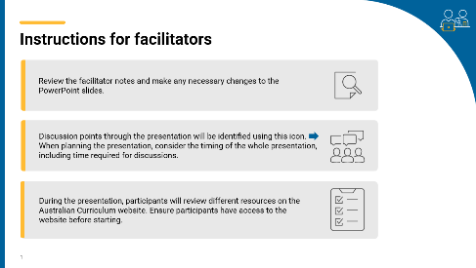
Slide 2: Title slide  On screen  Whole-school planning graphic: Including all learners  Speaker notes  This presentation provides an overview of inclusive planning approaches that support equitable access to the Australian Curriculum for all learners. | 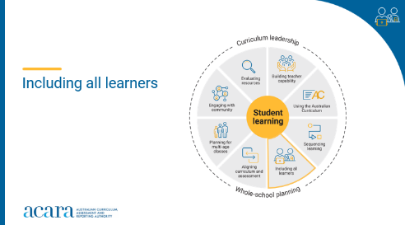
Slide 3: Outcomes  To prepare for this part of the presentation review the text on screen and adjust or adapt for your school context  On screen  By the end of this workshop, we will have:  - reflected on how we currently use the curriculum as the basis for planning for all learners  - examined the Curriculum, Abilities, Standards, Evaluation (CASE) model  - reviewed the ‘Meeting the needs of diverse learners’ advice for each learning area  - reviewed the connections between learning areas and the Personal and Social capability  - proposed actions for change or improvement.  Speaker notes  Clarifying expected learning up front helps keep discussions focused and supports good decision-making. | 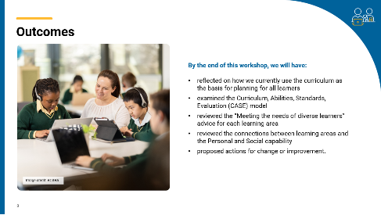
Slide 4: Reflect–Act–Evaluate  On screen  - Reflect: identify current practice and needs.  - Act: use insights from the reflect phase to determine actions to be taken.  - Evaluate: identify the measures for evaluation and schedule evaluation points.  Speaker notes  Explain to participants that the presentation will focus on the Reflect–Act–Evaluate cycle.  This is an opportunity for all participants to:  - provide their insight into current practice  - contribute to and enact whole-school plans  - offer their observations and feedback in the evaluation process. | 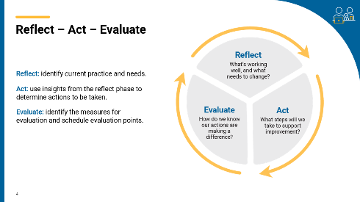
Slide 5: Including all learners  On screen  How do we currently ensure that all learners access knowledge, understanding and skills from the Australian Curriculum?  Activity instructions  Speaker notes  Australian schools are made up of learners from diverse social, cultural, family and community backgrounds. Each learner brings a wide range of physical, cognitive, sensory and social-emotional abilities to the classroom, contributing unique experiences, strengths and ideas. The Australian Curriculum recognises and values this diversity, supporting teachers to flexibly design teaching, learning and assessment that is coherent, sequenced and responsive to the capabilities of all learners.  Use the Think–Pair–Share activity to support teachers to reflect on the ways they use the curriculum when planning for all learners.  Sharing may consist of only one idea or statement from each group for larger teams or using digital tools to record responses.  Activity  Think–Pair–Share: how to use it  Participants  - Think independently about a prompt or problem.  - Pair up and discuss their ideas with a colleague.  - Share their ideas with the group. | 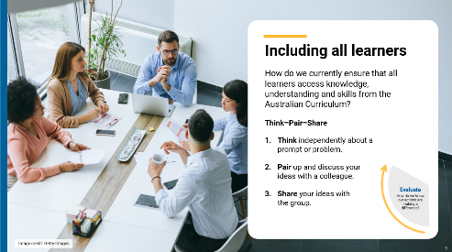

Slide 6: CASE Model  On screen  CASE Model graphic  Speaker notes  Originally designed to help teachers plan for students with disabilities, the CASE model is now recognised as a process that supports inclusive and equitable planning for all learners within a class.  By implementing the CASE model, teachers can ensure that:  - all learners can access and engage with the curriculum, and communicate their learning through multiple means of engagement, representation, action and expression  - Australian Curriculum achievement standards are used as a common reference point for assessing and reporting student progress  - evaluation of implementation approaches is included as an essential step in planning for student learning. | 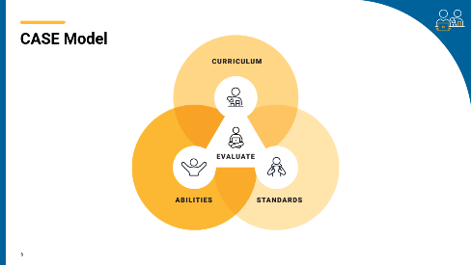
Slide 7: CASE Model  On screen  Activity instructions  Activity  Ask participants to read the information on the Planning for diversity page.  Use a PMI (Plus–Minus–Interesting) chart to help participants reflect on what they are reading.  This should take approximately 10 minutes.  Ask participants to share their thinking with the group while one or two people record.  Are there any common ideas or observations that may inform future planning?  Note: To learn more about the CASE model, participants can undertake the Planning for student diversity course in ACARA’s PL Hub. | 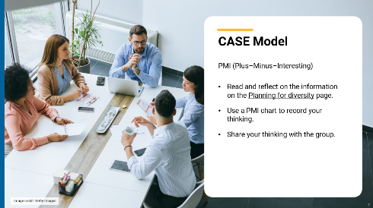

Slide 8: Understand this learning area: Meeting the needs of diverse learners  On screen  How would you use the information in ‘Understand this learning area: Meeting the needs of diverse learners’ when planning?  Speaker notes  Participants read and reflect on ‘Understand this learning area: Meeting the needs of diverse learners’ for a familiar learning area. This information is in the Understand this learning area: Key considerations for each learning area  Discussion  Participants discuss their reflections in small groups, with an option to share their observations with the wider group. | 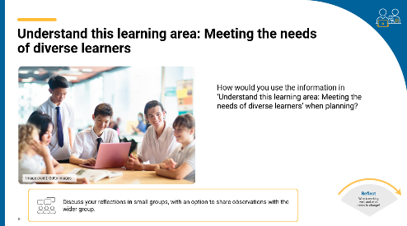
Slide 9: Student belonging and wellbeing  On screen  Students with well-developed social and emotional skills are better equipped to regulate themselves, build constructive relationships and navigate challenges.  What are some of the ways that students are supported to develop these skills in the classes you teach?  Speaker notes  Students with well-developed social and emotional skills are better equipped to regulate themselves, build constructive relationships and navigate challenges. They develop resilience, empathy and a sense of self-worth — qualities essential for both effective learning and active citizenship.  The Australian Curriculum embeds this learning focus through the Personal and Social general capability, highlighting opportunities for all learners to grow in their ability to manage emotions, collaborate effectively, resolve conflict and set goals. Personal and Social capability encompasses emotional and relational skills that underpin lifelong success in learning, work and relationships.  A whole-school approach to the integration of the Personal and Social capability across learning areas provides all learners with opportunities to practise skills and strategies in varied contexts, reinforcing their application in real-life situations.  Discussion  Ask participants to read the Personal and Social capability: About the general capability information.  Using the selector tool on the Australian Curriculum website to review the connections to the Personal and Social general capability for a learning area.  Using the question prompt on screen, participants discuss their reflections in small groups, with an option to share their observations with the wider group. | 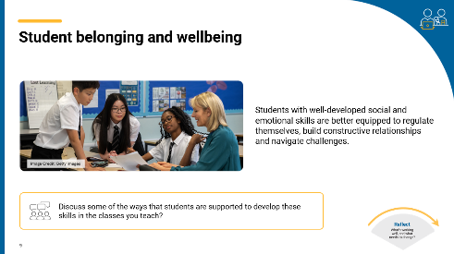
Slide 10: Planning for action  On screen  What are 3 actions that could improve how we use the Australian Curriculum when planning for all learners?  Activity instructions  Speaker notes  This slide will support participants to contribute to and collaborate on actions for change or improvement.  Provide participants with sticky notes to record their responses to the posed question.  After participants have had time to reflect and record their responses, review the suggestions and identify common themes or categories. Consider:  - Are there common ideas or approaches for improvement?  - How might the identified categories influence a whole-school approach to curriculum implementation?  Activity  Using the question prompt on screen, ask participants to:  - Write one idea per sticky note.  - Using a large surface, like a wall or board, ask participants to post their ideas.  - As a group, sort ideas into categories of similar actions.  - Review the categories created. | 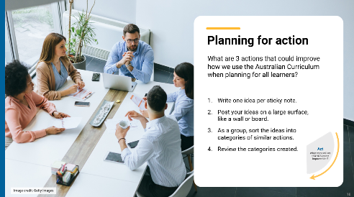

Slide 11: Prioritising actions  On screen  Dot voting instructions  Speaker notes  As a group, review and prioritise actions from the previous activity. Use the dot voting activity to support participants to prioritise actions. Use the highest ranked actions as the basis for creating an action plan for your implementation approach.  Activity  Dot voting – How to use it:  Display the options identified in the previous activity in an area accessible to participants. This may be on a wall or a table. Ask participants to indicate which action they would undertake by using dots to vote for their preferred options.  Participants indicate their preferences using dots:  - 3 dots for their 1st preference  - 2 dots for their 2nd preference  - 1 dot for their 3rd preference.  Use the highest ranked actions as the basis for creating an action plan for your implementation approach.  NOTE: Dots may be replaced with ticks or marks.  The activity could be varied so that participants add a sticky note to their preferred option with a concise explanation for why it is their preference. | 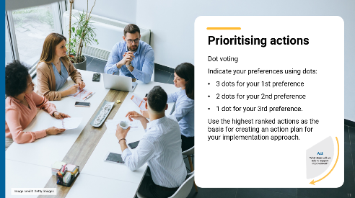
Slide 12: Action plan – actions, responsibilities and timelines  On screen  What actions will we implement?  Speaker notes  Use the prioritised actions from the previous activity to start planning the whole-school approach. Use existing planning documents or complete the relevant columns in the action plan to:  - describe what actions will be undertaken  - allocate responsibilities  - schedule actions over a specific timeframe  - identify what resources are needed.  Discussion  As a whole group, consider the priority actions. Allocate roles through self-nomination or allocation of activities to teams within the school. Support participants to discuss the timing of each action with consideration of existing commitments. Consider how other priorities might also be included in the plan. | 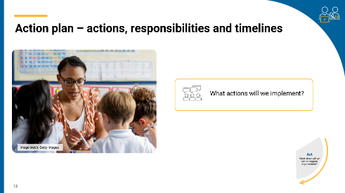
Slide 13: Action plan – evidence and evaluation  On screen  How will we reflect on our approach and evaluate its effectiveness over time?  Think–Pair–Share instructions  Speaker notes  Use the Action planning document to describe:  - what success will look like  - what evidence will need to be gathered  - what the review and evaluation cycle will look like in your school.  Use the Think–Pair–Share activity to support participants to contribute to the evaluation planning process.  Activity  Think–Pair–Share: how to use it  Participants  - Think independently about a prompt or problem.  - Pair up and discuss their ideas with a colleague.  - Share their ideas with the group.  Once sharing has been completed, use contributions to record evaluation approaches in the action plan. Consider what resources will be used as you put the plan into action and record. | 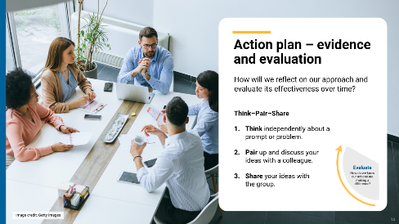
Slide 14: Building teacher capability – personal reflection  On screen  Whole-school planning graphic: Including all learners  What support do you need to build your capability using the curriculum when including all learners when planning? ​  What support could you provide to help others build their capability using the curriculum when including all learners when planning?  Speaker notes  When planning to implement the curriculum, it is important to consider how all aspects of curriculum implementation are interconnected and what support teachers need.  Reflection  Ask participants to reflect on the information provided in the session and identify their strengths and areas where they need additional support.  These reflections may form part of discussions with team leaders on individual goal setting. They can support identifying areas that may be the focus for future professional learning. | 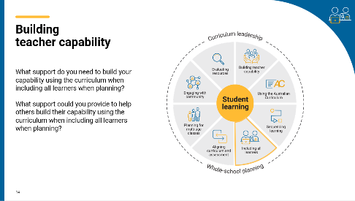
Slide 15: Thank you  On screen  For more resources visit the Resources page on the Australian Curriculum website.  ACARA uses images sourced under licence from third parties. It is a condition of access to this presentation that you do not allow for any party to copy, in whole or in part any image from this presentation. For all other copyright enquiries contact ACARA through the online enquiry form and select ‘copyright’. | 

