Facilitator notes – Engaging with community
This presentation provides an overview of approaches to engaging with local communities when implementing the curriculum. It will support school and curriculum leaders to identify opportunities to strengthen teacher capability and guide whole-school implementation of the Australian Curriculum.
The Reflect–Act–Evaluate cycle provides a framework through which participants can examine current approaches to curriculum implementation and plan for change.

Session objectives
- Reflect on how we support our families to understand the curriculum and examine resources to support current approaches.
- Reflect on how we involve local First Nations Australian communities in curriculum implementation
- Identify opportunities for engagement with different groups in the wider community.

Considerations
- How well do our current resources help our families understand the curriculum and support learning?
- How do we involve local First Nations Australian communities in curriculum implementation
- Do we have a clear understanding of the local organisations, businesses and services that can contribute to curriculum implementation in our school’s context?
- What are our priorities for change or improvement?

Pre-reading for facilitator
Review the:
- advice and downloads in the Engaging with community aspect
- resources on the Parent/carer information page
- resources on the FIRST framework page
- Supporting Family-School-Community Partnerships for Learning, Australian Government Department of Education website

Handouts for individuals
Engaging with community reflection

Whole group recording documents
Engaging with community: Planning for action

Slide 1: Instructions for facilitators  On screen  Instructions for facilitators  - Review the facilitator notes and ensure you have made any necessary changes to the PowerPoint slides.    - Discussion points through the presentation will be identified using the icon. When planning the presentation, consider the timing of the whole presentation, including time required for discussions.  - This presentation considers families, First Nations Australian communities and the wider community. Facilitators may consider breaking the presentation up over several sessions. | 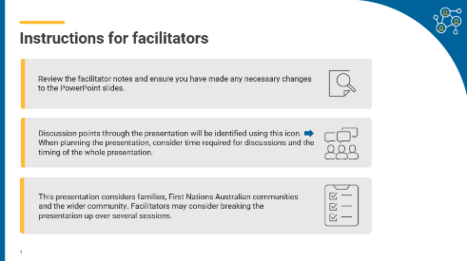
Slide 2: Title slide  On screen  Whole-school planning graphic: Engaging with community | 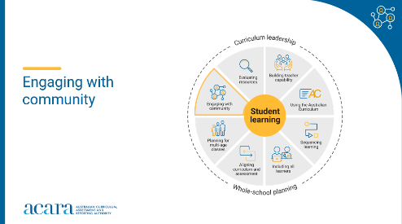
Slide 3: Outcomes  To prepare for this part of the presentation, review the text on screen and adjust or adapt for your school context.  On screen  By the end of this workshop, we will have:  - reflected on how we support families to understand the curriculum  - reflected on how we involve local First Nations Australian communities in curriculum implementation  - considered opportunities for engagement with different groups in the wider community  - proposed actions for change or improvement.  Speaker notes  Clarifying expected learning up front helps keep discussions focused and supports good decision-making. | 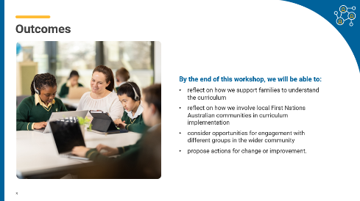
Slide 4: Reflect–Act–Evaluate  On screen  - Reflect: identify current practice and needs.  - Act: use insights from the reflect phase to determine actions to be taken.  - Evaluate: identify the measures for evaluation and schedule evaluation points.  Speaker notes  Explain to participants that the presentation will focus on the Reflect–Act–Evaluate cycle.  This is an opportunity for all participants to:  - provide their insight into current practice  - contribute to and enact whole-school plans  - offer their observations and feedback in the evaluation process. | 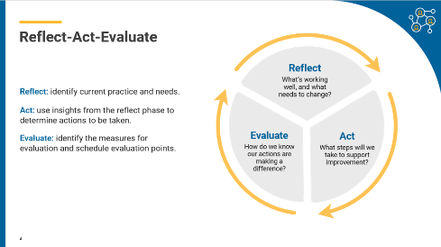
Slide 5: Engaging with families  On screen  How well do our current approaches help families understand the curriculum and support learning?  Activity instructions  Speaker notes  All schools have approaches to engaging with families that are specific to their context and include a range of activities and modes of communication. Research demonstrates that parental engagement in learning has a significant impact on outcomes for students. Engaging with families about the curriculum and how they can support their child’s learning is a first step in building positive relationships between school and home.  Activity  Ask participants to review the Parent/carer information pages for the year levels and learning areas they are responsible for teaching.  Use the Think–Pair–Share activity to support teachers to reflect on current approaches when communicating about the curriculum with families. Consider if any changes or improvements are needed and share with the group.  Record suggestions for use in later activities.  Sharing may consist of only one idea or statement from each partnership for larger teams or using digital tools to record responses.  Think–Pair–Share: how to use it  Participants:  - think independently about a prompt or problem.  - pair up and discuss their ideas with a colleague.  - share their ideas with the group.  Record suggestions for use in later activities.  Identify themes or categories by reviewing as a group. | 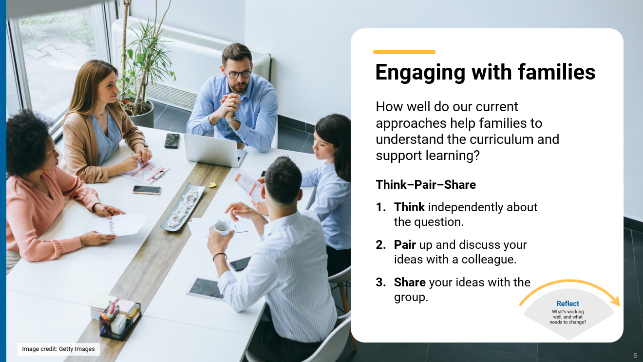

Slide 6: Engaging with First Nations Australian communities  On screen  How do we involve local First Nations Australian communities in curriculum implementation?  Speaker notes  When planning teaching activities involving engagement with First Nations Australians, teachers should follow protocols that describe principles, procedures and behaviours for recognising and respecting First Nations Australians and their intellectual property. Teachers should use approved resources such as those that may be provided by their state or territory school system, or First Nations Australian education consultative groups, or other protocols accredited by First Nations Australians.  ACARA has developed the FIRST framework to support teachers to facilitate culturally responsive and curriculum-aligned learning experiences in collaboration with local communities.  The FIRST framework supports school and curriculum leaders to identify the areas in which they can lead their school’s engagement with local First Nations communities.  Ask participants to review the information on FIRST framework page and reflect on current approaches to engagement with local First Nations Australian communities. Consider if any changes or improvements are needed and share with the group.  Discussion  In small groups, participants discuss their reflections and then share their observations and suggestions with the wider group.  Record suggestions for use in later activities.  Identify themes or categories by reviewing as a group. | 

Slide 7: Engaging with the wider school community  On screen  How do we identify and build partnerships with local organisations, businesses and services that align with our curriculum implementation goals?  Activity instructions  Speaker notes  The “wider school community” includes local businesses and industry, local councils, elected representatives and service agencies. It also includes community groups such as sporting clubs, arts and cultural organisations, not-for-profits, elders and family support services.  Community engagement prepares learners for active participation in their community.  Leaders who build purposeful partnerships enrich learning by placing the curriculum in real-world contexts that sustain high engagement. Collaborations with local businesses, industries and community organisations deepen conceptual understanding through authentic, local experiences. For example, they use real-world problems in STEM, or integrate sustainability and civics projects that connect directly to community needs.  Activity  Ask participants to reflect on the question on screen. Use the popcorn activity to encourage participants to share their ideas about any changes or improvements to current approaches.  Popcorn: how to use it  A fast-paced group strategy where everyone contributes ideas aloud in real time.  - Present a problem or question.  - Give a minute for silent reflection.  - Invite participants to share (one at a time) while one or two people record.  - Stop when ideas slow down, then review and discuss.  Identify themes or categories by reviewing as a group. | 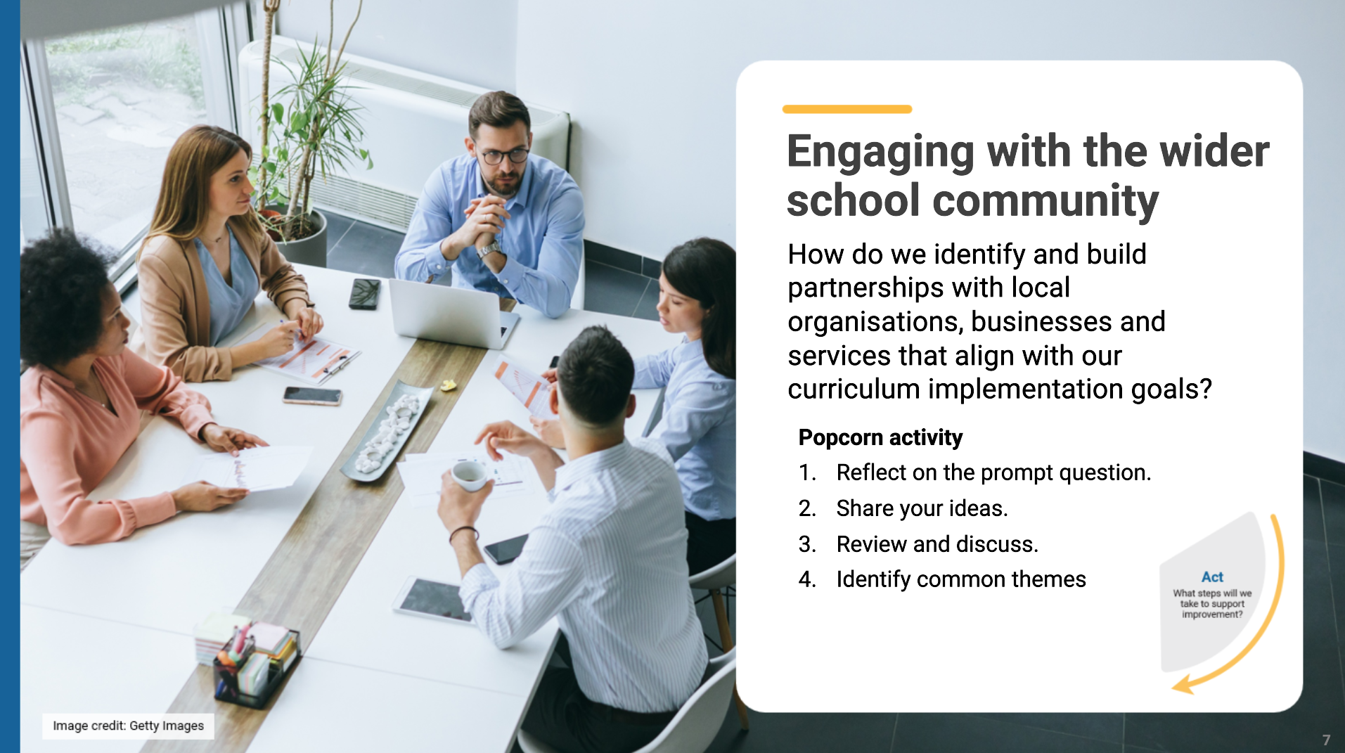

Slide 8: Prioritising actions  On screen  Dot voting instructions  Speaker notes  As a group, review and prioritise actions from each of the previous activities. Use the dot voting activity to support participants to prioritise actions. The prioritised actions will be used to inform whole-school planning.  Activity  Dot voting: how to use it  Display the options identified in the previous activity in an area accessible to participants. This may be on a wall or a table. Ask participants to indicate which action they would undertake by using dots to vote for their preferred options.  Participants indicate their preferences using dots:  - 3 dots for their 1st preference  - 2 dots for their 2nd preference  - 1 dot for their 3rd preference.  Use the highest ranked actions as the basis for creating an action plan for your implementation approach.  NOTE: Dots may be replaced with ticks or marks.  The activity could be varied so that participants add a sticky note to their preferred option with a concise explanation for why it is their preference. | 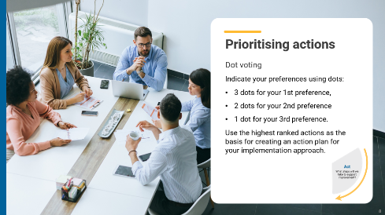
Slide 9: Action plan – actions, responsibilities and timelines  On screen  What actions will we implement?  Speaker notes  Use the prioritised actions from the previous activity to start planning the whole-school approach. Use existing planning documents or complete the relevant columns in the action plan to:  - describe what actions will be undertaken  - allocate responsibilities  - schedule actions over a specific timeframe  - identify what resources are needed.  Discussion  As a whole group, consider the top priority actions. Allocate roles through self-nomination or distribution of activities to teams within the school. Support participants to discuss the timing of each action with consideration of existing commitments. Consider how other priorities identified might also be included in the plan. | 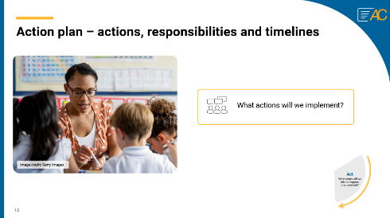
Slide 10: Action plan - evidence and evaluation  On screen  How will we reflect on our approach and evaluate its effectiveness over time?  Think-Pair-Share instructions  Speaker notes  Use the Think–Pair–Share activity to support participants to contribute to the evaluation planning process.  Use the Action planning document to describe:  - what success will look like  - what evidence will need to be gathered  - what the review and evaluation cycle will look like in your school.  Activity  Think–Pair–Share: how to use it  Participants  - think independently about a prompt or problem.  - pair up and discuss their ideas with a colleague.  - share their ideas with the group.  Once sharing has been completed, use contributions to record evaluation approaches in the action plan. Consider what resources will be used as you put the plan into action and record. | 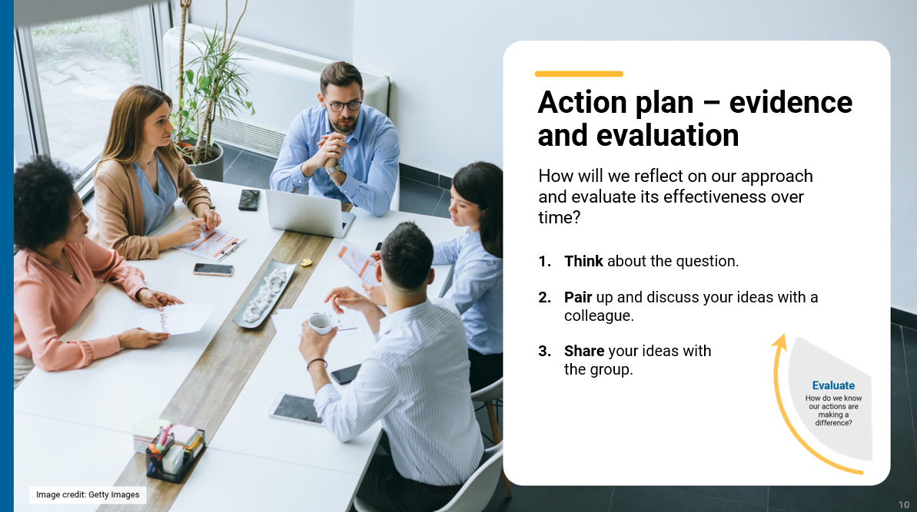
Slide 11: Building teacher capability - personal reflection  On screen  Whole-school planning graphic: Engaging with community  What support do you need to build your capability when engaging with the community? ​  What support could you provide to help others build their capability when engaging with he community?  Speaker notes  When planning to implement the curriculum, it is important to consider how all aspects of curriculum planning are interconnected and what support teachers need. Ask teachers complete the reflection record while considering the prompts on screen.  Activity  Throughout the presentation, participants have reflected on their strengths and areas where they would like support. These reflections may form part of discussions with school and curriculum leaders on individual goal setting. They can support identifying areas that may be the focus for future professional learning. | 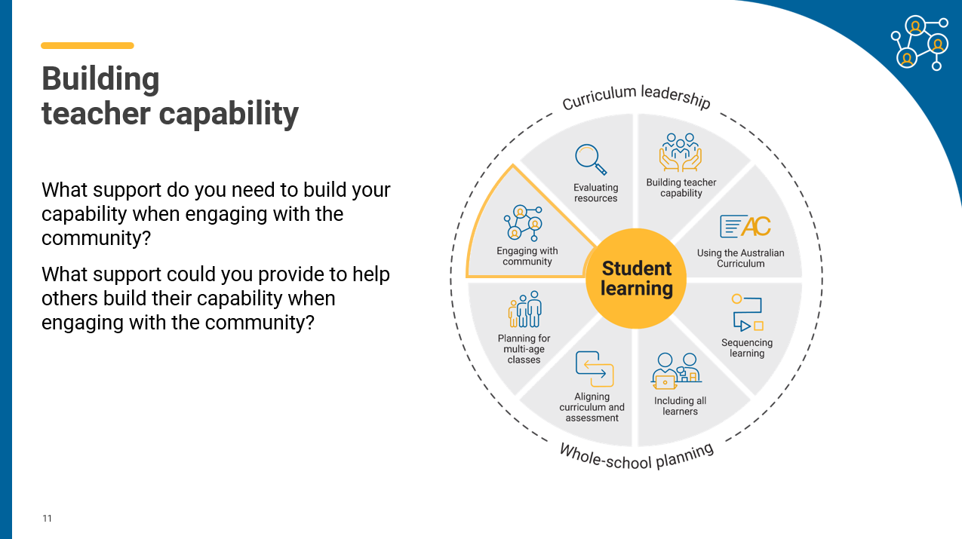
Slide 12: Thank you  On screen  For more resources visit the Resources page on the Australian Curriculum website.  ACARA uses images sourced under licence from third parties. It is a condition of access to this presentation that you do not allow for any party to copy, in whole or in part any image from this presentation. For all other copyright enquiries contact ACARA through the online enquiry form and select ‘copyright’. | 

