Facilitator notes – Building teacher capability
This presentation provides an overview of 7 considerations for whole-school curriculum planning. It will enable participants to reflect on current approaches and identify strengths and areas for growth. It will support school and curriculum leaders to identify opportunities to strengthen teacher capability and guide whole-school implementation of the Australian Curriculum.
The Reflect–Act–Evaluate cycle provides a framework through which participants can examine current approaches to curriculum implementation and plan for change.

Session objectives
- Reflect on current approaches to curriculum implementation.
- Identify strengths and areas for growth in curriculum knowledge and practice.
- Work together to agree on priority actions that will support teacher capability across the school.

Considerations
- What are our current approaches to curriculum implementation?
- What do our staff need, individually or collectively, in relation to curriculum implementation?
- What are our priorities for change and/or improvement?

Pre-reading for facilitator
- Review the advice and downloads in the Building teacher capability aspect.
- Review the advice and resources in the Using the Australian Curriculum aspect.
- Review the ‘Whole-school approach to sequencing learning’ in the Sequencing learning aspect.
- Review the advice and resources in the Planning for multi-age classes aspect.

Handouts for individuals
Building teacher capability reflection

Slide 1: Instructions for facilitators  On screen  Instructions for facilitators  - Review the facilitator notes and make any necessary changes to the PowerPoint slides.    - Discussion points through the presentation will be identified using the icon. When planning the presentation, consider the timing of the whole presentation, including time required for discussions.  - This presentation takes the participants through each aspect of whole-school curriculum planning. Facilitators may need to consider breaking the presentation up over several sessions. |  | 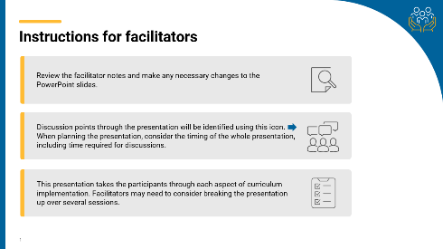
Slide 2: Title slide  On screen  Whole-school planning graphic: Building teacher capability  Speaker notes  This presentation will focus on supporting participants to reflect on their knowledge of the curriculum for the learning areas and year levels they teach. It will provide an opportunity for participants to identify what they want to learn more about in relation to curriculum implementation. |  | 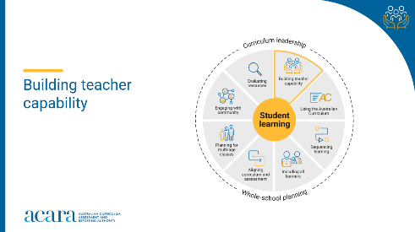
Slide 3: Outcomes  To prepare for this part of the presentation review the text on screen and adjust or adapt for your school context  On screen  By the end of this workshop, we will have:  - reflected on current approaches to curriculum implementation  - identified areas of strength, both personally and collectively  - planned for building personal and collective capability when implementing the curriculum.  Speaker notes  Clarifying expected learning up front helps keep discussions focused and supports good decision-making. |  | 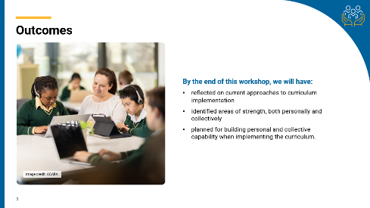
Slide 4: Reflect–Act–Evaluate  On screen  - Reflect: identify current practice and needs.  - Act: use insights from the reflect phase to make decisions about actions to be taken.  - Evaluate: identify the measures for evaluation and schedule evaluation points.  Speaker notes  Explain to participants that the presentation will focus on the Reflect–Act–Evaluate cycle.  This is an opportunity for all participants to:  provide their insight into current practice  contribute to and enact whole-school plans  offer their observations and feedback in the evaluation process. |  | 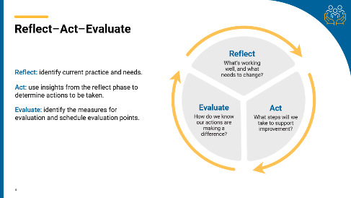
Slide 5: Whole-school curriculum planning  On screen  Whole-school planning graphic  Speaker notes  Schools use the Australian Curriculum to plan for student learning at many levels. These include planning for whole-school curriculum, year-level, learning area/subject, unit, classroom and lesson, and individual student. A whole-school approach to curriculum planning increases and promotes consistency, which supports teachers in improving outcomes for all students.  Eight aspects of curriculum implementation have been identified for schools to consider as they implement the Australian Curriculum.  This presentation, focused on building teacher capability, is an opportunity for participants to reflect on what they know and what they need to know more about in relation to each aspect.  The 8 aspects are:  - Building teacher capability  - Using the Australian Curriculum  - Sequencing learning  - Including all learners  - Aligning curriculum and assessment  - Planning for multi-age classes  - Engaging with community  - Evaluating resources.  Provide participants with a copy of the reflection record. At the end of each activity, encourage participants to reflect on their strengths and where they would like further support. |  | 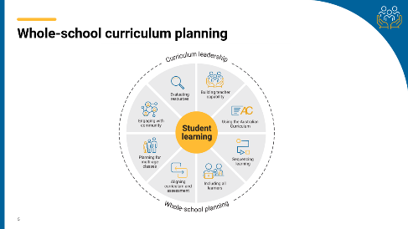
Slide 6: Using the Australian Curriculum  On screen  What do we understand about the structure and intent of the Australian Curriculum?  - Learning areas  - General capabilities  - Cross-curriculum priorities.  Speaker notes  The Australian Curriculum sets the expectations for what all students should be taught, regardless of their background or where they live. The Australian Curriculum has 3 parts or dimensions – learning areas, general capabilities and cross-curriculum priorities. Teachers with sound knowledge and understanding of the learning areas they teach are better able to consider the opportunities to embed the general capabilities and cross-curriculum priorities when planning for student learning. | 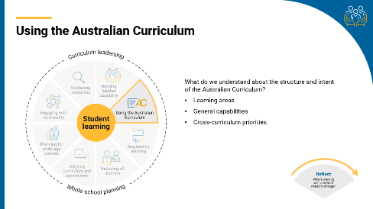
Slide 7: Australian Curriculum  On screen  Use an adaptation of the jigsaw activity to promote discussion and reflection on current practice.  Activity  Jigsaw adaptation – How to use it:  - Organise participants into 3 groups.  - Assign each group a different resource to review and discuss how this information might improve current practice.  - Ask each group present back to the whole group with the key points from their discussion.  Resources to review  - Learning areas tab from Using the Australian Curriculum aspect  - General capabilities tab from Using the Australian Curriculum aspect  - Cross-curriculum priorities tab from Using the Australian Curriculum aspect  Participants use the reflection record to identify their strengths and where they would like further support. | 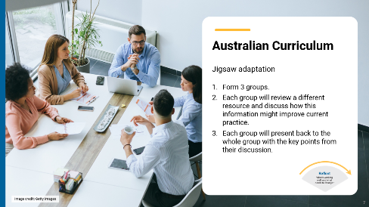
Slide 8: Sequencing learning  On screen  How do we sequence the curriculum and evaluate the effectiveness of our approaches?  Speaker notes  Sequencing learning within year levels is a foundational step in whole-school curriculum planning. It involves structuring what is taught, when and in what order, so that knowledge and skills build logically.  A whole-school curriculum plan makes this sequence visible. Aligned to the Australian Curriculum, it outlines the progression of content and achievement standards for each subject. It shows how learning connects across years and learning areas.  Discussion  In small groups, participants review the Whole-school approach to sequencing learning and discuss how this information might improve current practice. Ask each group to identify a step or an action they wish to investigate further. Share these with the wider group either through discussion or recording and displaying ideas on sticky notes.  Participants use the reflection record to identify their strengths and where they would like further support. | 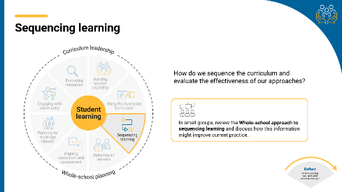
Slide 9: Including all learners  On screen  How do we ensure all learners are supported to access the curriculum?  Speaker notes  The Curriculum, Abilities, Standards, Evaluate (CASE) model provides a structured approach to planning inclusive and equitable teaching, learning and assessment opportunities for all learners. It ensures that all learners can access content and participate in learning on the same basis as their peers. Using the CASE model enables teachers to implement the Australian Curriculum in ways that are responsive to unique school contexts and the identities, abilities and experiences of all learners.  Discussion  Ask participants to review the information about the CASE model on the Planning for diversity page. Participants reflect on their current approaches to planning for all learners and identify where the application of the CASE model might strengthen existing practice.  Participants use the reflection record to identify their strengths and where they would like further support. | 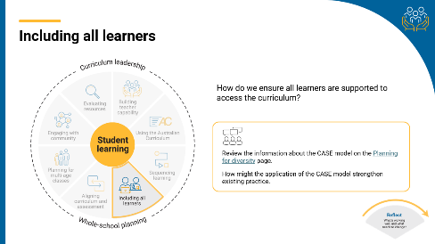
Slide 10: Aligning curriculum and assessment  Speaker notes  Aligning curriculum and assessment is a core part of whole-school approaches to curriculum implementation. Assessment provides the evidence needed to evaluate student learning, measure progress against the achievement standards, and assess the impact of teaching, learning and curriculum strategies.  Discussion  As participants watch the video, ask them to use a PMI chart or similar recording tool to record their thinking. Use a prompt such as, ‘How do we ensure our approaches to assessment align to the curriculum?’ to support reflection.  At the end of the video, encourage participants to reflect on current practice and share their observations and thinking with the group.  Participants use the reflection record to identify their strengths and where they would like further support. | 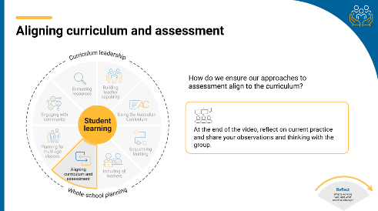
Slide 11: Aligning curriculum and assessment  On screen  Aligning curriculum and assessment video | 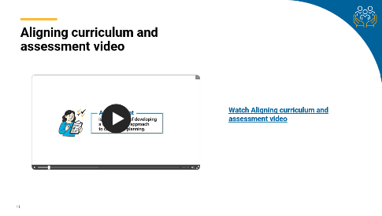
Slide 12: Planning for multi-age classes  Speaker notes  Consider whether reviewing this aspect is suitable for your context. If your school does not have multi-age classes (where students of different age groups, spanning more than one year level, are placed together in a single class), this slide should be removed from the presentation. | 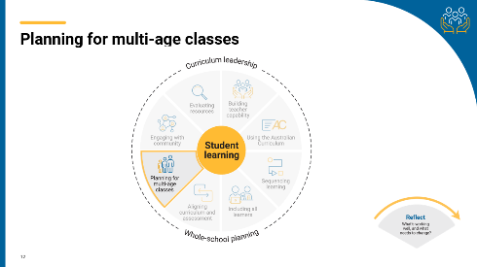
Slide 13: Planning for multi-age classes  On screen  Activity instructions  Speaker notes  Planning for learning in multi-age classes is complex. It requires collaboration among teachers, knowledge of the curriculum structure, careful sequencing of content, and an agreed approach to recording and evaluating curriculum plans. When school and curriculum leaders have a clear understanding of the different approaches to managing curriculum, they are better able to lead whole-school curriculum planning in multi-age contexts.  Use an adaptation of the jigsaw activity to promote discussion and reflection on current practice.  Discussion  Jigsaw adaptation – How to use it:  - Organise participants into 3 groups.  - Assign each group a different resource to review and discuss how this information might improve current practice.  - Ask each group present back to the whole group with the key points from their discussion.  Resources to review  - Conceptual threads model tab from Planning for multi-age classes aspect  - A/B model tab from Planning for multi-age classes aspect  - Split models tab from Planning for multi-age classes aspect  Participants use the reflection record to identify their strengths and where they would like further support. | 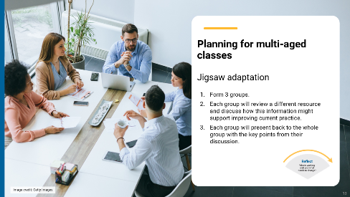
Slide 14: Engaging with community  On screen  How do we communicate and collaborate with our school community about our approaches to curriculum implementation?  - Families  - First Nations Australian communities  - Other community groups  Speaker notes  Effective curriculum planning requires collaboration with families, local First Nations Australian communities and the wider school community. When considering approaches to community engagement, schools need to be clear on the purpose for the engagement, who they will engage with and how they will engage. | 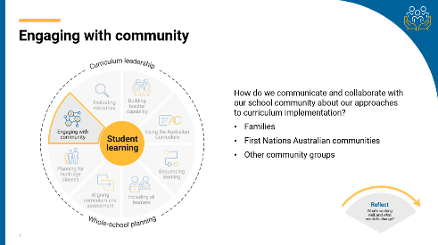
Slide 15: Engaging with community  On screen  How do we communicate and collaborate with our school community about our approaches to curriculum implementation?  Activity  Use the Think–Pair–Share activity to support teachers to reflect on how they engage with the broader community. Using the on-screen question as a prompt, consider the ways in which communication and collaboration occur with each of the groups on screen.  Think–Pair–Share: how to use it  Participants  - Think independently about a prompt or problem.  - Pair up and discuss their ideas with a colleague.  - Share their ideas with the group.  Sharing may consist of only one idea or statement from each group for larger teams or using digital tools to record responses.  Participants use the reflection record to identify their strengths and where they would like further support. | 
Slide 16: Evaluating resources  On screen  How do we review and evaluate the resources we use for teaching, learning and assessment?  Speaker notes  Evaluating teaching, learning and assessment resources ensures that educational materials are high quality and align with the Australian Curriculum achievement standards and content descriptions. Educational resources encompass everything a school needs to support quality teaching and learning.  Discussion  Using the question on screen, ask small groups to discuss the ways in which resources are currently evaluated. Share observations and thinking with the whole group.  Participants use the reflection record to identify their strengths and where they would like further support. | 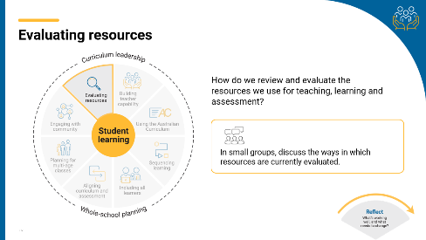
Slide 17: Building teacher capability – personal reflection  On screen  What support do you need to build your capability in understanding and using the Australian Curriculum?  What support could you provide to help others build their capability in understanding and using the Australian Curriculum?  Speaker notes  When planning to implement the curriculum, it is important to consider how all aspects of curriculum planning are interconnected and what support teachers need. Ask teachers complete the reflection record while considering the prompts on screen.  Discussion  Throughout the presentation, participants have reflected on their strengths and areas where they would like support. These reflections may form part of discussions with school and curriculum leaders on individual goal setting. They can support identifying areas that may be the focus for future professional learning. | 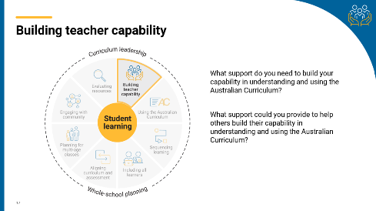
Slide 16: Thank you  On screen  For more resources visit the Resources page on the Australian Curriculum website.  ACARA uses images sourced under licence from third parties. It is a condition of access to this presentation that you do not allow for any party to copy, in whole or in part any image from this presentation. For all other copyright enquiries contact ACARA through the online enquiry form and select ‘copyright’. | 

