Facilitator notes – Aligning curriculum and assessment
This presentation provides an overview of the process of aligning curriculum and assessment. It will support school and curriculum leaders to identify opportunities to strengthen teacher capability and guide whole-school implementation of the Australian Curriculum.
The Reflect–Act–Evaluate cycle provides a framework through which participants can examine current approaches to curriculum implementation and plan for change.

Session objectives
- Consider a process for aligning curriculum and assessment.
- Reflect on current approaches to aligning curriculum and assessment.
- Propose actions for change or improvement.

Considerations
- How clearly do our current assessments align with achievement standards and content descriptions?
- What are our priorities for change or improvement?

Pre-reading for facilitator
- Review the advice and downloads in the Aligning curriculum and assessment aspect.
- Review the advice on the Formative assessment page.
- Review your sector’s advice on and resourcing of assessment.

Handouts for individuals
Aligning curriculum and assessment reflection

Whole group recording documents
Aligning curriculum and assessment: Planning for action

Slide 1: Instructions for facilitators  On screen  Instructions for facilitators  - Review the facilitator notes and ensure you have made any necessary changes to the PowerPoint slides.    - Discussion points through the presentation will be identified using the icon. When planning the presentation, consider the timing of the whole presentation, including time required for discussions. | 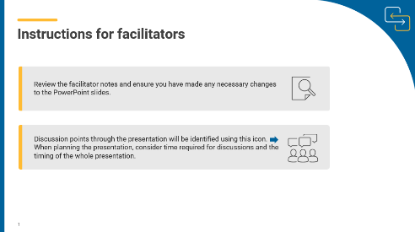
Slide 2: Title slide  On screen  Whole-school planning graphic: Aligning curriculum and assessment  Speaker notes  This presentation will focus on supporting participants to reflect on their knowledge of the curriculum and how they align curriculum and assessment in the classroom. It will provide an opportunity for participants to identify what they want to learn more about in relation to curriculum aligned assessment. | 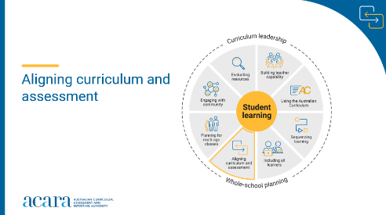
Slide 3: Outcomes  To prepare for this part of the presentation review the text on screen and adjust or adapt for your school context  On screen  By the end of this workshop, we will have:  - considered a process for aligning curriculum and assessment  - reflected on current approaches to aligning curriculum and assessment  - proposed actions for change or improvement.  Speaker notes  Clarifying expected learning up front helps keep discussions focused and supports good decision-making. | 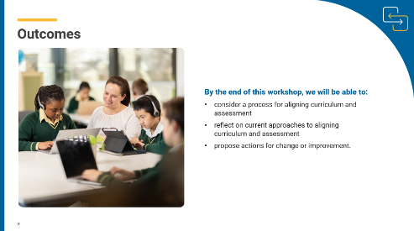
Slide 4: Reflect–Act–Evaluate  On screen  - Reflect: identify current practice and needs.  - Act: use insights from the reflect phase to determine actions to be taken.  - Evaluate: identify the measures for evaluation and schedule evaluation points.  Speaker notes  Explain to participants that the presentation will focus on the Reflect–Act–Evaluate cycle.  This is an opportunity for all participants to:  - provide their insight into current practice  - contribute to and enact whole-school plans  - offer their observations and feedback in the evaluation process. | 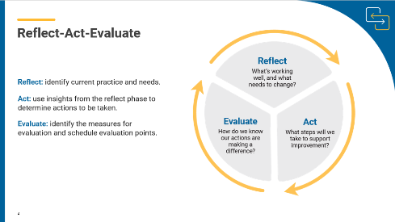
Slide 5: A process for aligning curriculum and assessment  On screen  Aligning curriculum and assessment video  Link opens in separate browser.  Speaker notes  The Australian Curriculum achievement standards describe the expected quality of learning students should typically demonstrate at the end of each year level or band of years.  Content descriptions are directly connected to the achievement standard statements. They specify the essential knowledge, understanding and skills that students are expected to learn.  Effective assessment practices use both the achievement standards and the content descriptions.  Ask participants to watch the video and reflect on current practice in relation to each step. | 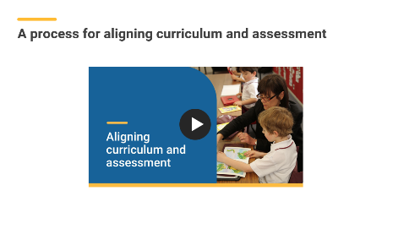

Slide 6: A process for aligning curriculum and assessment  On screen  - Define achievement.  - Plan curriculum content.  - Plan summative assessments.  - Plan formative assessment.  - Evaluate.  Speaker notes  This example process uses the achievement standards and content descriptions to plan and schedule assessments.  - Define achievement. Use the achievement standard to identify and describe what students should know and be able to do by the end of a teaching and learning cycle.  - Plan curriculum content. Identify the connected content descriptions that students need to learn to progress towards the learning described in the achievement standard, and consider what learning is required.​  - Plan summative assessment. Design and schedule assessments to gather evidence of student learning against the achievement standard.  - Plan formative assessment. Design and schedule assessments to gather evidence of what students know and can do. This evidence can actively inform teaching and support progress towards the learning described in the achievement standard.  - Evaluate. Evaluate assessment approaches to ensure the evidence gathered supported student learning and enabled judgements about progress against the achievement standard. | 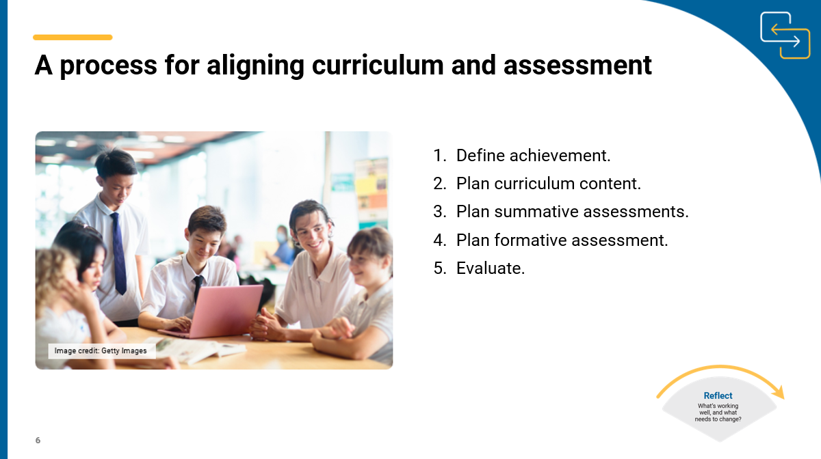
Slide 7: A process for aligning curriculum and assessment  On screen  Activity instructions  Activity  In pairs or teaching teams, ask participants to consider a learning area they teach. Use the Planning for assessment document to work through each step in the process. Note down ideas and possible approaches that they may take when aligning curriculum and assessment for the selected learning area. Ask participants to share their reflections on the process with the whole group.  Encourage participants to review other resources such as the advice on the Formative assessment page as they complete the activity. | 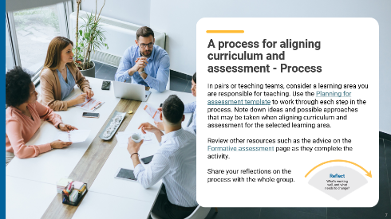
Slide 8: Planning for action  On screen  What current approaches are working well and are there opportunities for change and improvement?  Activity instructions.  Speaker notes  Aligning curriculum and assessment is a core part of whole-school curriculum implementation. Assessment provides the evidence needed to evaluate student learning, measure progress against the achievement standards, and assess the impact of teaching, learning and curriculum strategies.  Use the Think–Pair–Share activity to support participants to reflect on the ways they currently plan curriculum aligned assessments. Reflect on approaches that are working well and opportunities for change and improvement.  Sharing may consist of only one idea or statement from each group for larger teams or using digital tools to record responses.  Activity  Think–Pair–Share: how to use it  Participants:  - think independently about a prompt or problem.  - pair up and discuss their ideas with a colleague.  - share their ideas with the group. | 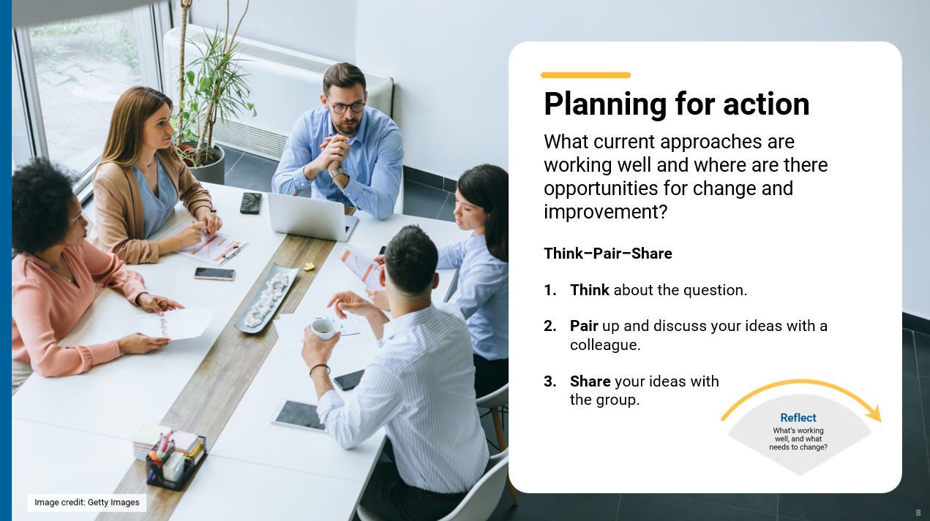

Slide 9: Prioritising actions  On screen  Dot voting instructions  Speaker notes  As a group, review and prioritise actions from the previous activity. Use the dot voting activity to support participants to prioritise actions. The prioritised actions will be used to inform whole-school planning.  Activity  Dot voting: how to use it  Display the options identified in the previous activity in an area accessible to participants. This may be on a wall or a table. Ask participants to indicate which action they would undertake by using dots to vote for their preferred options.  Participants indicate their preferences using dots:  - 3 dots for their 1st preference,  - 2 dots for their 2nd preference  - 1 dot for their 3rd preference.  Use the highest ranked actions as the basis for creating an action plan for your implementation approach.  NOTE: Dots may be replaced with ticks or marks.  The activity could be varied so that participants add a sticky note to their preferred option with a concise explanation for why it is their preference. | 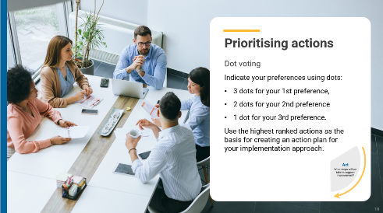
Slide 10: Action plan – actions, responsibilities and timelines  On screen  What actions will we implement?  Speaker notes  Use the prioritised actions from the previous activity to start planning the whole-school approach. Use existing planning documents or complete the relevant columns in the action plan to:  - describe what actions will be undertaken  - allocate responsibilities  - schedule actions over a specific timeframe  - identify what resources are needed.  Discussion  As a group, consider the priority actions. Allocate roles through self-nomination or allocation of activities to teams within the school. Support participants to discuss the timing of each action with consideration of existing commitments. Consider how other priorities might also be included in the plan. | 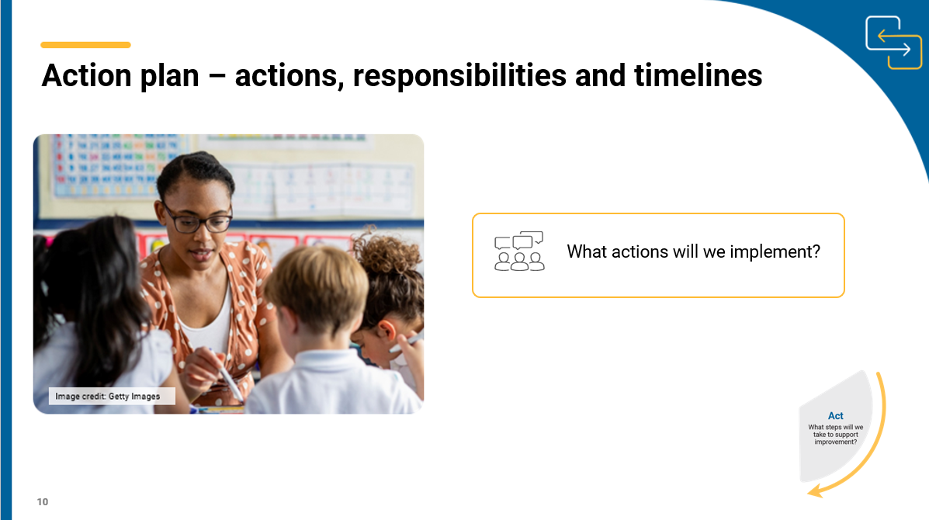
Slide 11: Action Plan – evidence and evaluation  On screen  How will we reflect on our approach and evaluate its effectiveness over time?  Think–Pair–Share instructions  Speaker notes  Use the Think–Pair–Share activity to support participants to contribute to the evaluation planning process.  Use the Action planning document to describe:  - what success will look like  - what evidence will need to be gathered  - what the review and evaluation cycle will look like in your school.  Activity  Think–Pair–Share: how to use it  Participants:  - Think independently about a prompt or problem.  - Pair up and discuss their ideas with a colleague.  - Share their ideas with the group.  Once sharing has been completed, use contributions to record evaluation approaches in the action plan. Consider what resources will be used as you put the plan into action and record. | 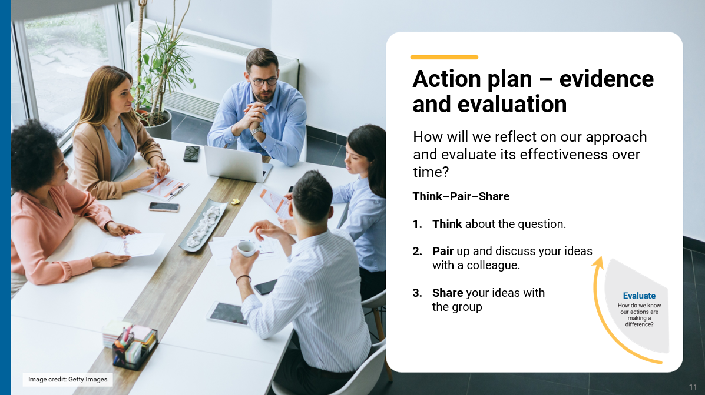
Slide 12: Building teacher capability -  self-reflection  On screen  Whole-school planning graphic: Aligning curriculum and assessment  What support do you need to build your capability when aligning curriculum and assessment? ​  What support could you provide to help others build their capability when aligning curriculum and assessment? ​  Speaker notes  When planning to implement the curriculum, it is important to consider how all aspects of curriculum implementation are interconnected and what support teachers need.  Reflection  Ask participants to reflect on the information provided in the session and identify their strengths and areas where they need additional support. These reflections may form part of discussions with team leaders on individual goal setting. They can support identifying areas that may be the focus for future professional learning. | 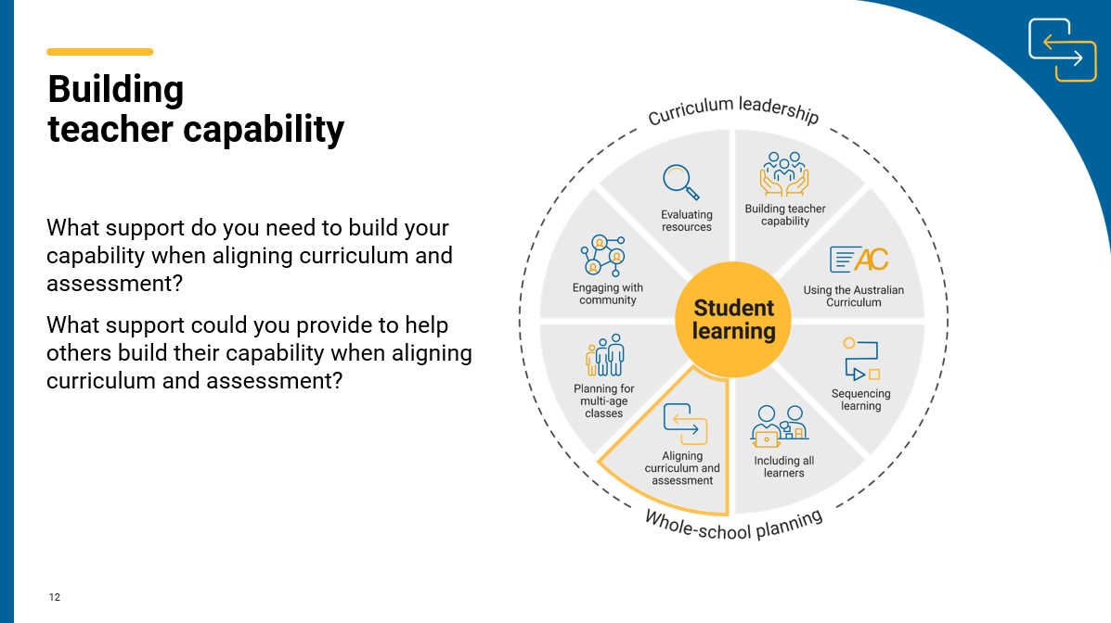
Slide 13: Thank you  On screen  For more resources visit the Resources page on the Australian Curriculum website.  ACARA uses images sourced under licence from third parties. It is a condition of access to this presentation that you do not allow for any party to copy, in whole or in part any image from this presentation. For all other copyright enquiries contact ACARA through the online enquiry form and select ‘copyright’. | 

