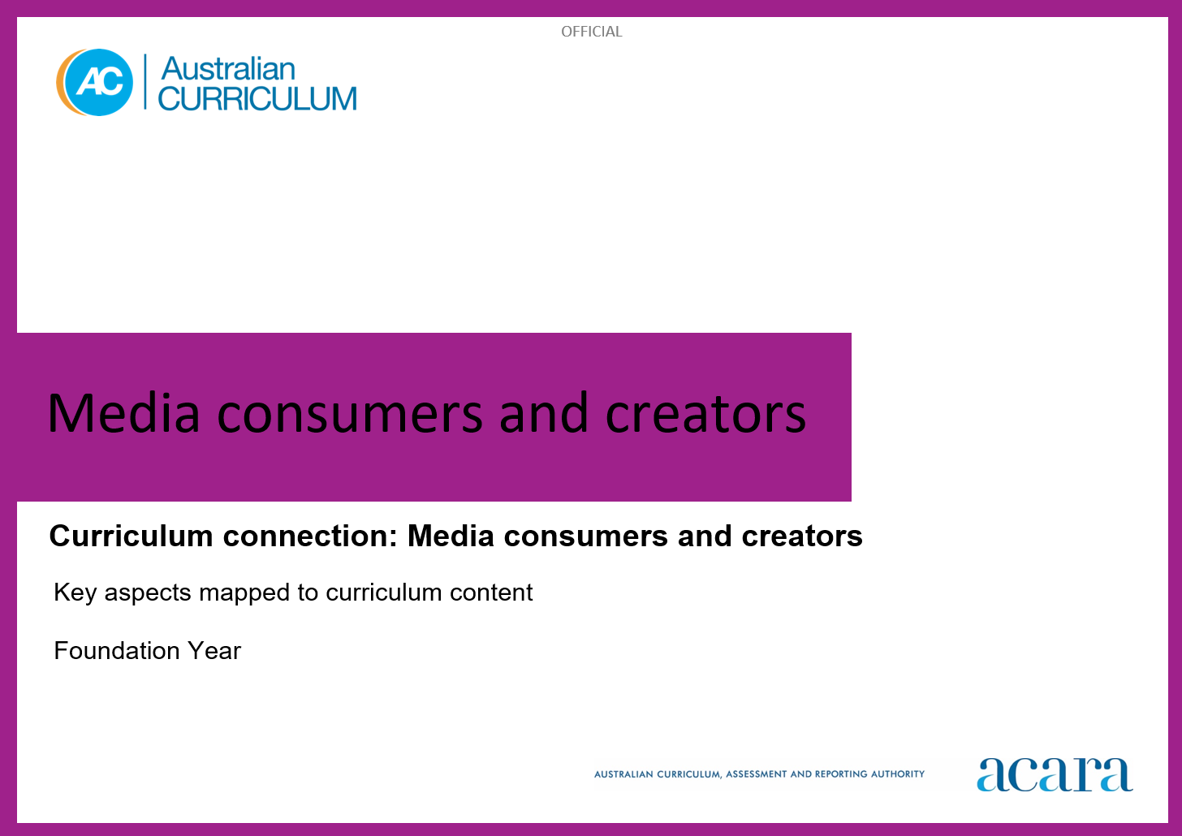

Copyright and Terms of Use Statement
© Australian Curriculum, Assessment and Reporting Authority 2024
The material published in this work is subject to copyright pursuant to the Copyright Act 1968 (Cth) and is owned by the Australian Curriculum, Assessment and Reporting Authority (ACARA) (except to the extent that copyright is held by another party, as indicated).
The viewing, downloading, displaying, printing, reproducing (such as by making photocopies) and distributing of these materials is permitted only to the extent permitted by, and is subject to the conditions imposed by, the terms and conditions of using the ACARA website (see, especially, clauses 2, 3 and 4 of those terms and conditions). The terms and conditions can be viewed at https://www.acara.edu.au/contact-us/copyright

Media Consumers and Creators
Key aspects
Understand and analyse contemporary media | Media describes all channels of communication. Contemporary media channels are a mix of traditional and new media that are increasingly digital and multimodal. Media consumers view, listen to, use and read media. Traditional media is any type of content that is distributed through established channels. Traditional media channels include television, film, radio and print publishing. New media includes digital newspapers, podcasts, online video platforms, video games and social media and the media forms of the future.  New forms of digital media play a significant role in modern communication, entertainment, education and information dissemination. Media forms can operate at a mass level or at an interpersonal level, where communication occurs between individuals and among online communities.  Media literacy is crucial as media is pervasive and powerful in contemporary society and impacts individuals and communities in both positive and negative ways. Media literacy is the ability to identify media messages and biases by analysing language and understanding the motivations behind, and intended audiences of, media content. It is also about understanding media representations, relationships and institutions, how media constructs versions of reality and how these representations influence public perception.  In this key aspect students develop media literacy. They understand that media influences and impacts people and society, and a range of media institutions impact media participation. They recognise the importance of media ownership. Students analyse media messages and critically evaluate their intent, recognising biases and commercial or political interests. They analyse the influence of media on consumer behaviour, opinions and societal trends, and the way media shapes public opinion, culture and societal norms. Students understand the role of algorithms and how these impact the content they consume.  Students understand that media constructs versions of reality. They engage with media representations with an understanding of how processes of selection and construction have been used to create stories. This critical awareness empowers students to be discerning consumers of media. They can identify credible sources and misinformation and understand the broader societal impacts of media content. They critically reflect on their own role as media consumers (audiences) and creators (producers) across multiple media forms.
Create media content | Media creation is a form of expression. It encompasses learning how to express ideas through traditional and new media using media production technologies and an understanding of media language. Media creation can be single mode or multimodal. Multimodal uses 2 or more modes of communication. There are 5 modes:  - The linguistic mode focuses on the meaning of written or spoken language in communication. It includes the choice and organisation of words.  - The visual mode focuses on the meaning of what can be seen by the reader, viewer or user. It includes images, signs and videos, and aspects of visual design such as colour, layout and font.  - The aural mode focuses on the meaning of what can be heard by the listener. It includes voice, ambient noise, music and silence.  - The gestural mode focuses on the meaning of communication through movement. It includes facial expressions and body language.  - The spatial mode focuses on the meaning of communication through physical layout. It includes position, spacing and proximity between people and objects.  Media language refers to the way that meaning is created through these modes, using production technologies and conventions to communicate ideas and information to audiences.  In this key aspect students plan for, generate and create media content. The content can be creative, novel and effective. The creative process is as important as the product itself. Students can express ideas, cultures, perspectives and stories. They can innovate when using emerging media and production technologies in media creation.  Students can work individually or collaboratively. When collaborating they may create a shared vision and synthesise diverse perspectives. They generate ideas, shift perspectives, make connections, and evaluate and elaborate those ideas. Imagination, experimentation and play are all central to the process.  Students use a variety of communication modes and create single mode and multimodal media content. They make exploratory choices about how they can combine and shape the use of production technologies and conventions. When students have opportunities to explore and experiment with media technologies, including digital tools, they develop and extend their creative abilities to engage different audiences.
Communicate and share media content | Media creators communicate information and ideas for diverse purposes and audiences, while responding to a range of contextual influences. Purposes include to inform, raise awareness, influence trends or opinion, transmit culture, and to entertain others. An audience is anyone who consumes a media product and can be viewers, listeners, users or readers. Media creators have in mind the intended audiences for their products, but in a contemporary media landscape there are often many other unintended audiences of media narratives.  Media may take many forms including news reports, podcasts, video games, commentaries, advertisements, influencer content, websites and multimodal social activism. Information and ideas may be communicated in a range of ways including visual and audio techniques and language features. When sharing information and ideas with audiences, media creators select the most appropriate content and use a range of techniques best suited to purpose and audience.  In this key aspect, as well as creating, students communicate their ideas to audiences, both offline and online. Students are aware of different media distribution platforms and how algorithms influence sharing. When collaborating, they learn to actively listen to the ways in which their content is being received and interpreted. They adapt and adjust their strategies for communication and sharing accordingly.  Students assess the means and medium through which to curate and communicate clear, compelling messages to different audiences. They can tailor their content to communicate to an intended audience demographic. Students develop skills of telling stories, crafting ideas and information. They reflect on the cultural context, diverse perspectives, and any social or political implications of their messages, ideas or perspectives. Students relate to their audiences through the selection of language, genre, style and form conventions.

Be critical and ethical | Critical and ethical practices ensure positive experiences when consuming and creating media. Media can be an empowering force to make a more inclusive and equitable world. Critical practices include questioning, analysing, reflecting and evaluating content to identify purpose, emphasis and omission, language, choice and placement of images, possible bias and intended audience. Being critical about media means understanding concepts like representation and stereotypes. It means understanding how media is constructed to appeal to specific audiences and reinforce ideas, and how ideas can be misrepresented through misinformation.  Ethical practices are principled and respectful processes to ensure increased responsibility, positive interactions, cultural sustainability and privacy protection. Ethical practices consider the importance of consultation with others such as First Nations Peoples. They include respectful representation of and avoiding potential bias against vulnerable populations. Ethical considerations should be given to the environmental impact of digital media production, storage and circulation. Ethical understandings include understanding and respecting intellectual property (IP) and Indigenous Cultural and Intellectual Property (ICIP) rights.  In this key aspect, students develop critical and ethical practices as they have responsibilities and agency as media consumers and creators. Students critically orient themselves with a range of interconnected concepts, including how:  - media are used to represent and portray people, places and ideas (including through stereotypes)  - ideas become misrepresented through misinformation  - media languages and techniques are used to construct narratives and to appeal to specific audiences.  Students are critical of the advantages and disadvantages of new media versus traditional media as consumers and creators. They understand their roles as responsible digital citizens to contribute inclusive, respectful and ethical media content. Students apply understanding of diversity in cultural perspectives in media consumption and creation. They critically contribute to a diverse, equitable and consciously created media environment. They acknowledge their sources to avoid plagiarism.  Students develop questioning skills and analytical skills to assess the source and purpose of media targeted towards themselves and others. They are critical and ethical when consuming and creating media generated using AI media creation platforms and AI-powered assistants. They build awareness of the personal, social and ethical impacts of their choices when consuming or creating media content.

Media CONSUMERs AND Creators: Foundation year
Foundation Year
Key aspect 1: Understand and analyse contemporary media
In this key aspect students develop media literacy. Media literacy is the ability to identify media messages and biases by analysing language and understanding the motivations behind, and intended audiences of, media content. It is also about understanding media representations, relationships and institutions, how media constructs versions of reality and how these representations influence public perception.
Learning area/subject | Strand/sub-strand | Content descriptions | Content elaborations
Media Arts | Exploring and responding | explore how and why the arts are important for people and communities  AC9AMAFE01 | - exploring how facial expressions, gestures and other ways of moving, and using voice or language, can communicate emotions and feelings in arts works; for example, characters in portraits, cartoons, songs, chants or dances from different times and cultures
Media Arts | Exploring and responding |  | - identifying arts works and experiences in their lives, such as songs they sing, dances or drama they watch or perform, animations, computer games or music videos, public art, 2D, 3D or screen-based works they encounter at school or in community settings, and sharing ideas and feelings about the works with peers and teachers
Media Arts | Exploring and responding |  | - exploring how illustrations/images in a text (fiction or non-fiction, print or screen) help to communicate narrative or information about characters, settings and/or mood
Media Arts | Exploring and responding |  | - listening to First Nations Australians talk about the importance of the arts for connecting to people, culture and Country/Place; for example, using resources created or co-created by First Nations Australians
English | Language  Language for interacting with others | explore how language is used differently at home and school depending on the relationships between people  AC9EFLA01 | - asking relevant questions, and expressing requests and opinions in ways that suit the contexts
English | Language  Language for interacting with others |  | - learning to use language according to the relationship between people; for example, between a parent and a child, a teacher and a student, siblings or friends, shopkeepers and customers
English | Language  Text structure and organisation | understand that texts can take many forms such as signs, books and digital texts  AC9EFLA03 | - comparing images in informative and imaginative texts, and identifying similarities and differences
English | Language  Text structure and organisation |  | - comparing different ways information might be presented; for example, on a sign or in a set of instructions
English | Language  Text structure and organisation |  | - identifying different forms of texts in school, home and community settings; for example, crossing signs, hand washing signs, directions and product labels
English | Language  Text structure and organisation |  | - understanding that many First Nations Australians’ stories are oral narrations and cultural accounts, and may be represented as or with images
English | Literature  Literature and contexts | share ideas about stories, poems and images in literature, reflecting on experiences that are similar or different to their own by engaging with texts by First Nations Australian, and wide-ranging Australian and world authors and illustrators  AC9EFLE01 | - engaging with texts that reflect the social and cultural groups to which students belong
English | Literature  Literature and contexts |  | - comparing experiences depicted in stories by wide-ranging world authors with own experiences
English | Literature  Literature and contexts |  | - viewing stories by First Nations Australian storytellers from print, visual, digital and multimodal sources
English | Literature  Literature and contexts |  | - engaging with texts that portray Australian family life in different settings across Australia; for example, suburban and remote settings
English | Literature  Literature and contexts |  | - identifying some features of culture that are revealed by characters and events in stories; for example, dress, food and daily routines
English | Literature  Examining literature | recognise different types of literary texts and identify features including events, characters, and beginnings and endings  AC9EFLE03 | - recognising that stories often have similar beginnings; for example, “Once upon a time”, “A long, long time ago” in fairytales or introducing the character: “A girl called Amira …”
English | Literature  Examining literature |  | - exploring literature by First Nations Australian authors and their cultural patterns of storytelling
English | Literature  Examining literature |  | - identifying how stories are told in poetry
English | Literature  Examining literature |  | - identifying typical features of fairytales such as princes and princesses or the moral of the story
English | Literacy  Texts in context | identify some familiar texts, such as stories and informative texts, and their purpose  AC9EFLY01 | - recognising symbols in everyday environments and discussing why they are used; for example, exit signs, school crossing signs, emblems or badges on school uniforms
English | Literacy  Texts in context |  | - using book covers to group imaginative and informative texts
English | Literacy  Texts in context |  | - grouping texts according to topic; for example, grouping a set of texts, which may include informative and imaginative texts, about farm animals
English | Literacy  Analysing interpreting and evaluating | identify some differences between imaginative and informative texts  AC9EFLY03 | - talking about what is “real” and what is imagined in texts
English | Literacy  Analysing interpreting and evaluating |  | - identifying and selecting texts for information purposes and commenting on how the text might help with a task
English | Literacy  Analysing interpreting and evaluating |  | - comparing images in imaginative texts with images in informative texts
English | Literacy  Analysing interpreting and evaluating | read decodable and authentic texts using developing phonic knowledge, and monitor meaning using context and emerging grammatical knowledge  AC9EFLY04 | - navigating a text correctly, starting at the right place and reading in the right direction, returning to the next line as needed and matching one spoken word to one written word
English | Literacy  Analysing interpreting and evaluating |  | • attempting to work out unknown words by using phonic decoding and knowledge of high-frequency words
English | Literacy  Analysing interpreting and evaluating |  | - pausing or asking for support when meaning breaks down
English | Literacy  Analysing interpreting and evaluating | use comprehension strategies such as visualising, predicting, connecting, summarising and questioning to understand and discuss texts listened to, viewed or read independently  AC9EFLY05 | - sequencing ideas in spoken texts, retelling well-known stories, retelling stories with picture cues, retelling information using prompts
English | Literacy  Analysing interpreting and evaluating |  | - listening for specific purposes; for example, details of a character or to answer a given question
English | Literacy  Analysing interpreting and evaluating |  | - relating one or two key facts from informative texts
English | Literacy  Analysing interpreting and evaluating |  | - retelling events from First Nations Australians’ stories and cultural accounts in sequence
English | Literacy  Analysing interpreting and evaluating |  | - predicting what might happen in a text based on the title and cover
Digital Technologies | Knowledge and understanding  Digital systems | recognise and explore digital systems (hardware and software) for a purpose  AC9TDIFK01 | - playing with (with guidance) and using different digital systems to explore what they do for a purpose, for example the class speaking to an expert via videoconference
Digital Technologies | Knowledge and understanding  Data representation | represent data as objects, pictures and symbols  AC9TDIFK02 | - using a symbol to represent an idea, but knowing that the symbol is not the data itself, for example the symbols and colour on both the Australian Aboriginal flag and the Torres Strait Islander flag
Digital Technologies | Processes and production skills  Privacy and security | identify some data that is personal and owned by them  AC9TDIFP01 | - identifying apps and websites they use where their personal data could be made visible, for example photos of themselves on parents’ or carers’ social media, or their username being shown to others in online games
Foundation Year
Key aspect 2: Create media content
Students plan for, generate and create media content. The content can be creative, novel and effective. The creative process is as important as the product itself. Students can express ideas, cultures, perspectives and stories. They can innovate when using emerging media and production technologies in media creation.
Learning area/subject | Strand/sub-strand | Content descriptions | Content elaborations
Media Arts | Developing practices and skills | use play, imagination, arts knowledge, processes and/or skills to discover possibilities and develop ideas  AC9AMAFD01 | - identifying and describing shapes, colours and lines they observe in their environment and exploring ways to use these shapes creatively; for example, imagining and trialling ways to use geometric and organic shapes and collage techniques to represent a familiar object such as a face; improvising movements that trace a series of shapes such as circle, rectangle and triangle; improvising a melody that follows the contour of the shape, or working collaboratively to form frozen or still images of each shape
Media Arts | Developing practices and skills |  | - responding to the emotions they experience while listening to different pieces of music and using movement to share their response; for example, using scarves and movement, or creating visual images using materials such as crayons or paint
Media Arts | Developing practices and skills |  | - improvising rhythmic patterns for clapping or stamping, or inventing new movements for familiar action songs, and interpreting these visually using elements of art/design such as shapes, lines and/or colours, and materials such as paper and pencil or string
Media Arts | Developing practices and skills |  | - improvising movements to explain the steps in a process, and then using a camera to capture a series of images/photographic story that can be displayed in the classroom to remind everybody about the process
Media Arts | Creating and making | create arts works that communicate ideas  AC9AMAFC01 | - creating arts works in a range of forms to communicate ideas from lived personal or social experiences; for example, creating a dance or scenes showing favourite activities such as games; using digital devices to record their peers playing a game and creating a voice-over that describes what's happening; composing a song or chant about a favourite food or activity; drawing a home scene of people and animals
Media Arts | Creating and making | create arts works that communicate ideas  AC9AMAFC01 | - creating works in response to inspiration from sources such as play, imagination, observation, literature, artworks from their cultures and communities or arts knowledge and skill development activities
Media Arts | Creating and making | create arts works that communicate ideas  AC9AMAFC01 | - manipulating objects, puppets, 2D images and/or available technologies to create or retell stories
English | Literacy  Creating texts | create and participate in shared editing of short written texts to record and report ideas and events using some learnt vocabulary, basic sentence boundary punctuation and spelling some consonant–vowel–consonant words correctly  AC9EFLY06 | - using beginning writing knowledge, sound–letter relationships, known words and punctuation to create short texts
English | Literacy  Creating texts |  | - using writing and drawing, which may include digital tools, to represent and communicate personal responses to ideas and events experienced through texts
English | Literacy  Creating texts |  | - “reading” their own texts back to an experienced writer
English | Literacy  Creating texts |  | - participating in shared editing by circling the capital letters at the beginning of sentences

Foundation Year
Key aspect 3: Communicate and share media content
Students communicate their ideas to audiences, both offline and online. Students are aware of different media distribution platforms and how algorithms influence sharing. When collaborating, they learn to actively listen to the ways in which their content is being received and interpreted. They adapt and adjust their strategies for communication and sharing accordingly.
Learning area/subject | Strand/sub-strand | Content descriptions | Content elaborations
Media Arts | Creating and making | create arts works that communicate ideas  AC9AMAFC01 | - devising a chant/rap that a character from an animated series, a text or a fictional hero could use to communicate a health or sustainability message or to learn the steps in a process; recording the chant/rap using an available digital device and sharing live or via a school-managed space such as a learning management system
Media Arts | Presenting and performing | share their arts works with audiences  AC9AMAFP01 | - sharing their artworks with the class via a “gallery” or “performance walk”; for example, walking around the space looking at the works and using positive language to comment on the works and identify features such as similarities or differences, use of materials and elements of art/design, such as line
Media Arts | Presenting and performing | share their arts works with audiences  AC9AMAFP01 | - taking images of class arts events (with permission from the people involved), creating an image sequence to document the occasion and adding sound; for example, importing the images to a software program, sequencing the images, and using instruments and voices to create a soundscape to accompany the images
Media Arts | Presenting and performing | share their arts works with audiences  AC9AMAFP01 | - sharing their work with their teacher and responding to questions such as “What is going on in your work?”, “Tell me the story of what is happening?”, “What did you enjoy about making this work?”
Media Arts | Presenting and performing | share their arts works with audiences  AC9AMAFP01 | - using digital devices to record their arts explorations; for example, curating (selecting, ordering) a sequence of digital images (photos) to show the steps in a process; for example, images that show how they created new colours by mixing primary colours (using playdough or paint) and adding commentary that expresses their feelings, emotions and understandings
English | Literacy  Creating texts | create and deliver short spoken texts to report ideas and events to peers, using features of voice such as appropriate volume  AC9EFLY07 | - sharing a personal experience, interest or discovery with peers in a semi-formal situation
English | Literacy  Creating texts |  | - sharing personal responses to ideas and events experienced through texts
English | Literacy  Creating texts |  | - using visual prompts to practise staying on topic or to sequence ideas

Foundation Year
Key aspect 4: Be critical and ethical
Students develop critical and ethical practices as they have responsibilities and agency as media consumers and creators. Students critically orient themselves with a range of interconnected concepts, including how:
- media are used to represent and portray people, places and ideas (including through stereotypes)
- ideas become misrepresented through misinformation
- media languages and techniques are used to construct narratives and to appeal to specific audiences.
Learning area/subject | Strand/sub-strand | Content descriptions | Content elaborations
English | Literacy  Analysing interpreting and evaluating | use comprehension strategies such as visualising, predicting, connecting, summarising and questioning to understand and discuss texts listened to, viewed or read independently  AC9EFLY05 | - sequencing ideas in spoken texts, retelling well-known stories, retelling stories with picture cues, retelling information using prompts
English | Literacy  Analysing interpreting and evaluating |  | - listening for specific purposes; for example, details of a character or to answer a given question
English | Literacy  Analysing interpreting and evaluating |  | - relating one or two key facts from informative texts
English | Literacy  Analysing interpreting and evaluating |  | - retelling events from First Nations Australians’ stories and cultural accounts in sequence
English | Literacy  Analysing interpreting and evaluating |  | - predicting what might happen in a text based on the title and cover

