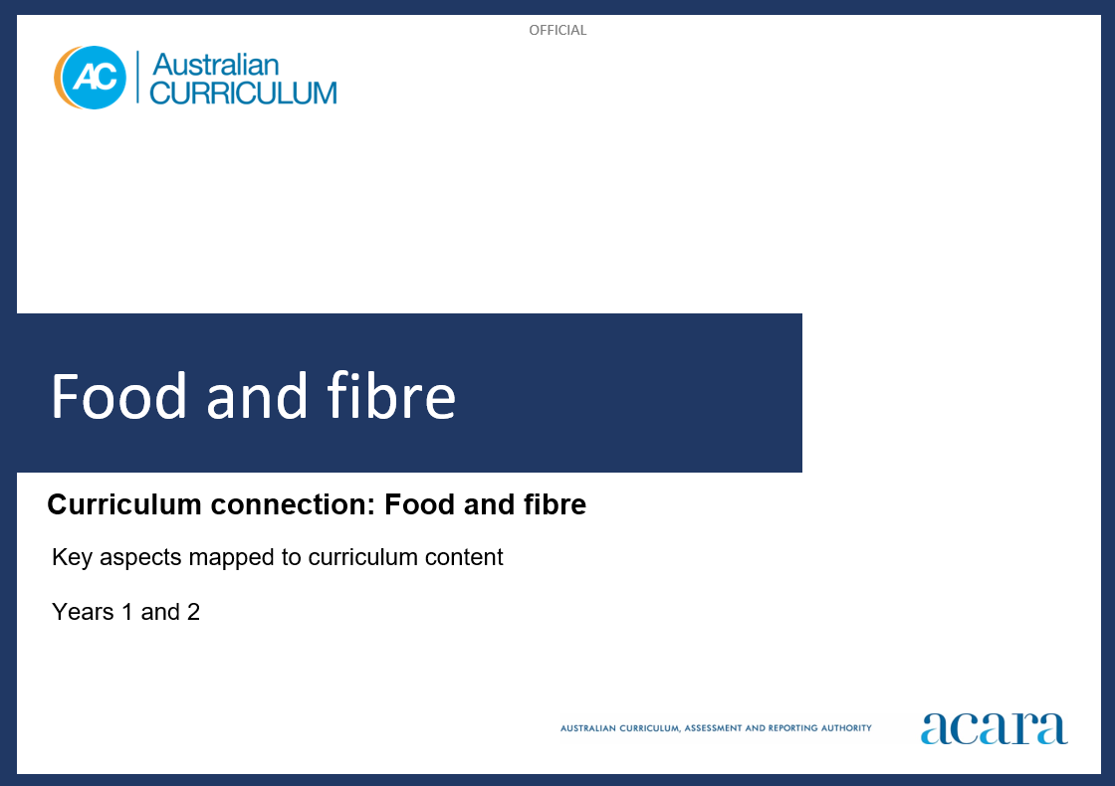

Copyright and Terms of Use Statement
© Australian Curriculum, Assessment and Reporting Authority 2023
The material published in this work is subject to copyright pursuant to the Copyright Act 1968 (Cth) and is owned by the Australian Curriculum, Assessment and Reporting Authority (ACARA) (except to the extent that copyright is held by another party, as indicated).
The viewing, downloading, displaying, printing, reproducing (such as by making photocopies) and distributing of these materials is permitted only to the extent permitted by, and is subject to the conditions imposed by, the terms and conditions of using the ACARA website (see, especially, clauses 2, 3 and 4 of those terms and conditions). The terms and conditions can be viewed at https://www.acara.edu.au/contact-us/copyright

food and fibre: years 1 and 2
The following table identifies how the key aspects of understanding food and fibre production are evident in content descriptions from across the Australian Curriculum Version 9.0. From this information, teachers can develop a sequential program for learning about food and fibre by connecting the key aspects of learning with learning area and subject-specific content descriptions.

Years 1 and 2
Key aspect 1: Sustaining life
Learning area/subject | Strand/sub-strand | Content descriptions | Content elaborations
Design and Technologies | Knowledge and understanding  Technologies context: Food and fibre production; Food specialisations | explore how plants and animals are grown for food, clothing and shelter  AC9TDE2K03 | - exploring how First Nations Australians grow plants and animals for food, for example how land is transformed through the construction of terraces at Wagadagam on Mabuiag Island in the Torres Strait, or how the Kombumerri Peoples of South East Queensland developed an important aquaculture industry farming mangrove worms  - identifying which plants and animals can provide food or materials for clothing and shelter, for example looking at a range of items and sorting them according to plant or animal source  - exploring where plants and animals are grown for food, clothing and shelter in Australia, for example citrus fruit in South Australia; cotton in New South Wales, which is harvested and made into yarn and fabric for clothing; or timber for building homes from sustainable forests in Tasmania
Digital Technologies | Knowledge and understanding  Data representation | represent data as pictures, symbols, numbers and words  AC9TDI2K02 | - recognising that pictures in First Nations Australians’ seasonal calendars are used to represent and communicate data, such as how the appearance of a flower can signify a connected event or a resource availability, for example how the Gulumoerrgin Peoples from the Darwin region of the Northern Territory understand that the fruiting of freshwater mangrove signifies it is time to harvest magpie geese
Science – Year 1 | Science understanding  Biological sciences | identify the basic needs of plants and animals, including air, water, food or shelter and, describe how the places they live meet those needs  AC9S1U01 | - identifying the places where plants and animals live, including in our homes, local areas such as ponds, national parks, gardens or zoos  - identifying what they do to look after pets or plants at home and grouping these activities  - identifying and comparing the needs of a variety of plants and animals, including humans, based on their own experiences  - creating dioramas of a place a plant or animal lives, and identifying the features that enable it to meet its needs  - recognising how First Nations Australians care for living things  - exploring why caring for plants and animals is important including as sources of food and fibre
Science – Year 1 | Science as a human endeavour  Use and influence of science | describe how people use science in their daily lives, including using patterns to make scientific predictions  AC9S1H01 | - learning from farmers, bush care volunteers, gardeners or nursery owners about how they observe the needs of plants, and how they have designed or managed habitats to meet those needs  - identifying ways that science knowledge is used in the care of the local environment and suggesting ways local gardens or parks could better meet the needs of native animals  - investigating how First Nations Australians use science to meet their needs, such as food and water supply and shelter  - recognising how First Nations Australians use changes in the landscape and the sky to answer questions about when to gather certain resources

Years 1 and 2
Key aspect 2: Valuing resources
Learning area/subject | Strand/sub-strand | Content descriptions | Content elaborations
Design and Technologies | Knowledge and understanding  Technologies and society | identify how familiar products, services and environments are designed and produced by people to meet personal or local community needs and sustainability  AC9TDE2K01 | - exploring how local products are designed, for example brainstorming the materials and processes needed to create a costume for a school or community event including using recycled clothing or components to minimise waste  - exploring how people come up with new ideas or modify existing designs, for example preventing water wastage when caring for plants
Design and Technologies | Processes and production skills  Producing and implementing | use materials, components, tools, equipment and techniques to safely make designed solutions  AC9TDE2P02 | - exploring how available materials can be used or re-used in construction play, for example using used wrapping paper and gift cards to design and make decorations or signage for the classroom or a school event to minimise waste
Design and Technologies | Processes and production skills  Evaluating | evaluate the success of design ideas and solutions based on personal preferences and including sustainability  AC9TDE2P03 | - reflecting on the environmental impacts of the production of a solution and considering alternative approaches that would minimise future negative impacts, for example identifying the negative environmental impacts of different food packaging and how these could be minimised

Science – Year 2 | Science understanding  Chemical sciences | recognise that materials can be changed physically without changing their material composition and explore the effect of different actions on materials including bending, twisting, stretching and breaking into smaller pieces  AC9S2U03 | - exploring how First Nations Australians make physical changes to natural materials to produce objects such as bowls, baskets and various fibre crafts

Years 1 and 2
Key aspect 3: Designing solutions and meeting challenges
Learning area/subject | Strand/sub-strand | Content descriptions | Content elaborations
Design and Technologies | Knowledge and understanding  Technologies and society | identify how familiar products, services and environments are designed and produced by people to meet personal or local community needs and sustainability  AC9TDE2K01 | - exploring how local products are designed, for example brainstorming the materials and processes needed to create a costume for a school or community event including using recycled clothing or components to minimise waste  - exploring how people come up with new ideas or modify existing designs, for example preventing water wastage when caring for plants
Design and Technologies | Knowledge and understanding  Technologies context: Food and fibre production; Food specialisations | explore how plants and animals are grown for food, clothing and shelter  AC9TDE2K03 | - identifying products that can be designed and produced from plants and animals, for example food products, paper and wood products, fabrics and yarns  - considering a range of tools and equipment that can be used to grow plants for a purpose and their suitability, for example naming and describing tools such as a spade or rake used to cultivate or mulch a home vegetable garden, or equipment such as a seed spreader or global positioning system (GPS) tractor to sow wheat, or a tubestock planting tool and drones to manage forestry plantations
Design and Technologies | Processes and production skills  Generating and designing | generate and communicate design ideas through describing, drawing or modelling, including using digital tools  AC9TDE2P01 | - communicating design ideas by modelling or producing and labelling 2-dimensional drawings using a range of technologies, for example designing a new environment such as a cubbyhouse or animal shelter and showing different views (top view and side view) with descriptions of materials and features
Design and Technologies | Processes and production skills  Producing and implementing | use materials, components, tools, equipment and techniques to safely make designed solutions  AC9TDE2P02 | - exploring how available materials can be used or re-used in construction play, for example using used wrapping paper and gift cards to design and make decorations or signage for the classroom or a school event to minimise waste  - practising a range of technical skills using tools and equipment safely, for example joining techniques when making products, watering and mulching gardens, preparing a recipe using a knife safely
Design and Technologies | Processes and production skills  Evaluating | evaluate the success of design ideas and solutions based on personal preferences and including sustainability  AC9TDE2P03 | - reflecting on the challenges of designing and producing a solution and recording these reflections, for example when growing a food product, designing a structure to take a load or making a nutritious snack
Design and Technologies | Processes and production skills  Collaborating and managing | sequence steps for making designed solutions cooperatively  AC9TDE2P04 | - using lists or storyboarding when planning and making, for example when creating an electronic planting calendar  - recording the procedure for making a product, for example the ordered steps for making a salad, instructions for making a container or bag
Digital Technologies | Processes and production skills  Generating and designing | follow and describe algorithms involving a sequence of steps, branching (decisions) and iteration (repetition)  AC9TDI2P02 | - following a short, ordered sequence of steps and making decisions to solve a simple problem, for example follow a recipe or directions to reach a location
Digital Technologies | Processes and production skills  Collaborating and managing | use the basic features of common digital tools to create, locate and communicate content  AC9TDI2P04 | - finding images of (local) Australian flora and fauna or places for use in a story and including First Nations Australians’ names for the items
Science – Year 1 | Science as a human endeavour  Use and influence of science | describe how people use science in their daily lives, including using patterns to make scientific predictions  AC9S1H01 | - learning from farmers, bush care volunteers, gardeners or nursery owners about how they observe the needs of plants, and how they have designed or managed habitats to meet those needs  - identifying ways that science knowledge is used in the care of the local environment and suggesting ways local gardens or parks could better meet the needs of native animals  - investigating how First Nations Australians use science to meet their needs, such as food and water supply and shelter  - recognising how First Nations Australians use changes in the landscape and the sky to answer questions about when to gather certain resources
Science – Year 2 | Science as a human endeavour  Use and influence of science | describe how people use science in their daily lives, including using patterns to make scientific predictions  AC9S2H01 | - learning from people who work with materials, such as woodworkers, product designers or artists such as fibre artists or sculptors, about how they learn about properties of materials and how they use creativity when manipulating materials

Years 1 and 2
Key aspect 4: Economy
Learning area/subject | Strand/sub-strand | Content descriptions | Content elaborations
Design and Technologies | Knowledge and understanding  Technologies context: Food and fibre production; Food specialisations | explore how plants and animals are grown for food, clothing and shelter  AC9TDE2K03 | - exploring how First Nations Australians grow plants and animals for food, for example how land is transformed through the construction of terraces at Wagadagam on Mabuiag Island in the Torres Strait, or how the Kombumerri Peoples of South East Queensland developed an important aquaculture industry farming mangrove worms  - exploring where plants and animals are grown for food, clothing and shelter in Australia, for example citrus fruit in South Australia; cotton in New South Wales, which is harvested and made into yarn and fabric for clothing; or timber for building homes from sustainable forests in Tasmania  - identifying products that can be designed and produced from plants and animals, for example food products, paper and wood products, fabrics and yarns  - considering a range of tools and equipment that can be used to grow plants for a purpose and their suitability, for example naming and describing tools such as a spade or rake used to cultivate or mulch a home vegetable garden, or equipment such as a seed spreader or global positioning system (GPS) tractor to sow wheat, or a tubestock planting tool and drones to manage forestry plantations

Years 1 and 2
Key aspect 5: People
Learning area/subject | Strand/sub-strand | Content descriptions | Content elaborations
Design and Technologies | Knowledge and understanding  Technologies and society | identify how familiar products, services and environments are designed and produced by people to meet personal or local community needs and sustainability  AC9TDE2K01 | - exploring how First Nations Australians have long understood their dependence on living systems to meet their local and community needs, for example exploring the material culture of the Ngarrindjeri Peoples who sustainably make woven items from a grass-like sedge  - exploring how people come up with new ideas or modify existing designs, for example preventing water wastage when caring for plants
Design and Technologies | Knowledge and understanding  Technologies context: Food and fibre production; Food specialisations | explore how plants and animals are grown for food, clothing and shelter  AC9TDE2K03 | - exploring how First Nations Australians grow plants and animals for food, for example how land is transformed through the construction of terraces at Wagadagam on Mabuiag Island in the Torres Strait, or how the Kombumerri Peoples of South East Queensland developed an important aquaculture industry farming mangrove worms  - exploring where plants and animals are grown for food, clothing and shelter in Australia, for example citrus fruit in South Australia; cotton in New South Wales, which is harvested and made into yarn and fabric for clothing; or timber for building homes from sustainable forests in Tasmania
Digital Technologies | Knowledge and understanding  Data representation | represent data as pictures, symbols, numbers and words  AC9TDI2K02 | - recognising that pictures in First Nations Australians’ seasonal calendars are used to represent and communicate data, such as how the appearance of a flower can signify a connected event or a resource availability, for example how the Gulumoerrgin Peoples from the Darwin region of the Northern Territory understand that the fruiting of freshwater mangrove signifies it is time to harvest magpie geese

Science – Year 1 | Science understanding  Biological sciences | identify the basic needs of plants and animals, including air, water, food or shelter, and describe how the places they live meet those needs  AC9S1U01 | - identifying the places where plants and animals live, including in our homes, local areas such as ponds, national parks, gardens or zoos  - identifying what they do to look after pets or plants at home and grouping these activities  - identifying and comparing the needs of a variety of plants and animals, including humans, based on their own experiences  - creating dioramas of a place a plant or animal lives, and identifying the features that enable it to meet its needs  - recognising how First Nations Australians care for living things  - exploring why caring for plants and animals is important including as sources of food and fibre
Science – Year 1 | Science as a human endeavour  Use and influence of science | describe how people use science in their daily lives, including using patterns to make scientific predictions  AC9S1H01 | - learning from farmers, bush care volunteers, gardeners or nursery owners about how they observe the needs of plants, and how they have designed or managed habitats to meet those needs  - identifying ways that science knowledge is used in the care of the local environment and suggesting ways local gardens or parks could better meet the needs of native animals  - investigating how First Nations Australians use science to meet their needs, such as food and water supply and shelter  - recognising how First Nations Australians use changes in the landscape and the sky to answer questions about when to gather certain resources
Science – Year 2 | Science as a human endeavour  Use and influence of science | describe how people use science in their daily lives, including using patterns to make scientific predictions  AC9S2H01 | - learning from people who work with materials, such as woodworkers, product designers or artists such as fibre artists or sculptors, about how they learn about properties of materials and how they use creativity when manipulating materials

