General Capabilities in the Australian Curriculum:
Health and Physical Education
The general capabilities play a significant role in the Australian Curriculum in equipping young Australians to live and work successfully in the twenty-first century.
In the Australian Curriculum, capability encompasses knowledge, skills, behaviours and dispositions. Students develop capability when they apply knowledge and skills confidently, effectively and appropriately in complex and changing circumstances, in their learning at school and in their lives outside school.
The Australian Curriculum includes seven general capabilities, as shown in the figure below.
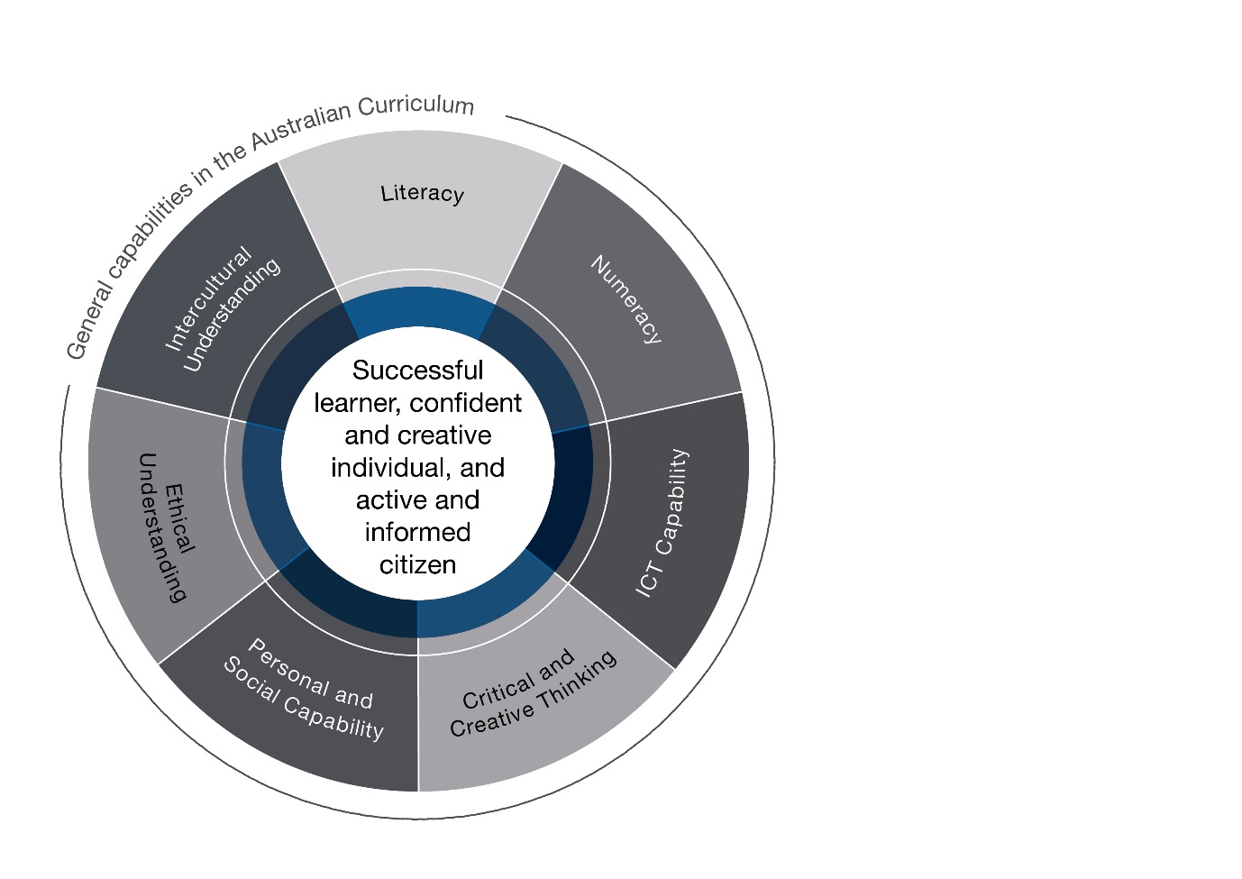

In the Australian Curriculum: Health and Physical Education, general capabilities are identified where they are developed or applied in the content descriptions. They are also identified where they offer opportunities to add depth and richness to student learning via the content elaborations, which are provided to give teachers ideas about how they might teach the content. Icons are used to indicate where general capabilities have been identified in learning area content descriptions and elaborations.

Literacy
The Australian Curriculum: Health and Physical Education assists in the development of literacy by introducing specific terminology used in health and physical activity contexts. Students understand the language used to communicate and connect respectfully with other people, describe their own health status, as well as products, information and services. They also develop skills that empower them to be critical consumers able to access, interpret, analyse, challenge and evaluate the ever-expanding and changing knowledge base and influences in the fields of health and physical education. In physical activity settings, as consumers, performers and spectators, students develop an understanding of the language of movement and movement sciences. This is essential in analysing their own and others’ movement and levels of fitness.
Students also learn to comprehend and compose texts related to the Australian Curriculum: Health and Physical Education. This includes learning to communicate effectively for a variety of purposes to different audiences, express their own ideas and opinions, evaluate the viewpoints of others, ask for help and express their emotions appropriately in a range of social and physical activity contexts.

Numeracy
The Australian Curriculum: Health and Physical Education provides students with opportunities to use calculation, estimation and measurement to collect and make sense of information related to, for example, nutrition, fitness, navigation in the outdoors or various skill performances. Students use spatial reasoning in movement activities and in developing concepts and strategies for individual and team sports or recreational pursuits. Students interpret and analyse health and physical activity information using statistical reasoning, identifying patterns and relationships in data to consider trends, draw conclusions, make predictions and inform health behaviour and practices.

Information and Communication Technology (ICT) Capability
The Australian Curriculum: Health and Physical Education enhances ICT learning by helping students to effectively and safely access online health and physical activity information and services to manage their own health and wellbeing. Students further develop their understanding of the role ICT plays in the lives and relationships of children and young people. They explore the nature of ICT and the implications for establishing and managing relationships in the twenty-first century. Students develop an understanding of ethical online behaviour, including protocols and practices for using ICT for respectful communication. Students use ICT as key tools for communicating, collaborating, creating content, seeking help, accessing information and analysing performance in the health and physical education field. Students become confident and critical consumers of a multitude of wellbeing apps that can assist them to seek help, relax, be mindful, report bullying, and so on.
They use a range of ICT to analyse, measure and enhance movement performances and to access and critically evaluate health information, products and services. They also use ICT to develop personalised plans for nutrition, physical activity participation and wellbeing.

Critical and Creative Thinking
In the Australian Curriculum: Health and Physical Education, students develop their ability to think logically, critically and creatively in response to a range of health and physical education issues, ideas and challenges. They learn how to critically evaluate evidence related to the learning area and the broad range of associated media and other messages to creatively generate and explore original alternatives and possibilities. In the HPE curriculum, students’ critical and creative thinking skills are developed through learning experiences that encourage them to pose questions and seek solutions to health issues by exploring and designing appropriate strategies to promote and advocate personal, social and community health and wellbeing. Students also use critical thinking to examine their own beliefs and challenge societal factors that negatively influence their own and others’ identity, health and wellbeing.
The Australian Curriculum: Health and Physical Education also provides learning opportunities that support creative thinking through dance making, games creation and technique refinement. Students develop understanding of the processes associated with creating movement and reflect on their body’s responses and their feelings about these movement experiences. Including a critical inquiry approach is one of the five propositions that have shaped the HPE curriculum.

Personal and Social Capability
In the Australian Curriculum: Health and Physical Education, students work independently and collaboratively in movement- and non–movement-based activities to develop personal and social skills as well as an awareness and appreciation of their own and others’ strengths and abilities. Taking a strengths-based approach is one of five propositions that have shaped the entire health and physical education curriculum. Students develop a range of interpersonal skills such as communication, negotiation, teamwork and leadership, and an appreciation of diverse perspectives.
The Australian Curriculum: Health and Physical Education provides explicit opportunities for students to explore their own identities and develop an understanding of factors that influence and shape who they are. They learn how to recognise, understand, validate and respond appropriately to their own and others’ emotions, strengths and values. In the Australian Curriculum: Health and Physical Education, students are provided with explicit opportunities to learn, practise, gain feedback about and refine their personal and social skills. Students develop the knowledge, understanding and skills to set and monitor personal and academic goals, effectively manage their time, and prioritise tasks and responsibilities to balance their school, home, work and social commitments.

Ethical understanding
The Australian Curriculum: Health and Physical Education focuses on the importance of treating others with respect, integrity, fairness and compassion, and valuing diversity and equality for all. Students examine ethical principles and codes of practice appropriate to different contexts, such as at school, at home, in the community, in relationships, on the sporting field, in the natural environment and when using digital technologies such as social media. As students explore concepts and consequences of fair play, equitable participation, empathy and respect in relationships, they develop skills to make ethical decisions and understand the consequences of their actions. They also develop the capacity to apply these skills in everyday situations and movement-based contexts.

Intercultural understanding
In the Australian Curriculum: Health and Physical Education students develop intercultural understanding as they learn about the similarities and differences among individuals and groups and explore how these are celebrated and respected in local, national and global contexts. Students learn about their own heritage and cultural identities, explore strategies to demonstrate respect, value diversity and show empathy. They describe how these strategies can positively influence relationships. They have opportunities to explore different points of view, promote inclusivity and investigate how respecting diversity and challenging stereotypes can influence individual and community health. Students participate in physical activities from their own and others’ cultures, and examine how involvement creates community connections and promotes intercultural understanding.

